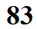
Humidity Variables Introduction

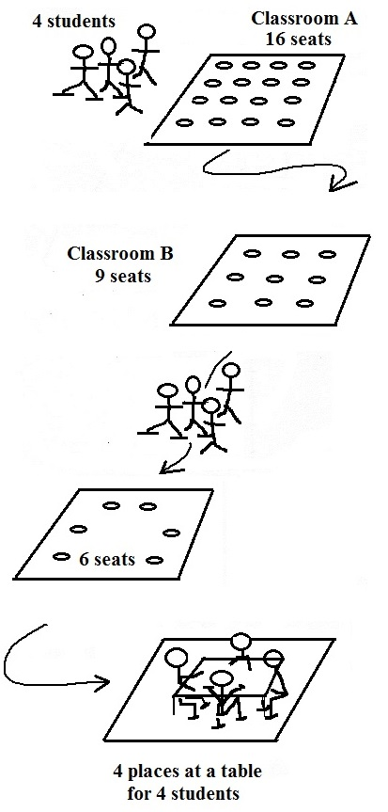
Mixing ratio (r) - one of several ways of specifying how much water vapor is actually in the air.

just a number ---> a big value means more water vapor water vapor than a small value.

Mixing ratio is not affected by changes in air temperature or pressure. It only changes when you add or remove water vapor to(from) the air.

Analogy (see figure at right) - actual number of students in a classroom.

Saturation mixing ratio (r_{s}) - the maximum amount of water vapor than can be found in air.

Depends on the air temperature. Warm air can potentially contain more water vapor than cold air.

Analogy - number of seats available in a classroom.

Relative humidity (RH) - tells you how close the air is to being filled to capacity (saturated) with water vapor.

RH doesn't really tell you how much water vapor is actually in the air. RH is still a useful quantity - when the RH approaches 100% dew, frost, fog, and clouds can form.

Analogy - how full in a particular classroom

Dew point temperature (Td) - (1) just like the mixing ratio, it gives you an idea of how much water vapor
is actually in the air. (2) When you cool the air to its dew point temperature, the relative humidity becomes 100%.

Analogy - moving to smaller and smaller classrooms until you find one that is filled to capacity

