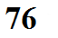
The changing orientation of the tilted earth as it orbits the sun (sometimes tilting toward the sun other times away from the sun) causes changes in the angle at which sunlight strikes the ground.

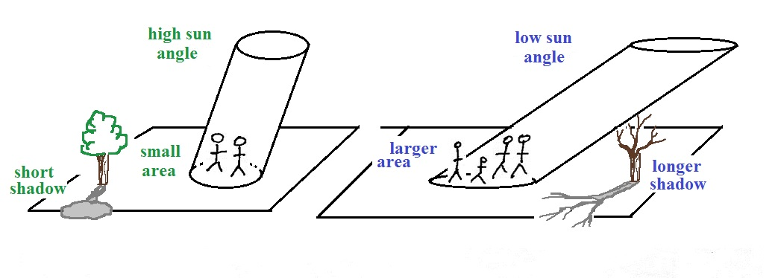
1a. In the summer the sun is higher in the sky, it shines more directly, and strikes a smaller area of ground. The energy received per square foot of ground is higher in the summer than in the winter.

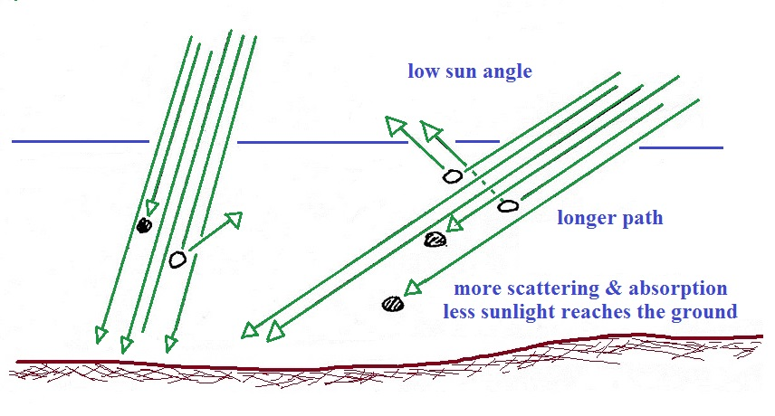
1b. More of the incoming sunlight energy reaches the ground in the summer because the sunlight takes a shorter path through the atmosphere and there is less chance for sunlight to be absorbed or scattered.

2. Another effect is something you will notice during the course of the semester. The changing orientation of the tilted earth causes changes in

