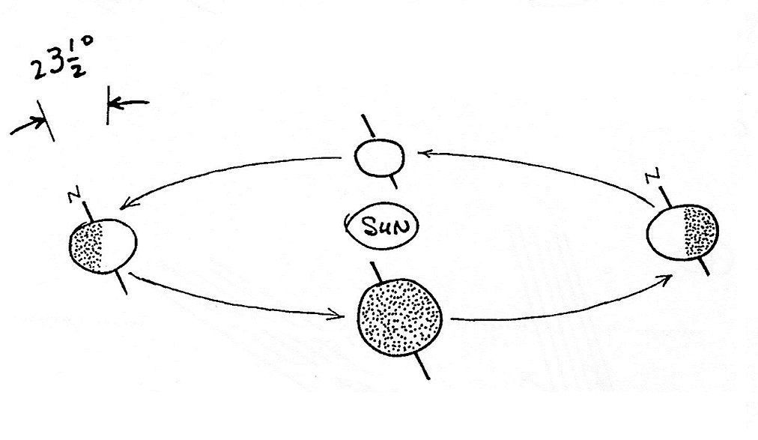
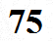
The earth's axis of rotation is tilted with respect to the plane of the earth's orbit around the sun. This is the main cause of seasonal variations.

