The earth's orbit around the sun is not circular, it's elliptical.
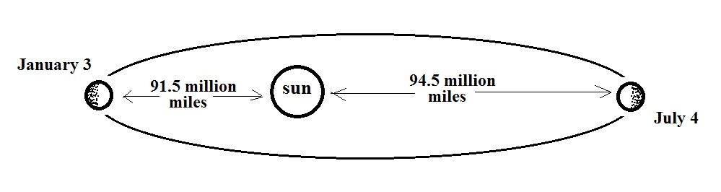

Many people incorrectly below that it is this changing distance between the earth and sun that causes the seasons. If this were the correct explanation then
1.

2.
