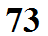
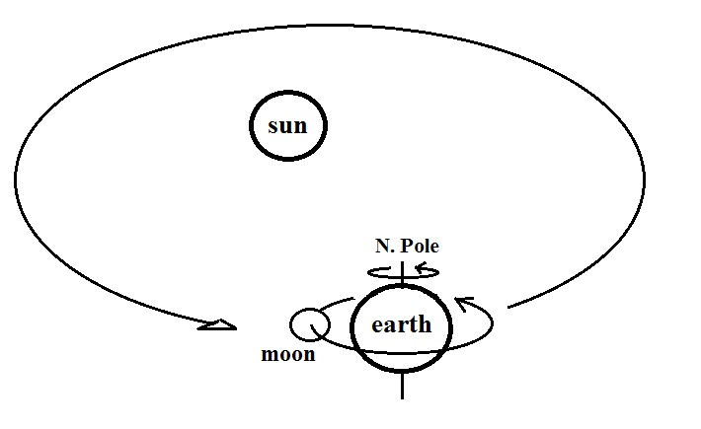

The earth completes an orbit around the sun every _______________
The earth makes a complete rotation on its axis every _______________
The moon completes an orbit around the earth every _______________

