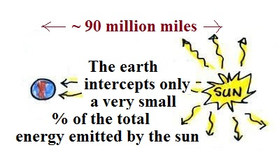

Radiative equilibrium (energy balance)
Earth without an atmosphere (simplest case)

How is it possible for the earth to be in energy
balance with the sun which is much larger and
much hotter?
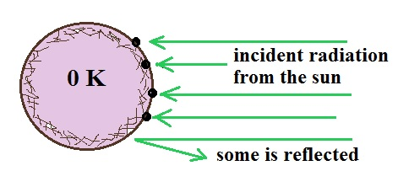

1. The earth is very cold in this first
picture and is only absorbing energy
from the sun, not emitting any
radiant energy of its own.

The absorption of energy will start
to warm the earth.
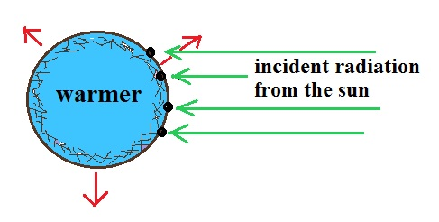

2. The earth is now emitting IR radiation
though not as much as it is getting from
the sun (note the incoming sunlight
that is reflected has been left off this
picture).

Because the earth is getting more
energy than it is giving off, it will
warm some more.
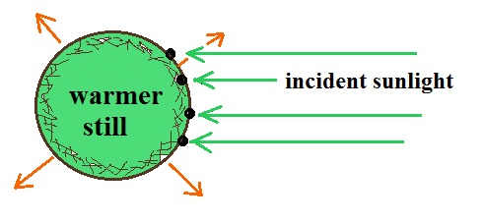

3. The earth has warmed enough that it
is now emitting as much energy as it
gets from the sun. The emitted energy
is far IR radiation, the absorbed sunlight
is a mixture of IR, visible, and UV light.

Because the amounts of absorbed and
emitted energy are equal, the earth's temperature won't change. The earth has reached its radiative equilibrium temperature (which for this case without an atmosphere is
about 0º F).

