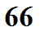
Emission of EM radiation by the earth and sun

