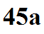
Energy and temperature relationship
Adding energy to (or removing energy from) an object will usually* cause the object's
______________________________ to increase (decrease)
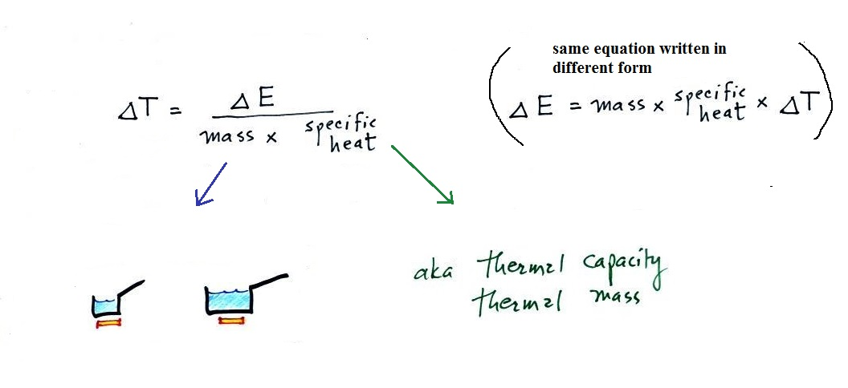
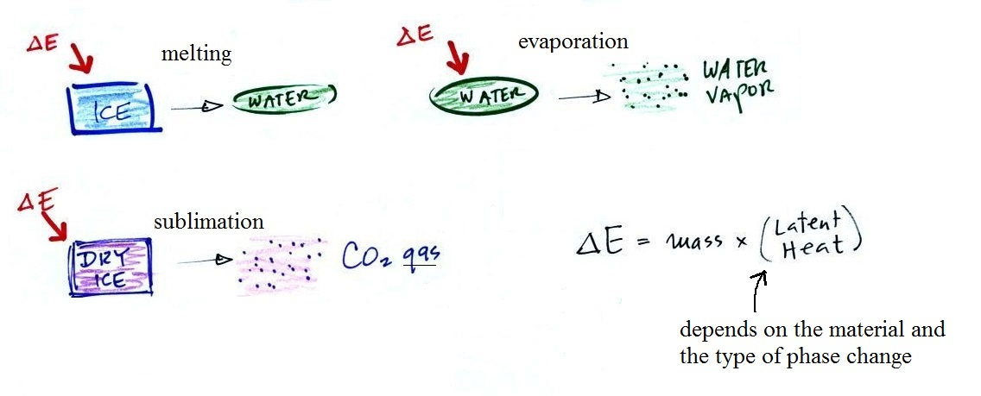
* What else might happen?

