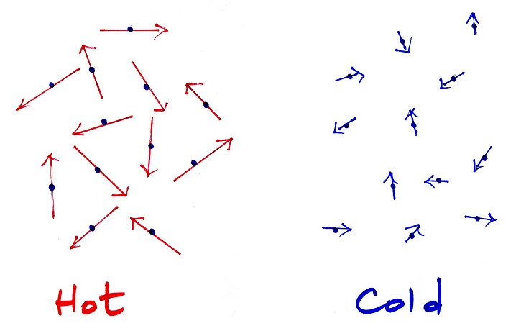
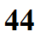
Temperature and
temperature scales

____________________________________________________________________________________
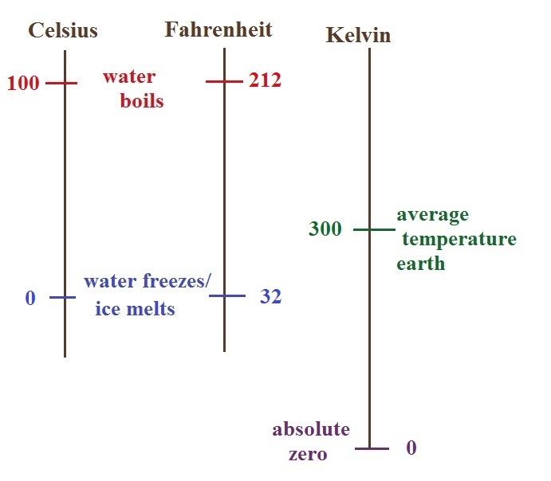

Hot temperature records Cold temperatures
129º F (Death Valley in 2013 & -70º F (Montana, 1954)
Mitribah, Kuwait in 2016) -80º F (Alaska, 1971)
-109º F (dry ice)
-129º F (Antarctica, 1983)
-320º F liquid nitrogen

