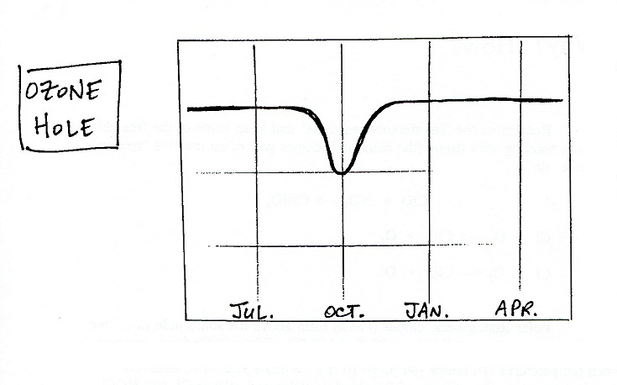
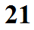

What?

Where?

When?

Importance?

