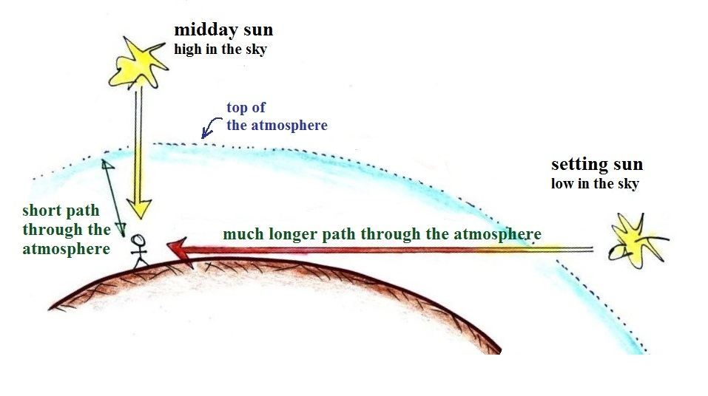

Light from the setting sun takes a much longer path through the atmosphere. Most of the shorter wavelength light is removed by scattering. The light that reaches the ground is weaker and composed of only the longer wavelengths of visible light. The setting sun has an orange or reddish color.
