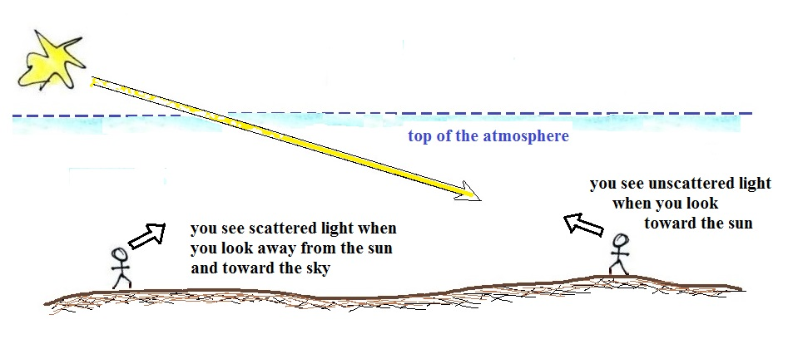

Incoming sunlight is white because it's a roughly equal mix of all the colors ( pt. a in the figure below)
When you look toward the sun (which you shouldn't do of course) you see light that passes through the atmosphere and reaches your eyes without being scattered by air molecules. As the figure below shows it's the original white light with a small amount of the shorter wavelength violet, blue, and green light removed (b in the figure). This results in a warm white; the white sunlight turns yellowish white (orange or red if the sun is low in the sky).

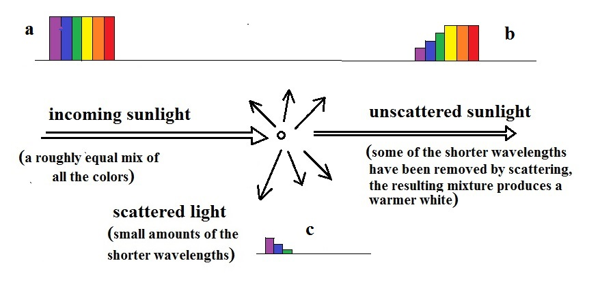

When you look away from the sun and at the sky you see sunlight that has been scattered by air molecules (pt. c). There's only a little bit of scattered light, so it's weak and safe to look at. Also it's made up of mostly just the shorter wavelengths of visible light. This is what gives the sky its blue color.

