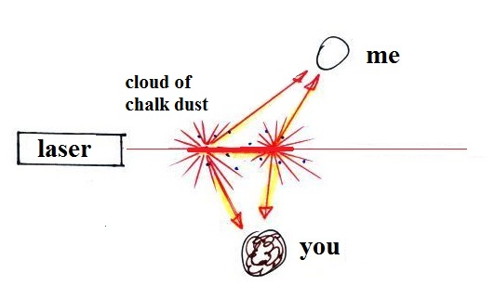


We can see the laser beam when it shines through air filled with chalk particles. The small particles intercept and scatter (redirect) the laser light.
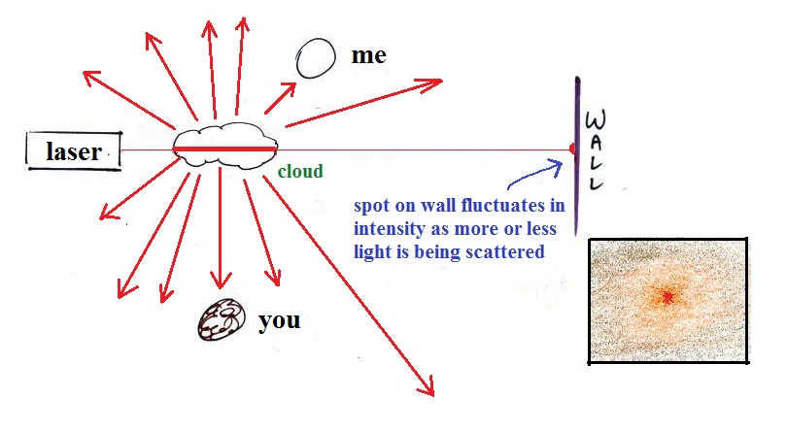

A cloud of water droplets (smaller but much more numerous than chalk particles) does a very good job of scattering light.
Light is scattered by clouds (made up of water droplets or ice crystals), raindrops & snowflakes, and particulate matter. Air itself can scatter light. We aren't able to see laser light scattered by air in the classroom but outdoors where there is more air and more intense sunlight the scattered light can be seen (it's what gives the sky its blue color).

