ATMO 170 Sect. 1 Name__________________________________
Practice Quiz Feb. 1, 2018 (please also put your name on the back)

1. (5 pts)What is missing from the O₂ + ___________________ → O + O
photo-dissociation reaction shown at right?

2. (5 pts) To reduce carbon monoxide emissions would it be best to INCREASE or DECREASE the amount of oxygen available during combustion. (circle the answer)

3. (5 pts) An increase in the atmospheric concentration of _______ might change the color of the sky from a deep blue to a bluish-white.
a. ozone b. water vapor c. particulate matter d. argon

4. (5 pts) Sea level atmospheric pressure is determined by the _______ of the atmosphere.
a. weight b. density c. temperature d. composition e. thickness

5. (5 pts) The air is healthiest when value of the Air Quality Index (AQI) is HIGH LOW.

6. (15 pts) _______ is generally considered to be the first recognized air pollutant. High concentrations of _______ is partly what made the Great London Smog of 1952 so deadly (4000 people died in a one week period). _______ react(s) with water in clouds to make acid rain. (fill in each blank with one of the choices below, answers can be used more than once)
a. Carbon monoxide b. Ozone c. Sulfur dioxide
d. Radon e. Chlorofluorocarbons f. Argon

7. (5 pts) An object with _______ would have the highest density.
a. large mass and large volume b. large mass and small volume
c. small mass and large volume d. small mass and small volume

8. (5 pts) Most of the _______ in our atmosphere is thought to have come from photosynthesis.
a. nitrogen b. carbon dioxide c. water vapor d. oxygen e. argon

9. (5 pts) _______ is(are) one of the best ways of removing particulate pollution from the air.
a. Clouds b. Photosynthesis c. Ultraviolet light d. Wind

10. (5 pts) If you carry an object from the earth to the moon, the object’s _______ will change.
a. composition b. density c. mass d. volume e. weight

11. (10 pts) Is there more NITROGEN or OXYGEN in the earth’s atmosphere? Is there more ARGON or CARBON DIOXIDE in the air we breathe?

12. (15 pts) In Tucson the concentration of _______ peaks in the summer, _______ is a wintertime pollutant, _______ is a problem year round, and ______ is generally not a problem in Tucson. (fill in the blanks, each answer below should be used once)
a. carbon monoxide b. particulate matter c. ozone d. sulfur dioxide
Name___________________________________

13. (10 pts) There is less and less air left overhead when you move upward in the atmosphere. This explains why PRESSURE TEMPERATURE always DECREASES INCREASES with increasing altitude.

14. (5 pts) _______ react with and destroy stratospheric ozone.
a. Radon & argon b. Chlorofluorocarbons c. Nitrogen & oxygen d. Greenhouse gases

15. (10 pts) A(n) INCREASE DECREASE of air DENSITY PRESSURE TEMPERATURE with increasing altitude is called an inversion and produces stable atmospheric conditions.

16. (5 pts) Moist air must be cooled to _________________________ in order for fog or a cloud to form.

17. (10 pts) During complete combustion fuels react with oxygen to form _______. During incomplete combustion _______ is produced. (fill in the blanks)
a. carbon monoxide b. ozone c. hydrogen d. carbon dioxide e. smog

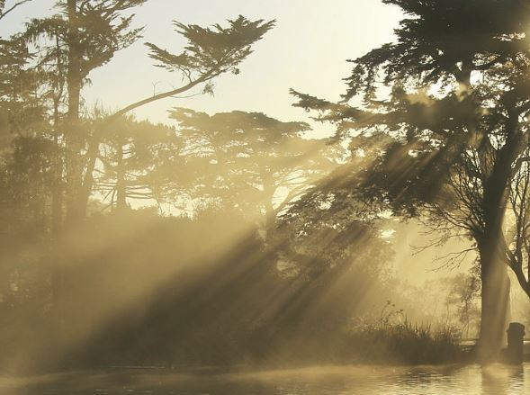
18. (5 pts) Hydrocarbons react with _______ to form photochemical smog.
a. water vapor b. carbon monoxide c. sulfur dioxide
d. ozone e. carbon dioxide f. chlorofluorocarbons

19. (5 pts) You are able to see beams of sunlight shining through gaps
between the branches of the tree in the picture because sunlight is
being ____________________ by small particles of dust in the air.

20. (5 pts) Is photochemical smog another name for LOS ANGELES-type or LONDON-type smog?

21. (5 pts) On the earth two objects that have the same weight must also have the same
a. volume b. composition c. mass d. density

22. (5 pts) The dew point temperature tells you whether the air is _______.
a. dry or moist b. stable or unstable c. clean or polluted d. hot or cold

Extra Credit (you can earn up to 10 pts)
1. (5 pts) When ice melts it turns from a solid to a liquid. Dry ice is different.
It turns directly from a solid into a gas. What gas does dry ice turn into?

2. (5 pts) Average sea level pressure is about 1000 _______.
a. inches of mercury b. millibars c. pounds per square inch d. kilograms

3. (5 pts) Even when the air is free of pollutants, rain naturally contains some dissolved carbon dioxide and has a pH of about 5.6. Is this natural rain ACIDIC BASIC or NEUTRAL.

