ATMO 170 In-class Optional Assignment Name__________________________________
(due at the end of class)

1. Three of the following would all be located at about the same altitude. Which one is found at considerably higher altitude than the other three?
a. the flat top of a thunderstorm b. the summit of Mt. Everest
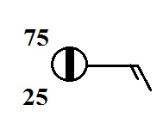
c. a commercial airliner at 30,000 ft. altitude d. the ozone layer

2. According to the information plotted at right,
is MORE or LESS than half of the sky covered with clouds

3. The atmosphere is split into layers (troposphere, stratosphere, mesosphere, etc.) according to how _______ changes with altitude.
a. composition b. density c. pressure d. temperature
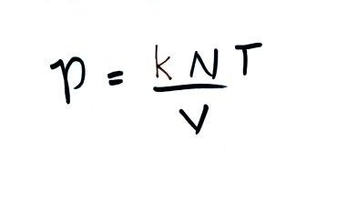
4. If you double the number (N) of air molecules in a balloon,
double the volume (V) of the balloon, and double the temperature (T),
the pressure of the air in the balloon will
a. increase by a factor of 2 b. increase by a factor of 4
c. remain constant
d. decrease by a factor of 2 e. decrease by a factor of 4

5. Warming or cooling a parcel of air in the atmosphere will cause _______ and _______ to change. The _______ and _______ remain constant. (fill in the blanks with ρ (density), V (volume, N (number of air molecules), or P (pressure). Each answer should be used once.)
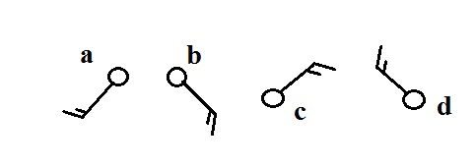
6. Circle the figure at right that shows winds
blowing from the southwest.

7. Are clouds more likely to form when moist air is WARMED or COOLED?
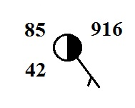
8. Which of the following are not shown at right?
a. relative humidity b. temperature c. pressure
d. dew point e. altitude

9. Would you expect the station pressures measured in Tucson and at the summit of Mt. Lemmon to be nearly EQUAL or very DIFFERENT. Would you expect the sea level pressure estimates for Tucson and Mt. Lemmon to be nearly EQUAL or very DIFFERENT.

10. When it is 10:00 am in Tucson it is 5:00 pm in London. What time would it be in London when it is 15:00 MST in Tucson?

