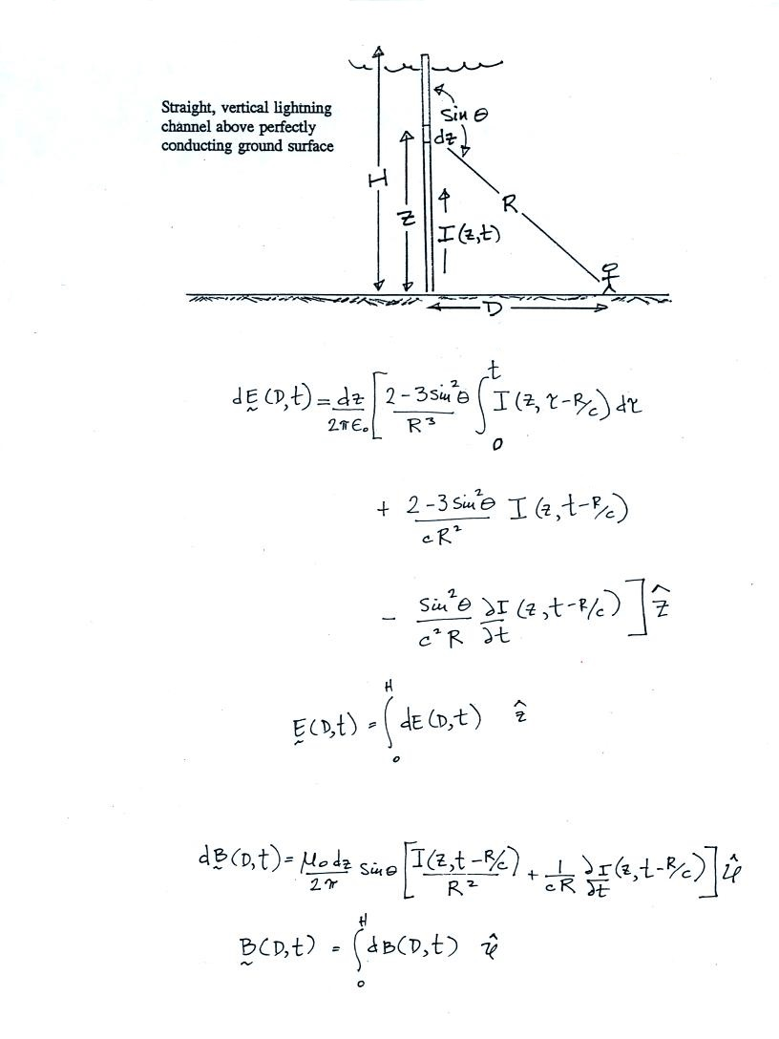

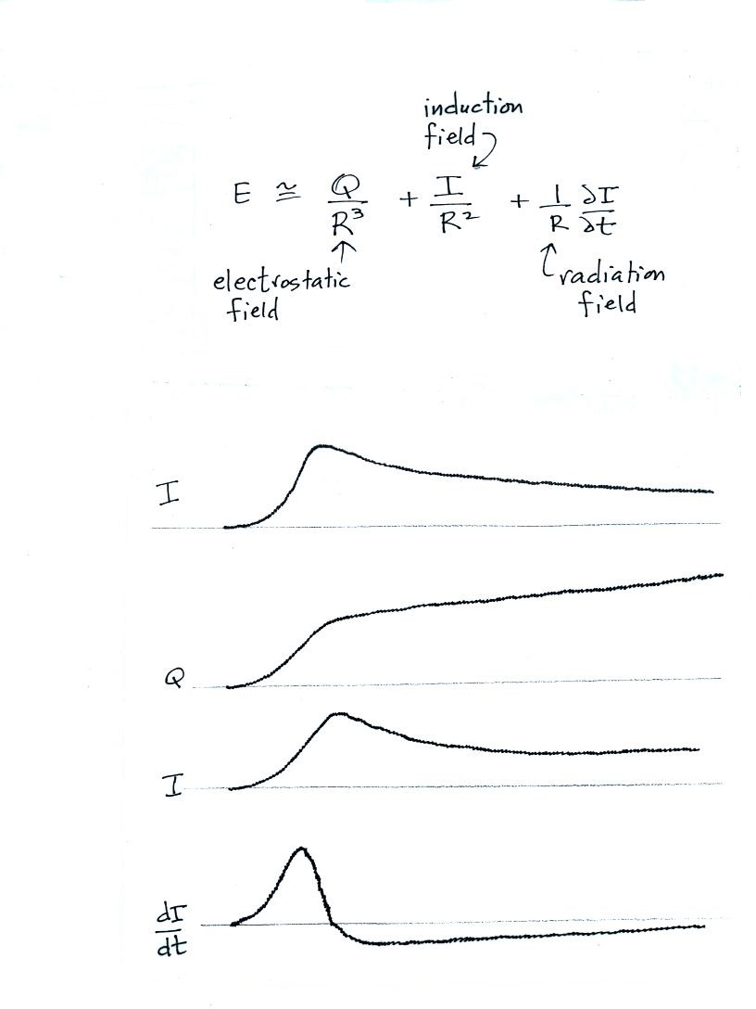

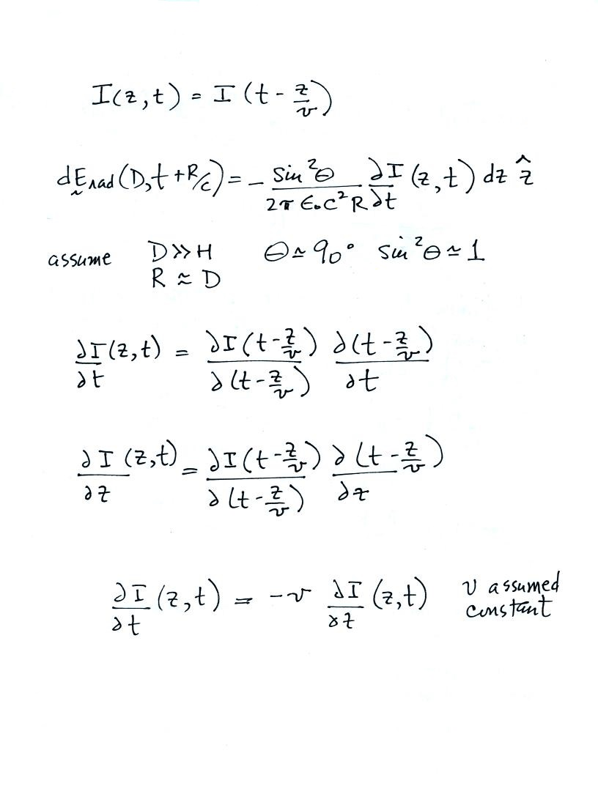

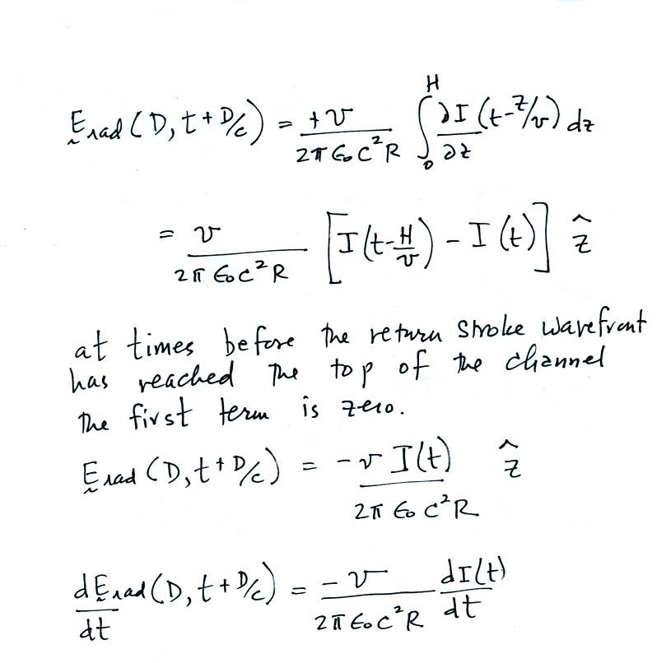
E_{rad} has the same shape as the current waveform measured at the ground. Ditto for dE_{rad}/dt and dI/dt.
This expression is widely used to estimate I_{peak} and peak values of dI/dt from measured E_{rad} and dE_{rad}/dt.
note: peak I and peak dI/dt occur when the tip of the upward moving return stroke current waveform is close to the ground. The assumption that the return stroke channel is straight and vertical might not be too bad at this point.

