Conducting Sphere in a Uniform Electric Field

Notes on the distortion of an initially uniform electric field Eo by the presence of an uncharged conducting sphere. The sphere distorts the field such that the field lines are everywhere normal to the surface of the conductor. Choosing the origin of our coordinate system at the center of the sphere
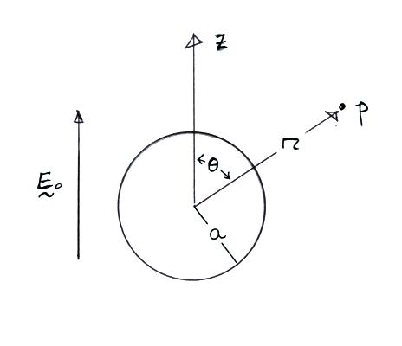
Spherical polar coordinates are used, there is azimuthal symmetry, so the potential and the electric field depend on r and θ only. We can proceed to solve Laplace's equation for the potential, Φ, subject to the boundary conditions that
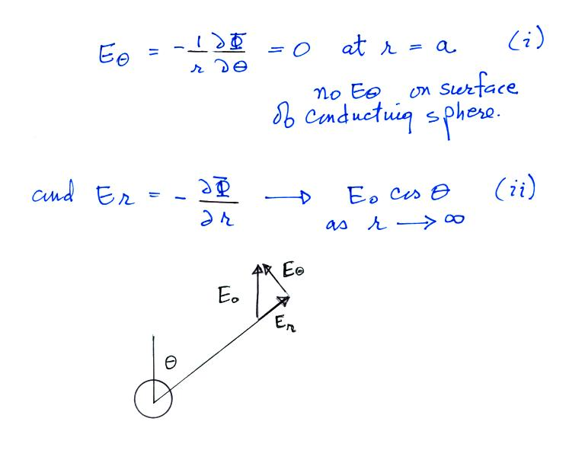
In the spherical coordinate system
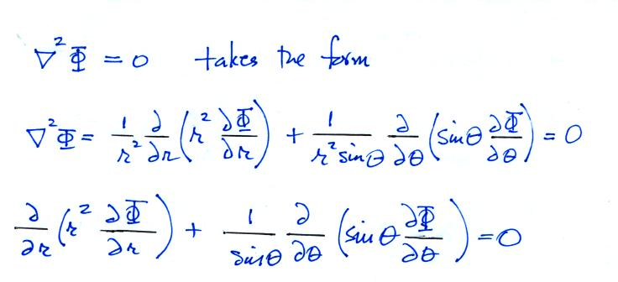
Assuming the variables are separable, we try a general solution of the form:
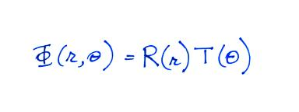
Just looking at the boundary condition (Eqn. (ii)), we simply try a T(θ) function of the form
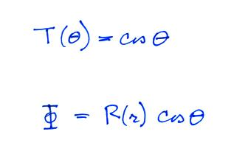
Now, inserting this into our original differential equation, we find
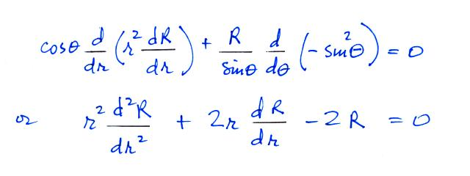
some of the missing details are at the end of these notes.
Now, let's try a solution to the R equation of the form
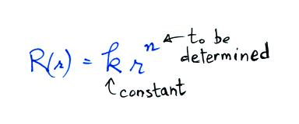
When we substitute this into the differential equation above we get
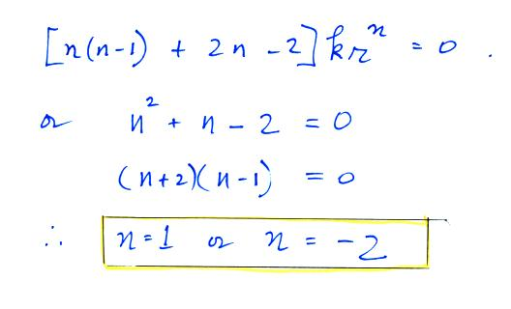
Now a general R solution will be of the form
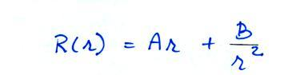

and
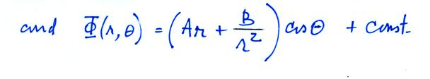
Where A and B must be determined from the boundary conditions.
Now,
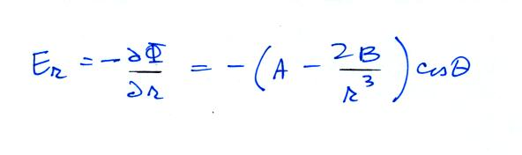
applying boundary condition (ii) as r goes to infinity
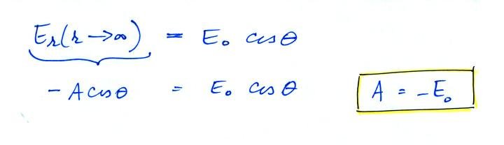
since
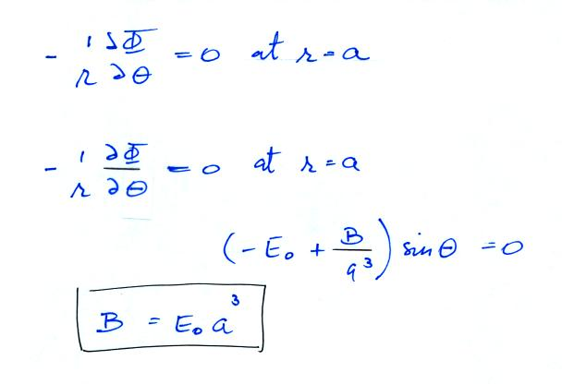
and our potential function is now
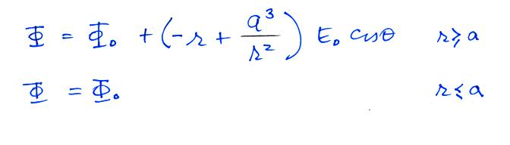
with this Φ our electric field components are:
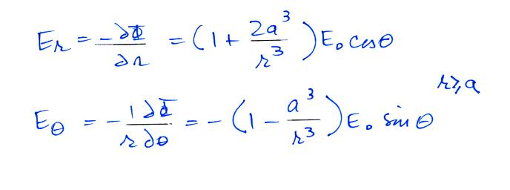
and the surface charge density is
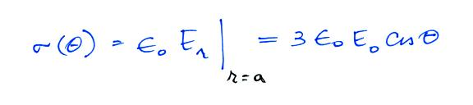
Note: The presence of the sphere increases the value of the ambient field at the top and bottom surface of the sphere by a factor of 3.

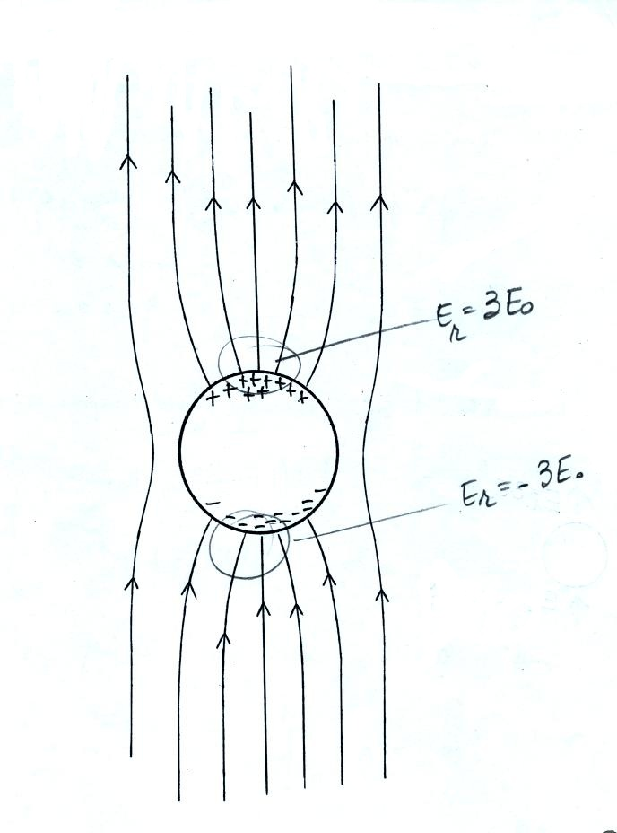
This figure gives you a rough idea of how the field is changed in the vicinity of the sphere. E field lines must intersect the sphere perpendicularly. The field is enhanced (amplified) by a factor of three at the top and bottom of the sphere.
