ATMO/ECE 489/589 Spring 2013
Homework #3 due Tue., Feb. 19

1. (10 pts) The basic dipole structure of a thunderstorm was deduced in the early 1900s when researchers observed that the electric field polarity switched signs depending on whether the cloud was close to or far from the measuring site.

(a) Write an equation for the vertical electric field at the ground as a function of D. You can assume the ground is a perfect conductor. (note you've already done this problem for the case of one charge above the ground, no need to go through all the details again, you should be able to just write down the solution to this two-charge problem)

(b) Determine the field reversal distance, D_{R} (the point at which the field reverses polarity), for the case where H_{P} = 9 km and H_{N} = 6 km.
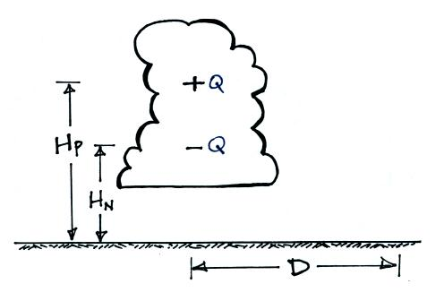

(c) (5 pts extra credit) At what distance D would the peak values of the positive and negative polarity E field be found?

2. (10 pts) A simplified ion balance equation is given below:

dn/dt = q - an² - BnZ
where
n is the concentration of positive or negative small ions ( n₊ = n₋ )
q is the small ion production rate
a is the ion-ion recombination coefficient
B is the ion-particle attachment coefficient
Z is the aerosol particle concentration

(a) Derive an expression for n(t) for the case where ion-aerosol attachment is the dominant loss process and ion-ion recombination can be neglected. Assume n(t) = 0 for t = 0.

(b) Compute the steady-state small ion concentration for the case where
q = 10 (ion pairs)/cm³ sec
B = 2 x 10⁻⁶ cm³ / sec
Z = 1000 cm⁻³

(c) Use the result from (b) to compute the air conductivity assuming that the small ions are singly charged and that the mobilities B_{e}(+) and B_{e}(-) are both 1 (cm/sec)/(volt/cm).

