Friday Apr. 3, 2009
Music today was from Ticket to Memphis from The Tangelos, a local group.
The Experiment #4 reports are due next Monday.
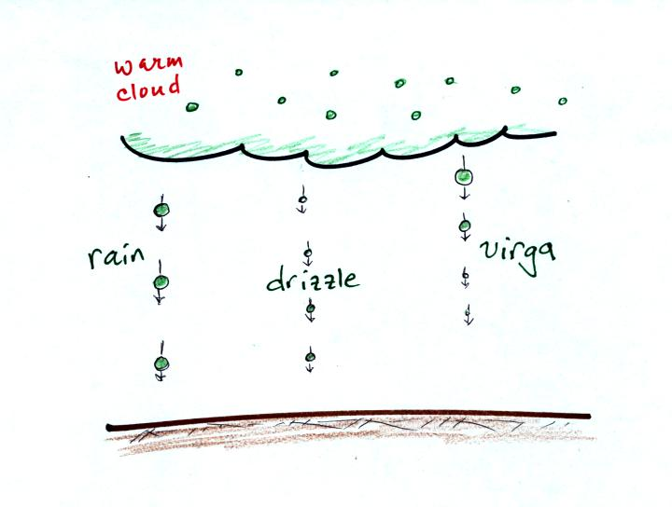
Here's about all the collision-coalescence process can do. Virga is rain that evaporates before reaching the ground.
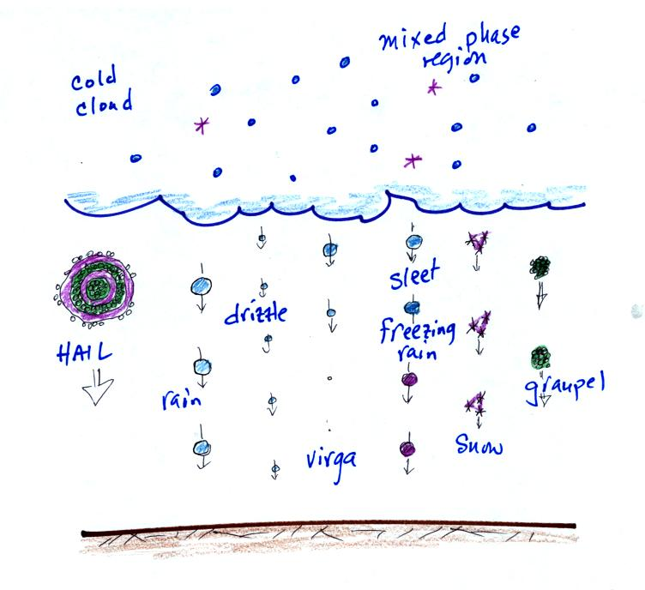
The ice crystal process is a whole lot more interesting because of the variety of different types of precipitation that it can produce. Much of what is shown above happens inside the cloud, some of it happens after the particles leave the cloud and fall toward the ground.
Before learning about the ice crystal process, we need to first look at the structure of cold clouds. The figure below is a redrawn version of what was shown in class.
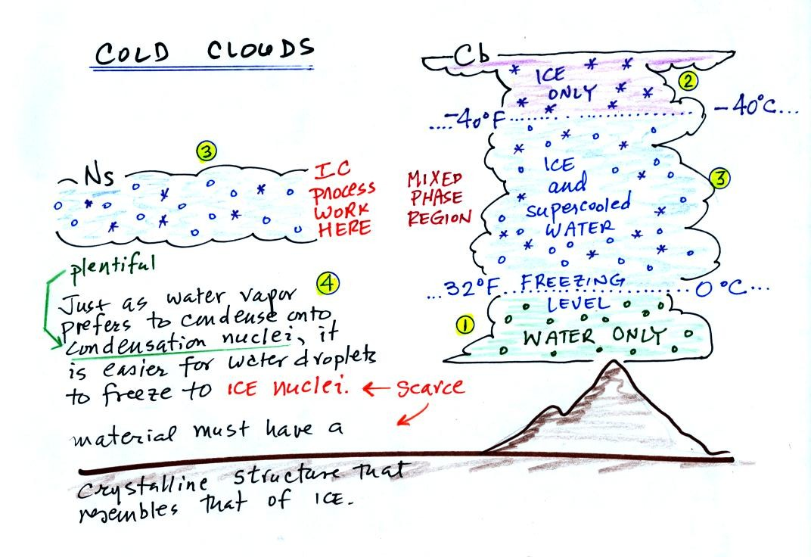
The bottom of the thunderstorm, Point 1, is warm enough (warmer than freezing) to just contain water droplets. The top of the thunderstorm, Point 2, is colder than -40 C (also -40 F) and just contains ice crystals. The interesting part of the thunderstorm and the nimbostratus cloud is the middle part, Point 3, that contains both supercooled water droplets (water that has been cooled to below freezing but hasn't frozen) and ice crystals. This is called the mixed phase region. This is where the ice crystal process will be able to produce precipitation. This is also where the electrical charge that results in lightning is generated.
The supercooled water droplets aren't able to freeze even though they have been cooled below freezing. At Point 4 we see this is because it is much easier for small droplets of water to freeze onto an ice crystal nucleus or for water vapor to be deposited onto an ice crystal nucleus (just like it is easier for water vapor to condense onto condensation nuclei rather than condensing and forming a small droplet of pure water). Not just any material will work as an ice nucleus however. The material must have a crystalline structure that is like that of ice. There just aren't very many materials with this property and as a result ice crystal nuclei are rather scarce.

We'll see next how the ice crystal process works. There are a couple of "tricky" parts.
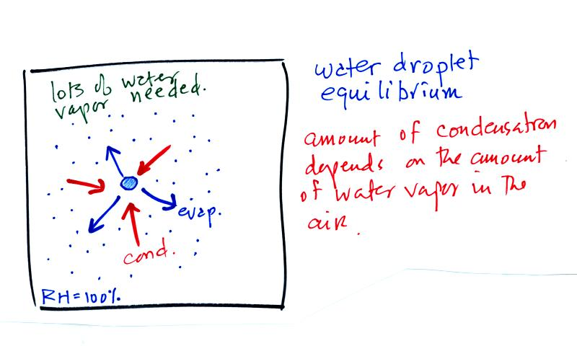
The first figure above (see p.101 in the photocopied Class Notes) shows a water droplet in equilibrium with its surroundings..The droplet is evaporating (the 3 blue arrows in the figure). The rate of evaporation will depend on the temperature of the water droplet. The droplet is surrounded by air that is saturated with water vapor (the droplet is inside a cloud where the relative humidity is 100%). This means there is enough water vapor to be able to supply 3 arrows of condensation. Because the droplet loses and gains water vapor at equal rates it doesn't grow or shrink.
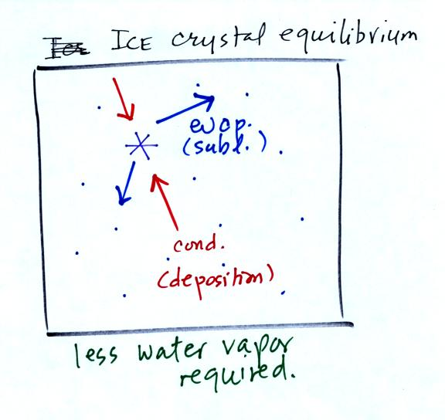
This figure shows what is required for an ice crystal (at the same temperature) to be in equilibrium with its surroundings. First, the ice crystal won't evaporate as rapidly as the water droplet (only two arrows are shown). Going from ice to water vapor is a bigger jump than going from water to water vapor. There won't be as many ice molecules with enough energy to make that jump. A sort of analogous situation is shown in the figure below. The class instructor could with a little warmup and practice jump from the floor up and onto the seat of a chair (maybe 15 inches tall). Trust me, he could, and so could most of the people in the room. The class instructor does some stupid things in class, but he wouldn't begin to consider trying to jump from the floor up to the top of the cabinet (30 inches or more).
To be in equilibrium only two arrows of condensation are needed. There doesn't need to be as much water vapor in the air surrounding the ice crystal to supply this lower rate of condensation.
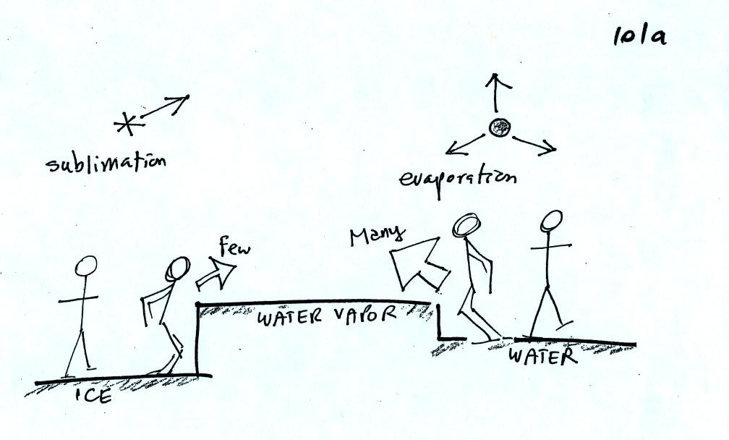
There are going to be fewer people able to make the big jump on the left just as there are fewer ice molecules able to sublimate. Going from water to water vapor is a "smaller jump" and more molecules are able to do just as more people would be able to make the shorter jump at right in the picture above.
Now what happens in the mixed phase region of a cold cloud is that ice crystals find themselves in the very moist surroundings needed for water droplet equilibrium. This is shown below.
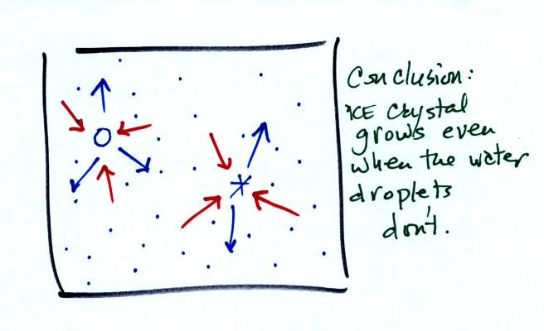
The water droplet is in equilibrium (3 arrows of evaporation and 3 arrows of condensation) with the surroundings. The ice crystal is evaporating more slowly than the water droplet. Because the ice crystal is in the same surroundings as the water droplet water vapor will be condensing onto the ice crystal at the same rate as onto the water droplet. The ice crystal isn't in equilibrium, condensation (3 arrows) exceeds evaporation (2 arrows) and the ice crystal will grow. That's what makes the ice crystal process work.
The equal rates of condensation are shown in the figure below using the earlier analogy.
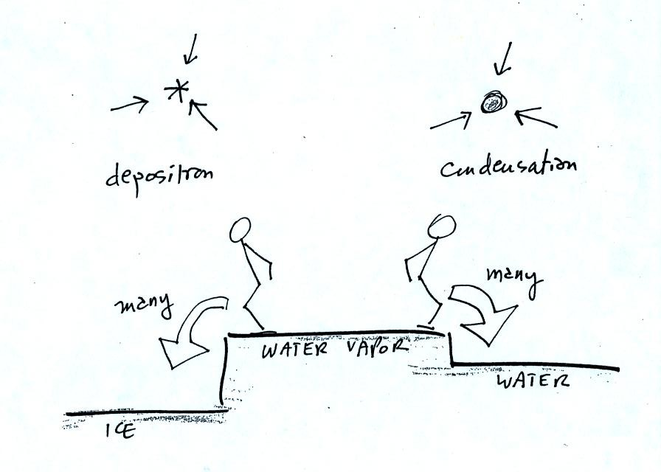
Even though he was afraid to try to jump up to the top of the counter, the instructor could jump from the counter to the floor.

Now we will see what can happen once the ice crystal has had a chance to grow a little bit.
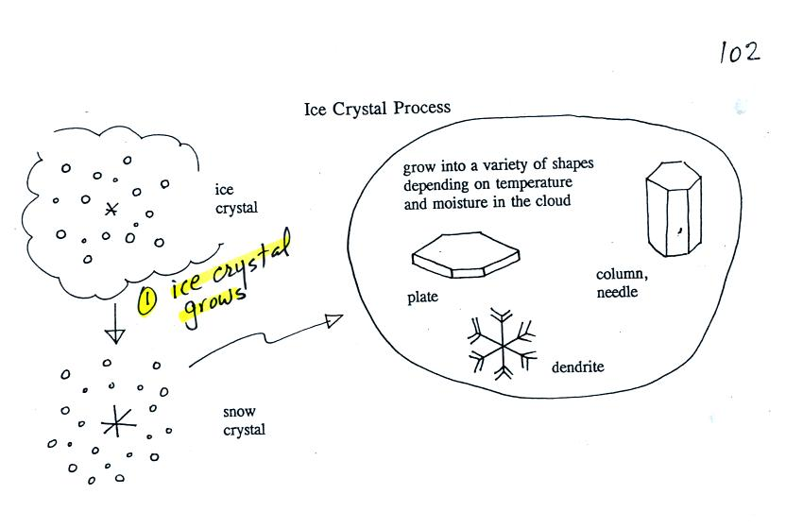

Once an ice crystal has grown a little bit it becomes a snow crystal (this figure is on p. 102 in the photocopied classnotes). Snow crystals can have a variety of shapes (plates, dendrites, columns, needles, etc.; these are called crystal habits) depending on the conditions (temperature and moisture) in the cloud. Dendrites are the most common because they form where there is the most moisture available for growth. With more raw material available it makes sense there would be more of this particular snow crystal shape.
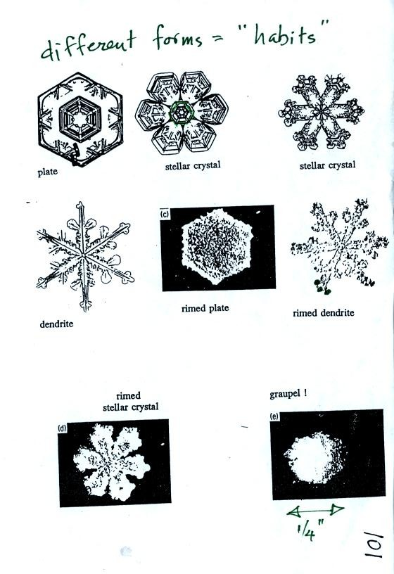
Here are some actual photographs of snow crystals (taken with a microscope). Snow crystals are usually 100 or a few 100s of micrometers in diameter (tenths of a millimeter in diameter).
You'll find some much better photographs and a pile of addtional information about snow crystals at www.snowcrystals.com
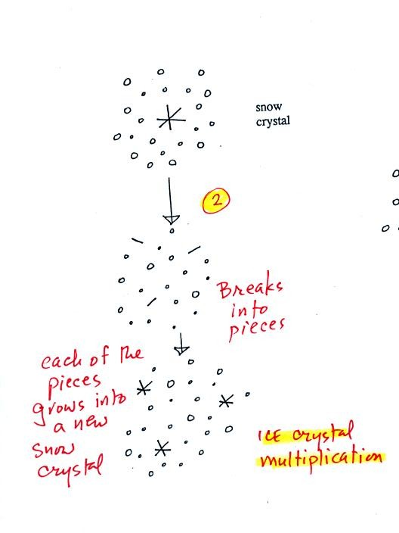
A variety of things can happen once a snow crystal forms. First it can break into pieces, then each of the pieces can grow into a new snow crystal. Because snow crystals are otherwise in rather short supply, ice crystal multiplication is a way of increasing the amount of precipitation that ultimately falls from the cloud.
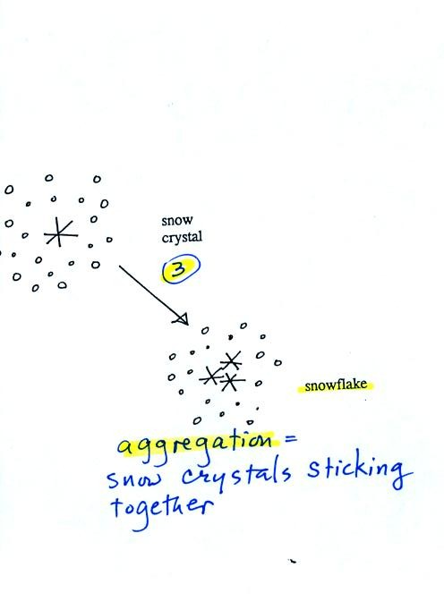

Several snow crystals can collide and stick together to form a snowflake. Snow crystals are small, a few tenths of a millimeter across. Snowflakes can be much larger and are made up of many snow crystals stuck together. The sticking together or clumping together of snow crystals is called aggregation.
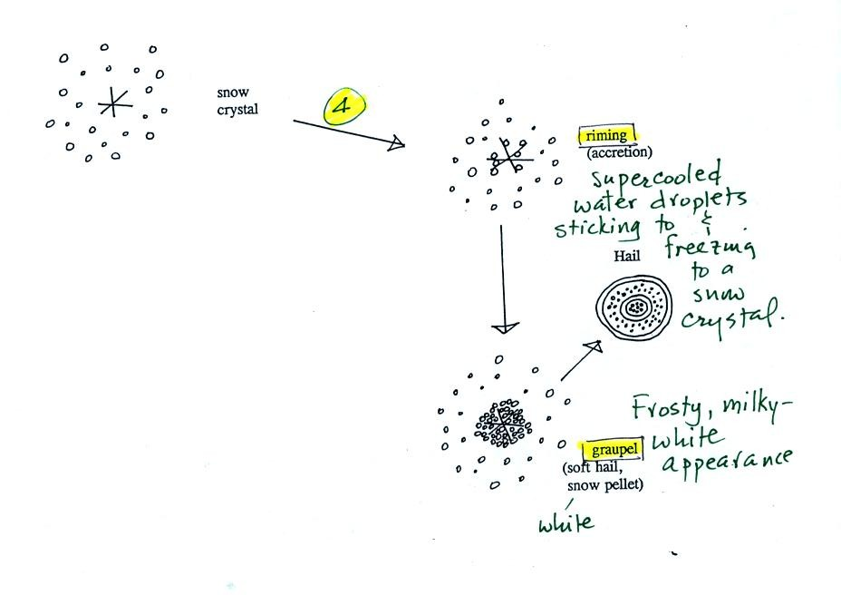
Snow crystals can collide with supercooled water droplets. The water droplets may stick and freeze to the snow crystal. This process is called riming or accretion (note it is really the same idea as collision and coalescence). If a snow crystal collides with enough water droplets it can be completely covered with ice. The resulting particle is called graupel (or snow pellets). Graupel is sometimes mistaken for hail and is called soft hail or snow pellets. Rime ice has a frosty milky white appearance. A graupel particle resembles a miniature snow ball. Graupel particles often serve as the nucleus for a hailstone.

This figure gives you an idea of how hail forms.
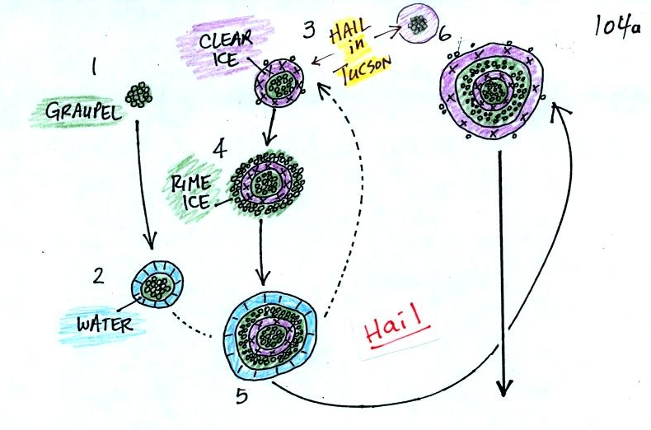
In the figure above a hailstone starts with a graupel particle (Pt. 1, colored green to represent rime ice). The graupel falls or gets carried into a part of the cloud where it collides with a large number of supercooled water droplets which stick to the graupel but don't immediately freeze. The graupel gets coated with a layer of water (blue) at Pt. 2. The particle then moves into a colder part of the cloud and the water layer freeze producing a layer of clear ice (the clear ice, colored violet, has a distinctly different appearance from the milky white rime ice), Pt. 3. In Tucson this is often the only example of hail that you will see: a graupel particle core with a single layer of clear ice.
In the severe thunderstorms in the Central Plains, the hailstone can pick up a new layer of rime ice, followed by another layer of water which subsequently freezes to produce a layer of clear ice.
This cycle can repeat several times; large hailstones can be composed of many alternating layers of rime and clear ice. An unusually large hailstone (around 3 inches in diameter) has been cut in half to show (below) the different layers of ice.
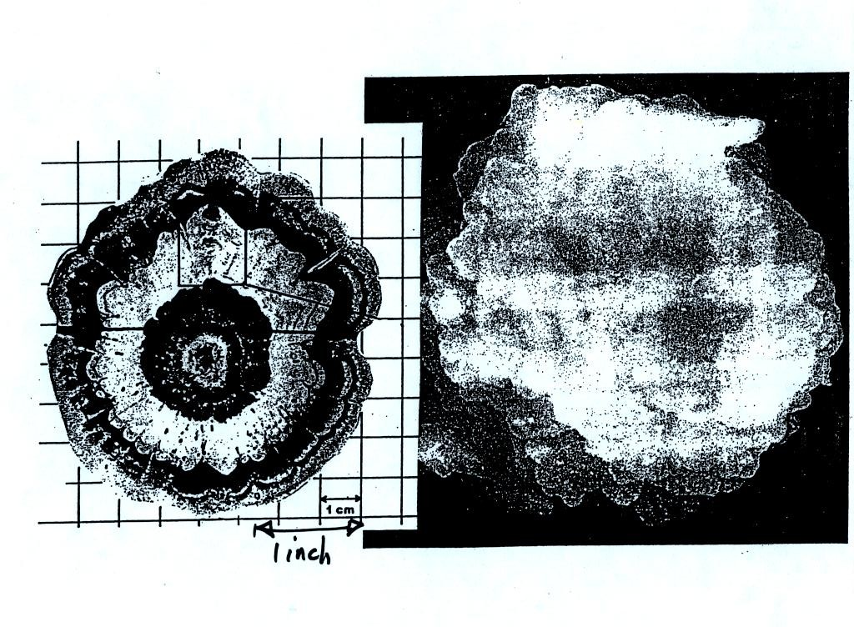
Hail is produced in strong thunderstorms with tilted updrafts. You would never see hail falling from a nimbostratus cloud. The figure below wasn't shown in class.
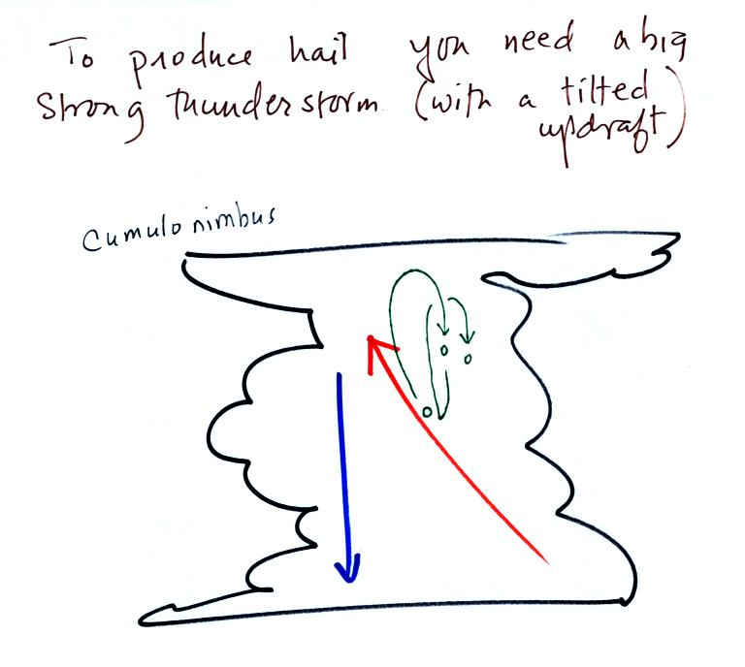
The growing hailstone can fall back into the updraft (rather than falling out of the cloud) and be carried back up toward the top of the cloud. In this way the hailstone can complete several cycles through the interior of the cloud.

Students in class today were given the option of answering the questions below and turning in their answers at the end of class for a little bit of extra credit.
Here are the questions and the answers:
1. Dendrites, plates, and columns are all names of different types of snow crystals.
2. Several snow crystals sticking together would form
a. hail b. graupel c. sleet d. snow
3. The largest raindrops are only about 5 or 6 mm (~ 1/4 inch) in diameter. What frozen precipitation particle can get much larger than this? Hail.
4. How many 20 micrometer diameter cloud droplets would be needed to make one 200 micrometer diameter drop of drizzle? The 200 micrometer drizzle droplet is 10 times bigger across than the 20 micrometer cloud droplet. Volume is length x width x height. So there is a factor of 10 x 10 x 10 = 1000 times difference in volume.
5. Is most of the rain in Tucson produced by the COLLISION-COALESCENCE or the ICE CRYSTAL process?
6. Which of the following is found in the greatest amounts in the mixed-phase region of a cold cloud?
a. ice crystal nuclei b. ice crystals c. supercooled water droplets d. graupel
7. What differences are there between condensation nuclei and ice crystal nuclei? Ice nuclei are much less abundant than condensation nuclei. Ice nuclei must have a crystalline structure resembling ice. The same requirement doesn't apply to condensation nuclei.
8. What is virga? Rain or drizzle that evaporates before reaching the ground.

