Term Project
Introduction to Weather and Climate

Stage1 – Time-Series Plots
Due: 11:59 pm MST, February 26

Stage 2 – Weather Diagnosis, Final Draft
Due: 11:59 pm MST, April 8

PREFACE
The term project constitutes 30% of your final course grade. Its successful completion should be considered a mandatory prerequisite to passing the course. In other words: Passing the term project very likely positions you to pass the course (earn a grade of D or higher), but failing it (combined score on Stage 1 and Stage 2 of less than 50%) or not submitting it nearly guarantees that you will not pass course, regardless of your scores on quizzes and other assignments.

There are two submission stages to the project. Each stage has its own separate due date and dropbox. The due date for Stage 1 is Friday, Oct. 8 by 11:59 pm MST. The due date for the final version of Stage 2 is Sunday, Nov. 14 by 11:59 pm MST (The due date of Stage 2 is subject to change with sufficient, advanced notice; the date of Stage 1 looks firm.)

The project is to be done as an individual, not as a member of a group. This means that you neither accept the aid of another nor give aid to another, outside of the bounds of interactions that I deem allowable via written communication. (See below.) This is your project. It must represent your work, and your work alone.

LEARNING OUTCOMES
- Accurate collection, organization and processing of current weather data.
- Presentation of temporal data in graphical form.
- Time-series analysis (e.g. correlation between fields and identification of extremes/outliers).
- Diagnosis of synergist weather phenomena in terms of course concepts.
- Composition of a cogent paper that addresses points 3) and 4) and that follows the concise, precise writing conventions of scientific publications.
- Experience the process of peer review, revision and submission of a “more polished” final draft.

ANALYSIS OF SURFACE WEATHER OBSERVATIONS

Stage I
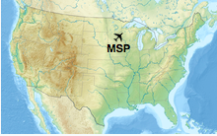
Over the next few weeks, you will access hourly weather observations for Minneapolis/St. Paul International Airport (KMSP: 44.9˚N/ 93.2˚W). KMSP is located in the State of Minnesota, which borders Canada. (See Map.) The elevation of KMSP is 256 m (841’); the surrounding terrain is can be considered flat for our purposes.

You are to collect surface weather observations for an hour that is close to local solar noon. That hour for KMSP is 1800 UTC (Coordinated Universal Time), where UTC is standard time in London, United Kingdom. KMSP is located in the Central Time zone, which is UTC-6 or six hours behind London time. 1800 UTC corresponds to 12:00 pm Central Standard Time (CST) or 1:00 pm Central Daylight Time (CDT), which is the GMT hour closest to solar noon at KMSP. The hourly observation is taken a few minutes before 1800 UTC. The typical time is 1753 UTC for KMSP, but you must check every time carefully as the observation time can vary by a few minutes each day. Collect data for every date for the period below.
(Friday)
Analysis period: Daily dates from Sept. 20 to Oct. 7, inclusive.
You must collect data for above period. I have done the first few dates to jumpstart your data collection and for you to crosscheck to ensure you are getting the correct data. (You should check that you get the same values when looking up the data.) That leaves less than 30 dates for you to record and plot.

Your archive of surface weather observations for 1800 UTC must include:
- Temperature︎
- Dew point
- Relative humidity
DATE | TEMP | DEW PT | R.H. | DATE | TEMP | DEW PT | R.H.
9-13 | 23 | 10 | 44 | 9-16 | 28 | 16 | 49
9-14 | 19 | 13 | 68 | 9-17 | 19 | 7 | 45
9-15 | 24 | 9 | 38 | 9-18 | 22 | 7 | 38

Weather Data Access: Use the web site https://vortex.plymouth.edu/myowxp/sfc/statlog-a.html at Plymouth State University to get observations that are 24-36 hours or older. I show the web site below.

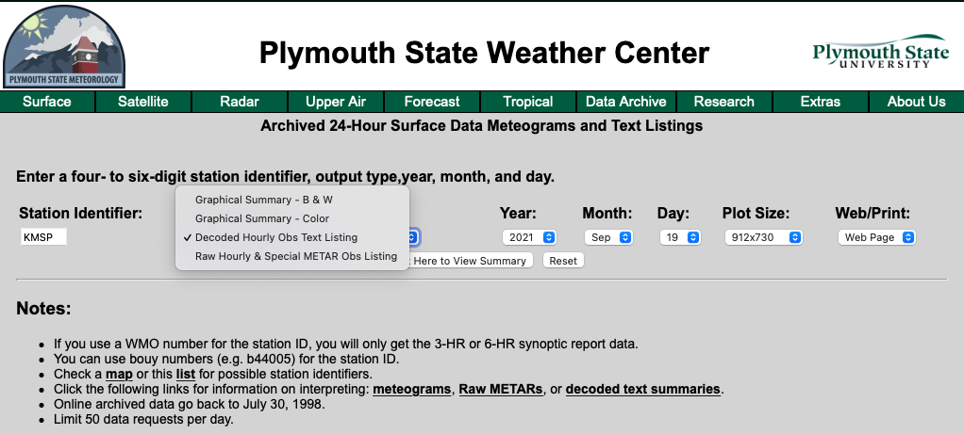
The Plymouth State Weather archive gathers coded and decoded “METAR” (Meteorological Terminal Aviation Routine Weather Report) data, where METAR is the international code to report routine, hourly weather conditions at air terminals. You will select a “Type of Output” option that allows you to access data without learning the nuances of deciphering METAR code, as I describe next.

Do the following to get data that you need: Enter the station identifier (KMSP fall semester; KMSP spring semester) and select “Decoded Hourly Obs Text Listing”. Set “Year”, “Month” and “Day” to the desired values, being extra careful that the values are set correctly. When you click the "Click Here to View Summary" button, it will produce a list of observations.

I show in the figure that follows what the Plymouth State Weather site returns for 19 Sept. 2021. Always double check the station and date that are inside the two red ovals. You need to read the column TIME to find the report closest to local solar noon. I shade in blue the observation for the time that is closest to 1800 UTC (1753). Always record the 1753 report. Record the temperature (T), dew point (TD) and relative humidity (RH). Other columns have sea-level pressure (SLP), wind direction (DIR), wind speed (SPD), wind gusts (GST), horizontal visibility (VIS), ceiling (CIL), and cloud cover (COV) for the time and date.
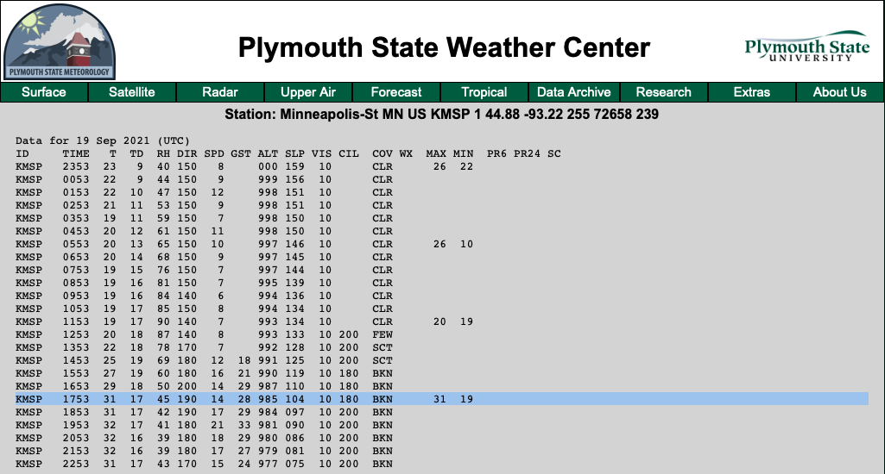
Moving from left to right, observations that you would need to record for 1753 UTC are:
Temperature (T)=31˚C.
Dew point (TD)=17˚C.
Relative humidity (RH)=45%

You do not need to collect observations in real-time. That said, I highly recommend that you do just that because you learn weather by following weather…every day. If you want observations for the current day, then go to http://vortex.plymouth.edu/myowxp/sfc/statlog.html. As before, enter the station identifier (KMSP) and select “Decoded Hourly & Special Obs Listing”, and the available observations up to the current hour are displayed in the same form as the above figure. A valuable learning experience is following weather maps in real-time as you gather data. A simultaneous combination of data collection and monitoring of the maps enables you to associate trends and fluctuations in the time-series with surface weather features. To view or download animations of 3-days worth of prior surface maps, you can go to https://www.wpc.ncep.noaa.gov/html/sfcloop/namusloop_wbg_3day.html for analyses that have station plots and https://www.wpc.ncep.noaa.gov/html/sfcloop/radsfcus_exp_3day.html for maps that have radar imagery superimposed.

Time Series Plots: You are to plot temperature, dew point and relative humidity on a graph for daily data. Plot temperatures in degrees Celsius on the left axis and relative humidity in percent on the right axis. I encourage you to put all of the curves on the same plot. If you decide to put temperatures and RH on the same graph, you will need to use a different vertical axis scale for RH and to arrange the plot so the temperature curves and RH curves lines do not intersect. The end of this document has Excel plots of daily time-series for KMSP from the spring 2018 semester. Note how RH is scaled so it does not intersect the dew point curve.ly intersect on one date, and barely so at that.
I urge that you use a spreadsheet program like Excel. I give a link to an Excel program (see Appendix) that you can use to produce your graph; you just input the correct data. Less desirable options are using online plotting tools such as Google Sheets (https://www.google.com/sheets/about/, which can be clunky to set up) or the web-based ChartGo (http://www.chartgo.com/en/chartline.jsp, which is even clunkier to set up) to produce your graphs if you are comfortable using such software since the teaching team can offer no individualized help on the use of plotting software. For help with getting started on using plotting software, read the Appendix at the end of this document where you will finds links to canned programs that plot time-series graphs. Otherwise, scanned copies of accurate and neatly drawn plots on old-fashion graph paper are your only option. Whatever option you chose, you must show the data value on your graph at all of your data points. (See the example graph from Excel.)

The temperature/dew point/RH graph with data labels completes Step 1. Your graph must be submitted as a single pdf file. No other file type is acceptable. Upload your pdf to the dropbox before the deadline. Make certain your graph is properly oriented with its top at the top of the page. This may require that you rotate the pdf file, which is simple to do if you have Adobe Acrobat Reader DC (free from http://www.adobe.com) on your system. Plots that are not properly oriented will receive a deduction.

Stage 2
Overview of the Weather and Climate for the Data Collection Period: Use the time series plots to determine whether there is a general upward or downward trend in data through the period. Write a brief (one but no more than 1½ pages double-spaced text) summary of the trends in the data. Did the temperatures tend to fall/rise as we might expect during fall/spring season? Was there an apparent trend in the dew point or the relative humidity with time? How do the variables seem to correlate with each other? Comment on any interesting maxima and minima in the time series. Note periods of extended above or below average temperatures, and abrupt changes in the weather. Were there any record high or low temperatures? Were there any extreme weather events or extended periods of anomalous weather?

Detailed Diagnosis of Significant Weather: I will identify for you (at a later date) period(s) of “interesting weather” that will serve as the focus (foci) for your diagnosis. Broadly speaking, we can consider “interesting weather” to correspond to abrupt changes in surface conditions; record breaking events (always possible but not likely during our 6-week observation period); highly anomalous weather (an extended heat wave or cold snap of a few days); strong winds (sustained winds faster than 20-25 mph or gusts faster than 35-40 mph); severe thunderstorms with hail or heavy rain (and especially tornadoes); flooding events; snow; etc. You will use course materials and other online weather resources to answer a few (typically 3 to 5) specific questions that I pose about the weather situation(s). The diagnosis portion of the project should not exceed 1½ to 2 pages.

Specific instructions on the diagnosis component of Stage 2 will come when I announce the focus period(s) and associated questions.

REVISION BEFORE SUBMITTING THE FINAL VERSION OF STAGE 2
Optional Review by a Tutor at the Writing Center and Revision: Finish your penultimate draft of Stage 2 at least one week (preferably two weeks) prior to the due date of Stage 2. You should then go to the Writing Center (see https://thinktank.arizona.edu/writing-center) to have it reviewed by peer tutor. While having your early draft reviewed by the Writing Center prior to submitting its final version is not a requirement, it works to your benefit to interact with a tutor at the Center at the earliest possible date, and it qualifies you to earn some extra credit for interacting with the Center. If you live too far from Tucson to meet with a tutor at the Writing Center in person, you can still interact with one by arranging for an online session. For information on how to arrange for online tutoring, go to https://thinktank.arizona.edu/online-tutoring.

The process of obtaining independent feedback from an authority with the opportunity to do a revision is a component of what is known as "peer review". Peer review constitutes an essential component of scientific research and its publication. This is your opportunity to receive feedback from a trained and certified writing tutor to improve your term paper…the most important assignment of the course.

A tutor at the Center will go over your penultimate draft and offer suggestions on how to improve your paper. Do understand that the tutor will NOT rewrite the paper for you though! This means the more polished your penultimate draft is, the more helpful the tutor’s suggestions can be, and the better your final draft will be. Simple logic. Remember to bring a copy of the grading Rubric to share with your tutor.

More detailed instructions about the review process at the Writing Center will be given in a separate document, shortly before the target “due date” of your penultimate draft. It is only after you thoughtfully consider and incorporate comments, suggestions and corrections of the tutor into your manuscript that you should submit a final version of the project for grading.

If you would like to earn a little extra credit for interacting with the Writing Center and for revising your paper, you must submit (to a dropbox to be opened) a copy of the receipt that the Writing Center will email you to demonstrate you met with a tutor to discuss your paper. I recommend that you finish your penultimate draft well in advance of the deadline to allow yourself sufficient time to revise the paper.

SUBMISSION OF STAGE 2
All components of Stage 2 must be assembled into a single pdf file. Your complete project (Stage 2) must include each item in the following order:
1) Your full name must appear in the upper-right corner of the 1st page.
2) Written analysis of time series, preferably after you incorporate comments of the Writing Center tutor(s).
3) Diagnosis of the weather over the focus period(s) in terms of course concepts.
4) All images (e.g. weather maps, satellite, radar images, etc.) that support your diagnosis. Make certain these plots are properly rotated where north is to the top of the page.
5) References.
⇒ Do not include a copy of the graph that you submitted in Stage 1 ⇐

Submit your papers in to the D2L Dropbox. Note that all submissions are processed by plagiarism detection software (see below). If you plagiarize, you will likely be caught.

GRADING ALGORITHM
Your grade will be based the following criteria. Criterion 3 is the most important to address and counts 40% of the Stage 2 grade. The other three criteria count 20% each.
(1) Demonstration of a timely, complete and accurate collection of data as judged from your time-series plots. The evaluation of Stage 1 is independent of the evaluation of Stage 2.
(2) Succinct overview of the weather and climate for the observation period.
(3) Sound, succinct diagnosis of the weather during the focus period that is based on course concepts. Point 3 is the most important component of the project. Submissions that do not address the issue of the underlying physical reasons of “why the weather did what it did” will be subject to a major deduction as large as 25 points.
(4) Organization, clarity, grammar, punctuation, spelling, appropriate use of terms, and an overall sense of professionalism. For guidance on writing, I recommend https://owl.purdue.edu/owl/purdue_owl.html or http://atmo.arizona.edu/~mullen/atmo170A1/project/Grammar_Girl.pdf, but there are dozens of other online sites with excellent resources on writing that you may find more useful.

Once I identify the focus topics, you are to write a succinct summary of your diagnosis and conclusions. Your weather synopsis must contain the following components:
- An overview of the time series plots. Note periods of above or below normal temperatures, anomalous precipitation events, strong winds, and of course any record events for the date.
- A detailed description of the weather during the focus period(s) that incorporates relevant weather maps, satellite and/or radar imagery, and supplemental surface data beyond the 1900 UTC surface data in your time-series plots. This will satisfy a portion of point (3).
- Focused use of course concepts to diagnose the weather during the interesting period. This will satisfy the bulk of point (3)
- High-quality writing that is coherent, succinct, organized and grammatically proper.

You may include up to 4 supplementary figures to support your diagnosis of the weather during the focus period. Be certain that each figure has a caption (a tight description of what the figure shows) and is assigned a figure number, where the number is determined by the order in which the figure is first referenced in the text. Pick your figures wisely; the teaching team will view unfavorably an excessive number of figures, ones of marginal value, or ones not referenced in the text.

Your write-up is to be no longer than three double-spaced pages of text using #12-point, Times New Roman font. The limit excludes references, tables, figures and figure captions. Three pages is very little space (about 1/3 of the words in this document) to write a summary of the time-series and present a detailed diagnosis of a weather event. But it is enough. Hence, it is critical that you make every word count. I suggest that you target one page but no more than 1.5 pages for the time-series analysis, and at least 1.5 pages but no more two for the weather diagnosis.

I have posted in the D2L Content section the file “Example Term Project” from a prior class (when the project differed greatly from yours). It is not a file for you to use as a template or to cut-and-paste portions thereof into your document, even if the specifics differ. I offer it as an example of “what” that I am confident you are capable of doing in regards to concise writing. Do take note how succinct the presentation is. Note how the paper satisfies the key criteria of the assignment in only two pages.

DUE DATES
The due date for Stage 1 (completed graph only) is before 11:59 pm MST, February 26. In view of the purpose of Stage 1, “a timely, complete and accurate collection of data as judged from your time-series plots”, late submissions of the graphs will not be accepted, regardless of circumstances.

The due date for final version of Stage 2 (completed project) is before 11:59 pm MST, April 8.

Assignments can only be submitted to the appropriate D2L dropboxes. This means that hand drawn plots must be either digitally photographed or “scanned” into a digital format (.jpeg, .png) that can be imported into your word processing program. You should plan to complete the final version of your project at least two days prior to the due date to give yourself ample of time to make certain your materials are complete, proofed, properly ordered and rotated, and can be uploaded to the D2L dropbox successfully. You are responsible for checking that you final submission is uploaded to D2L

Late Stage 2 submissions will accumulate a subtractive penalty of -10% per calendar day late. For example, if your project is 3 days late, 30% is subtracted from your score. That means if your project is 5 days late, you will be assigned an “E” score for your project. Extensions of the due date will not be granted under any circumstances beyond the extenuating ones specified in the syllabus. I recommend that you finish Stage 2 long before the deadline. Besides, think how nice it would be to finish the project early so it does not conflict with end-of-semester requirements in other courses.

WHEN TO EXPECT TO GET YOUR GRADE
You should not expect to see your total score on the term project any earlier than the last week that classes meet. Please keep in mind that it takes time to assess with care dozens of submissions. It takes a grader many hours to evaluate their share of the submissions, and their grading for our class must be worked around their graduate studies, research obligations and grading for other courses. The teaching team is committed to complete the grading of the project by the Monday before “Dead Day”.

I close with a last request: do not send emails of the ilk, “Where is the grade on my term project?” before I announce all of the projects are graded and the scores are released. Such emails will not be acknowledged since replies would only serve to slow down the grading process.

APPENDIX: HELP WITH PLOTTING

I urge every student to use a spreadsheet program like Excel or an online plotting tool like Google Sheets to produce their plots.

I give a link to an Excel file where you just enter the temperature, dew point and relative humidity data. Click http://www.atmo.arizona.edu/courses/mullen/Graph_KMSP_Students.xlsx. It is configured for the dates that you are responsible for plotting. A plot using the program is shown below for a prior year. (Note that the example shows temperatures in ˚F whereas your graph will have temperatures in ˚C.) If you have Excel on your computer, the file might open automatically. If not, the file should download automatically to your computer where you can open it. Once the file is on your computer, Excel can open it. The left axis has temperature and dew point, and the right axis has relative humidity. Also make note of the “Data Labels” on the dots/bars that give the data values. Data labels for every field are mandatory. For illustrative purposes, I show observations for 1753 UTC starting Sept. 13, 2020 and ending Oct. 7, 2020 at KMSP. Pages (Apple) and LibreOffice (open source) should open the file too, as can Google Sheets (see next paragraph). If you have MS Office on your computing platform, or any office software program that can open .xlsx files without issues, I recommend that you use the above Excel file. Using Excel is your easiest path to success.

----------------------
I also provide a link to a Google Sheets program at the end of the paragraph. You can use it as a template to make graphs. You can open the link into any mainstream browser (Edge, Safari, Firefox, Chrome, Opera). Where you enter the data for a particular date is self-evident; note that RH must be in the first column with data to plot for the field on the bar graph. The graph below illustrates observations for 1753 UTC starting Sept. 13, 2020 and ending Oct. 7, 2020 at KMSP. (Note that the example shows temperatures in ˚F whereas your graph will have temperatures in ˚C.) Your graph will look similar.
https://docs.google.com/spreadsheets/d/1EiHySU23q_jriFmAQS8PBbRh4uoavsUj8SByJo4e1EY/edit?usp=sharing
Unfortunately, a shared link in Google Sheets cannot be edited by anyone other than the owner, me, and I cannot figure out how to download the file to my hardware for posting online. (If you know how to do it, please educate me.) You can upload the Excel file of the first paragraph to Google Drive then edit it with Google Sheets. What initially opens in Google Sheets is a much too busy, three-line chart where the RH line crosses the temperature lines, but Google Sheets can be modified to look very similar to the combination lines/bar chart in Excel by plotting RH relative to the right vertical axis and scaling it accordingly. See the settings in my link. Again, note the mandatory data labels that appear near the dots and above the bars. Google Sheets produced the graph.

----------------------

Important: Whether you use plotting software (as I strongly urge) to draw the graphs or you do them by hand, you must include labeling of every data point. Switching the Data Labels option to “On” enables the teaching team to assess the fidelity of your data accurately. In fact, the display of data values is so greatly faciliated by using plotting software that one benefit per se is a sufficient, compelling reason to NOT draw graphs and plot labels by hand. Moreoever, use of software is faster: insert all the data in the appropriate columns …boom…done!

Firm due date. No late submissions regardless of circumstances.
UTC was formally termed Greenwich Mean Time (GMT). UTC is now commonly called Military Time or “Zulu” Time (or “Z” for short). “Z” often appears on weather products instead of “UTC”.
Daylight Time begins on the second Sunday in March and ends on the first Sunday in November in the United States. The states of Arizona (outside of the Navajo Nation) and Hawaii do not observe Daylight Time.
Solar noon is the moment when the sun reaches at its apparent highest point in the sky for the day. Colloquially called “high noon.” In most locations, solar noon does not occur at 12 O’clock local time. For example, it occurs at 12:36 PM MST on January 26th at Tucson.

