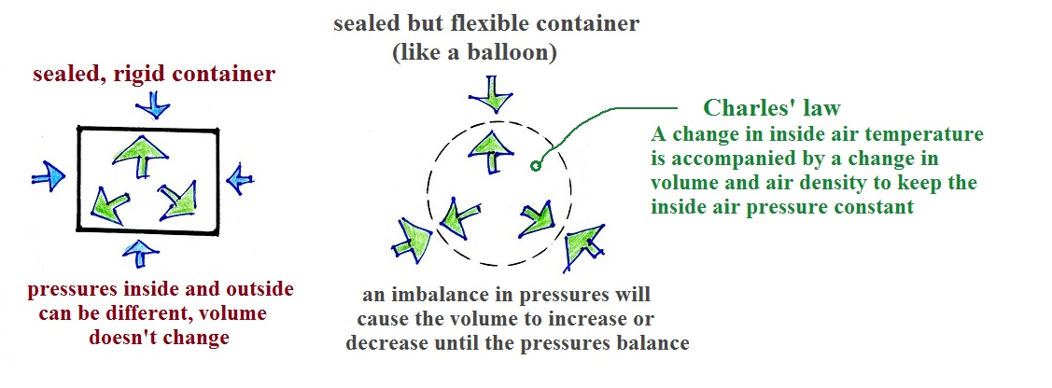
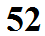
A volume of air is free to expand or shrink and will do so in order to keep the pressure inside the parcel (that is pushing out) equal to the pressure of the air surrounding the parcel (that is pressing inward on the parcel).

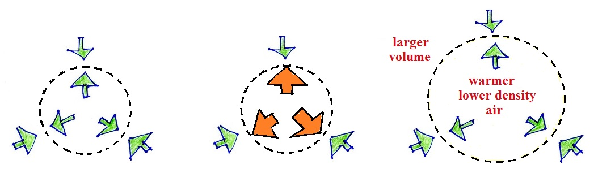
Warming air inside a parcel will cause a momentary increase in the pressure (middle picture below). The parcel will expand until the inside air pressure is again in balance with the outside pressure. You'll end up with a parcel of warm low density air (right picture).
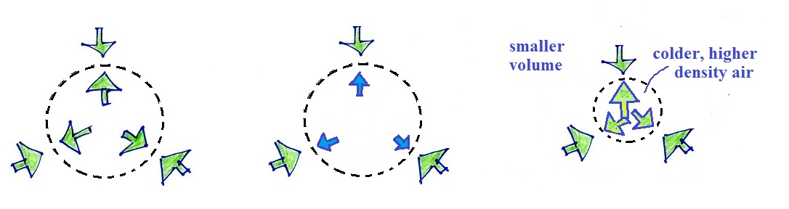
In a similar way if you cool a parcel of air, there'll be a momentary drop in pressure. You'll end up with a smaller volume of colder higher density air.

