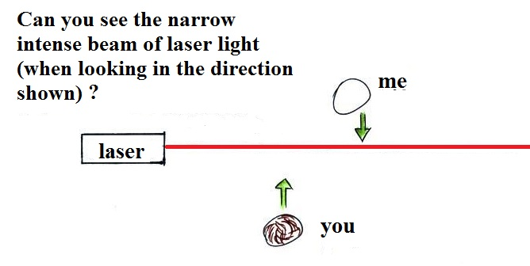
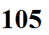

None of us is able to see the laser beam at this point.
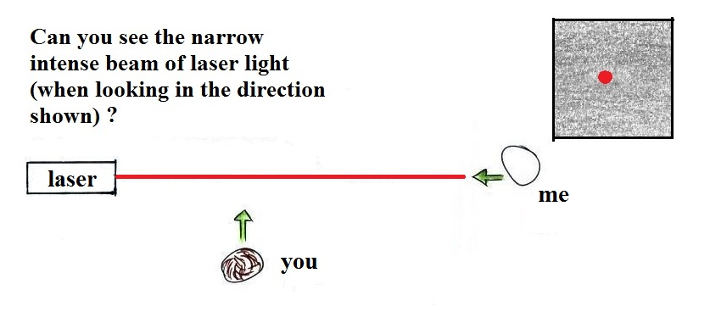

Too see the laser light you need to look back in the direction of one of the rays of light (look toward the source of the light). That's not a safe thing to do with a beam of laser light.
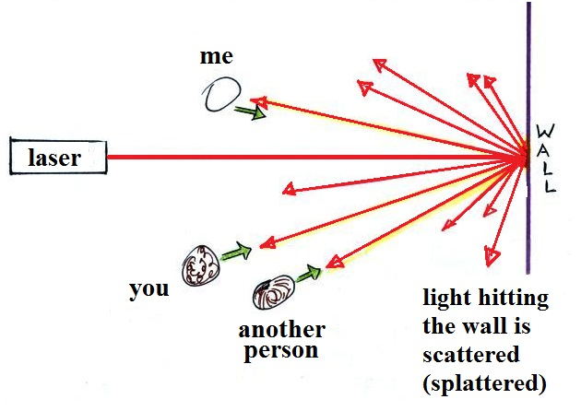

We can see where the laser hits the wall. The intense beam is scattered (split up) into many weaker beams. Everyone sees a different ray of laser light.

