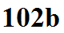

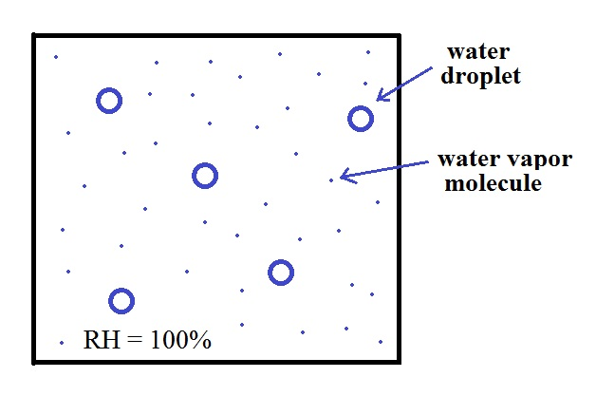
The relative humidity is high
enough that the water droplets in the figure
at right are in equilbrium with their
surroundings. I.e. the air is moist enough that
any evaporation from droplets is balanced
with an equal amount of condensation.
Any loss is balanced by an equal amount of
gain and the droplets don't grow or shrink.

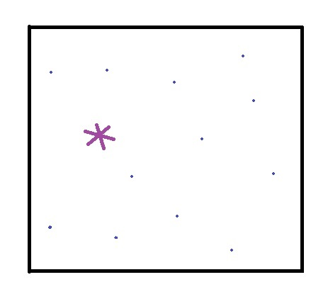
An ice crystal won't evaporate as quickly
as a water droplet (turning from ice to vapor
is a bigger "jump" than going from water
to vapor and there aren't as many ice
molecules with the needed energy). With
less evaporation there won't need to be as
much condensation to keep the ice crystal
in equilibrium with its surroundings. Note
the lower water vapor concentration in
this picture.

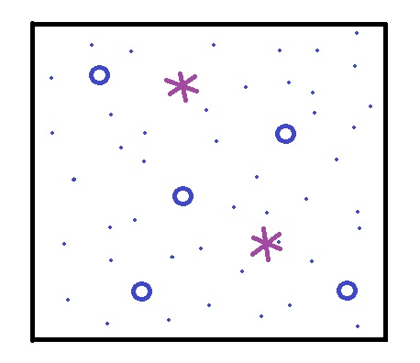
Now we put some ice crystals in the moister
air surrounding a bunch of supercooled water
droplets (both the crystals and the droplets
have the same temperature). The ice crystal
will still evaporate more slowly than the water
droplets. Both types of particles are surrounded
by the same moist air so the rates of condensation
will be equal. The ice crystals aren't in
equilibrium in this picture; the rate of condensation
exceeds the rate of evaporation and the ice crystal
will grow.

