ATMO 170 Fall 2017 In-class Optional Assignment Answers

1. Air pressure is usually about 1000 millibars (mb) at sea level. Would you expect to find HIGHER or LOWER sea level pressure in the center of a strong hurricane.

2. On the earth two objects that have the same weight must also have the same ___c____
a. volume b. composition c. mass d. density

3. Both the weight and the density of an object depend on the
a. object's mass b. strength of gravity c. object's composition d. object's temperature

4. If you compress a layer of air but don't add or remove any air will the density of the air in the layer INCREASE DECREASE or remain the SAME?

5. Atmospheric pressure is about 14.7 psi. This value is determined by which two of the following?
a. the amount (mass) of air in the atmosphere b. the thickness of the atmosphere
c. the composition of the atmosphere d. the strength of the earth's gravity
Pressure depends on the weight of the atmosphere, weight depends on mass & gravity

6. Air _______ always decrease with increasing altitude
a. density & temperature b. pressure & density c. pressure & temperature

7. Which of the following are not units of pressure? (more than one answer)
a. inches of mercury b. kilograms (mass) c. micrometers (distance)
d. millibars e. pounds per square inch

8. To be of practical size a barometer must be filled with a liquid of HIGH LOW density

9. An object with large mass and small volume would have HIGH LOW ZERO density

10. In an inversion layer you would find DECREASING INCREASING air TEMPERATURE DENSITY PRESSURE with increasing altitude (circle one word in each group)

Note: The following question was not graded, it would have taken too long to read all the answers. I'd rather spend that time reading 1S1P reports.
11 If the earth's gravity suddenly got stronger, the sea level pressure would increase but the reading on a mercury barometer would stay the same. How would you explain this (you can assume that there is no change in the amount (mass) of air in the atmosphere)?
Pressure depends on the weight of the air overhead. An increase in gravity would mean the atmosphere weighs more and that the pressure would increase. The weight of the mercury column in a barometer would also increase by the same amount. So a mercury column of the same height would balance the weight of the atmosphere.

You can double your score on this assignment by answering the following questions correctly.

The bottom layer of air in two columns of the atmosphere are shown below. The layer in the left figure is thinner than the layer in the right figure. The drop in pressure between the bottom and top of each layer is the same, 100 mb.
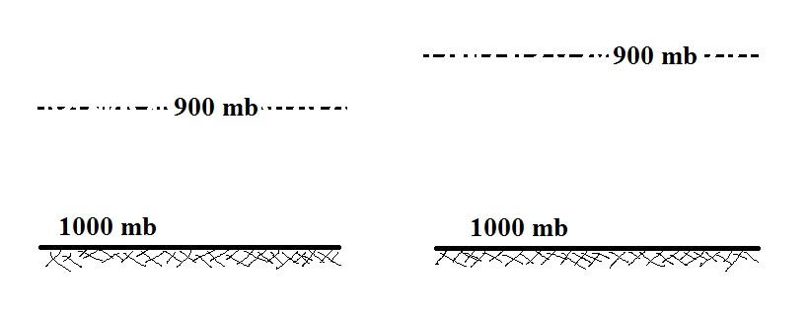

Is the rate of at which pressure is decreasing with increasing altitude in the left layer GREATER than, EQUAL to, or LESS than the rate of pressure change with altitude in the right layer.

Knowing that the pressure decreases 100 mb as you move from the bottom to the top of each layer, what can you say about the weight of the air in each layer? Is the weight of the thin layer at left GREATER than, EQUAL to, or LESS than the weight of the thicker layer at right?

Is the amount of air (the mass) contained in the left layer GREATER than, EQUAL to, or LESS than the mass of the air in the right layer?

Is the density of the air in the left layer GREATER than, EQUAL to, or LESS than the density of the air in the right layer?

Use your answers above to determine whether the following statement is TRUE or FALSE.

Pressure decreases more rapidly with increasing altitude
in high density air than it does in low density air

