Atmo 170 Optional Assignment Name__________________________
Thermal Circulations and the 3-Cell Model

1. (1 pt) At 32º N latitude, Tucson is closest to which of the following features in the 3-cell model?
a. doldrums b. ITCZ c. subtropical high pressure d. subpolar low pressure

2. (2 pts) Are the tradewinds EASTERLY or WESTERLY winds? Do they blow TOWARD or AWAY from the equator?

3. (3 pts) In the 3-cell model the doldrums are found at ZERO FIFTEEN degrees latitude, in a belt of HIGH LOW pressure where the winds are STRONG WEAK.

4. (3 pts) The term "horse latitudes" refers to a belt of HIGH LOW pressure, where winds are STRONG WEAK and precipitation is ABUNDANT SCARCE.

5. (2 pts) In the 3-cell model of the earth's global scale wind and pressure pattern, you'd expect to find rising air, clouds, and precipitation at _______ and _______ latitude.
a. 0º b. 15º c. 30º d. 45º e. 60º f. 75º g. 90º

6. (1 pt) The "roaring 40s" are strong winds found near 40º latitude. Would these winds blow from the EAST or the WEST?

7. (1 pt) A sea breeze circulation is created or caused by _______ differences.
a. humidity b. temperature c. altitude d. surface roughness
8. (1 pt)In a thermal circulation the pressure gradient force is STRONGER than, the SAME strength as, WEAKER than the Coriolis force.
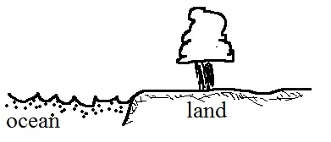
9. (3 pts) The figure at right shows showers that have formed just inland along a coast. Would this be produced by a SEA or LAND breeze, when the land is WARMER or
COLDER than the ocean, during the DAY or at NIGHT.

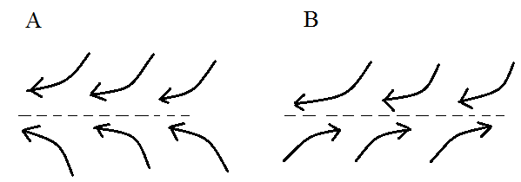
10. (3 pts) In the figure at right you'd expect to find a belt of low pressure in
Fig. A Fig. B both figs. neither fig.
Does FIG A or FIG B best depict the ITCZ.. Where would the other figure be found?

