ATMO 170A1 Optional Assignment Name_______________________________
(due at the start of class on Thu., Sep. 19)

1. According to the data at right, altitude (ft) temperature (ºF)
there is a temperature inversion between 0 47
_________ and _________ feet altitude. 1000 43
2000 45
3000 41

2. The highest concentration of ____________________ in the atmosphere is found in the stratosphere, at about 25 km altitude.
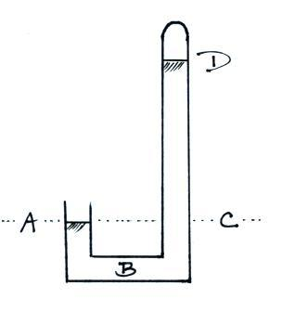

3. The same pressure would be measured at
Points _______ and _______ on the
barometer shown at right. The pressure is
zero at Point _______. The highest
pressure would be found at Point _______.
(each letter in the figure at right should be
used once as an answer)

4. Which one of the following doesn’t belong in the same group as the other three?
a. stable layer b. stratosphere c. temperature inversion d. thunderstorm

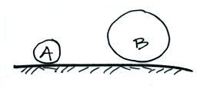
5. Objects A and B at right have the same weight.
Object A has larger _______, smaller ______,
but the same _______ than(as) Object B. (fill in
each blank with one of the choices below)
a. composition b. density
c. mass d. volume

6. The atmosphere can be split into layers such as the troposphere and stratosphere according to how air COMPOSITION DENSITY PRESSURE TEMPERATURE change with altitude.

7. Object A has a volume of 3 cm³ and a mass of 4.5 grams, Object B a mass of 15 grams and a volume of 6 cm³? Does OBJECT A or OBJECT B have the highest density?

8. Pressure DECREASES INCREASES with increasing altitude in the atmosphere. Is the rate of change of pressure at ground level GREATER than the SAME as or LESS than the rate of change at higher altitude?

9. The blue color of the sky
is caused by scattering of sunlight by ___________________________________.

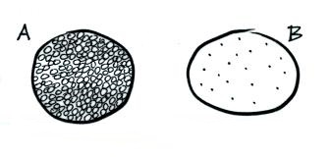
10. You fill a balloon with air. If you could look
inside, which of the following would be the
most realistic representation of what you would
see? Would the air molecules take up all the
available space inside the balloon (Fig. A) or
would there be mostly empty space inside the
balloon (Fig. B)?

11. If the force of gravity on the earth were to increase but the amount (mass) of air in the atmosphere remained constant, would atmospheric pressure at sea level INCREASE DECREASE or remain the SAME ?

12. If you travel from Tucson (2500 ft. altitude) to the top of Mt. Lemmon (9000 ft. altitude) you would expect to observe a __________ in air temperature, a __________ in air density, and a __________ in air pressure. (fill in each blank with RISE or DROP )

13. The ideal gas law equation allows you to determine the pressure of the air inside a balloon.
P = (N k T) / V

N is the number of air molecules in the balloon, T is the temperature of the air in the balloon, V is the volume of the balloon, and k is just a constant that you won't need to worry about.

If you were to double the number of air molecules, double the temperature, and double the volume of the balloon would the pressure INCREASE DECREASE or remain the SAME?

14. Which two of the following don't always decrease with increasing altitude?
a. air density b. air pressure c. air temperature d. wind speed

15. On Oct. 14, 2012 Felix Baumgartner jumped from a balloon at an altitude of 127,852 feet which is about _______________ kilometers or about _______________ miles high. At one point during the descent he was falling at a speed of 843.6 miles per hour. It took a little over 4 minutes to reach the ground in eastern New Mexico.

