ATMO 170A1 Optional Assignment Name___Answers___________________
(due at the start of class on Thu., Sep. 19)

1. According to the data at right, altitude (ft) temperature (ºF)
there is a temperature inversion between 0 47
___1000__ and ___2000___ feet altitude. 1000 43
2000 45
3000 41
The temperature increases with increasing altitude between 1000 and 2000 ft.

2. The highest concentration of _______ozone________ in the atmosphere is found in the stratosphere, at about 25 km altitude.
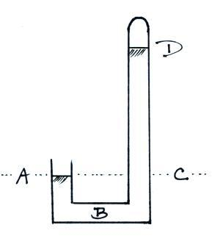

3. The same pressure would be measured at
Points ___A___ and ___C___ on the
barometer shown at right. The pressure is
zero at Point ___D___. The highest
pressure would be found at Point ___B___.
(each letter in the figure at right should be
used once as an answer)

4. Which one of the following doesn’t belong in the same group as the other three?
a. stable layer b. stratosphere c. temperature inversion d. thunderstorm
Thunderstorms form when the atmosphere is unstable. A temperature inversion produces stable conditions. The stratosphere is a very stable layer because temperature increases with increasing altitude throughout most of the stratosphere.

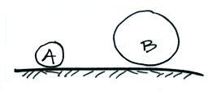
5. Objects A and B at right have the same weight.
Object A has larger _density_, smaller _volume_,
but the same __mass__ than(as) Object B. (fill in
each blank with one of the choices below)
a. composition b. density
c. mass d. volume

6. The atmosphere can be split into layers such as the troposphere and stratosphere according to how air COMPOSITION DENSITY PRESSURE TEMPERATURE change with altitude.

7. Object A has a volume of 3 cm³ and a mass of 4.5 grams, Object B a mass of 15 grams and a volume of 6 cm³? Does OBJECT A or OBJECT B have the highest density?
Object A has a density of 4.5/3 = 1.5 gm/cm³, Object B a density of 2.5 g/cm³.

8. Pressure DECREASES INCREASES with increasing altitude in the atmosphere. Is the rate of change of pressure at ground level GREATER than the SAME as or LESS than the rate of change at higher altitude? The most rapid rate of pressure decrease with increasing altitude is in the densest air at the bottom of the atmosphere.

9. The blue color of the sky
is caused by scattering of sunlight by _________air molecules___________________.

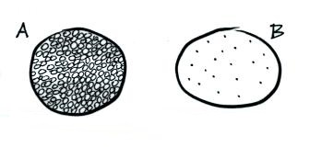
10. You fill a balloon with air. If you could look
inside, which of the following would be the
most realistic representation of what you would
see? Would the air molecules take up all the
available space inside the balloon (Fig. A) or
would there be mostly empty space inside the
balloon (Fig. B)? Fig. B is most realistic

11. If the force of gravity on the earth were to increase but the amount (mass) of air in the atmosphere remained constant, would atmospheric pressure at sea level INCREASE DECREASE or remain the SAME ?
Pressure depends on the weight of the air overhead. If gravity increases the atmosphere will weigh more even though its mass is the same.

12. If you travel from Tucson (2500 ft. altitude) to the top of Mt. Lemmon (9000 ft. altitude) you would expect to observe a ___DROP___ in air temperature, a __DROP___ in air density, and a ___DROP___ in air pressure. (fill in each blank with RISE or DROP )

13. The ideal gas law equation allows you to determine the pressure of the air inside a balloon.
P = (N k T) / V

N is the number of air molecules in the balloon, T is the temperature of the air in the balloon, V is the volume of the balloon, and k is just a constant that you won't need to worry about.

If you were to double the number of air molecules, double the temperature, and double the volume of the balloon would the pressure INCREASE DECREASE or remain the SAME? Doubling N and T would increase the pressure by a factor of 4. Doubling V would reduce this by a factor of 2. The overall change would be a 2 times increase in pressure.

14. Which two of the following don't always decrease with increasing altitude?
a. air density b. air pressure c. air temperature d. wind speed

15. On Oct. 14, 2012 Felix Baumgartner jumped from a balloon at an altitude of 127,852 feet which is about _____39________ kilometers or about _______24______ miles high. At one point during the descent he was falling at a speed of 843.6 miles per hour. It took a little over 4 minutes to reach the ground in eastern New Mexico.

There are 5280 feet per mile. So 127,852 feet divided by 5280 feet per mile is 24.3 miles. There are 1.6 kilometers per mile so this is 38.7 km.

There are about 3 feet in one meter. So 127,852 feet divided by 3 feet per meter is 42.6 km. A more accurate conversion is 3.28 feet per meter. So a more accurate estimate is 127,852 feet divided by 3.28 feet per meter or 39.0 km.

