Monday Nov. 7, 2011
Music before class today was Caravan performed at the Django Reinhardt New York Jazz Festival in 2004
Photos of the All Souls Procession from the Arizona Daily Star
New 1S1P Bonus Assignment now available (due on or before Wed., Nov. 16)

In the next two or three classes we will be looking at how and why surface and upper level winds blow the way they do.
Some real world examples of where this occurs are shown in the figure below (found on p. 121 in the ClassNotes). The two largest types of storm systems, middle latitude storms (extratropical cyclones) and hurricanes (tropical cyclones), develop around surface centers of low pressure. Winds spin counterclockwise around cyclones (centers of low pressure) in the northern hemisphere and clockwise in the southern hemisphere.
Winds spin clockwise around "anticyclones" (high pressure) in the northern hemisphere and counterclockwise in the southern hemisphere.
Why do winds blow in opposite directions around high and low pressure. Why do the winds change directions when you move from the northern to the southern hemisphere. These are the kinds of questions we'll be addressing.

Storm systems in the tropics (0 to 30 degrees latitude) generally move from east to west in both hemispheres. At middle latitudes (30 to 60 degrees), storms move in the other direction, from west to east. To understand why this is true we need to learn something about the earth's global scale pressure and wind patterns. This is a topic we will be getting into later this week.

I've borrowed some more carefully drawn figures below from the Spring 2009 online notes. Step #1 is found on p. 122a in the ClassNotes.

Upper level winds spinning around high and low pressure in the northern and southern hemispheres are shown in the first set of four pictures. The first thing to notice is that upper level winds blow parallel to the contours. We will see that 2 forces, the pressure gradient force (PGF) and the Coriolis force (CF), cause the winds to blow this way. Eventually you will be able to draw the directions of the forces for each of the four upper level winds examples. Here is an example of what you’ll be able to do:

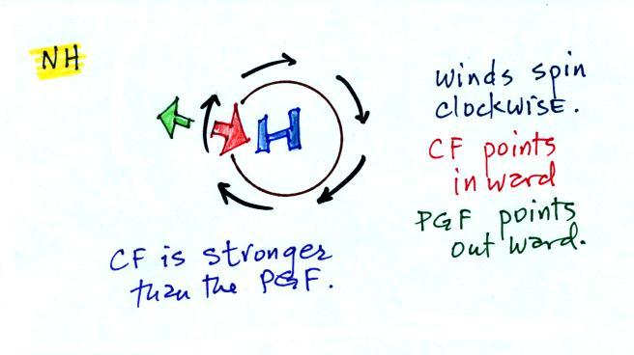

The four drawings at the bottom of the page show surface winds blowing around high and low pressure in the southern hemisphere. These winds blow across the contour lines slightly, always toward low pressure. The frictional force is what causes this to occur. He is an example of what you will be able to say about surface winds blowing around low pressure in the southern hemisphere:
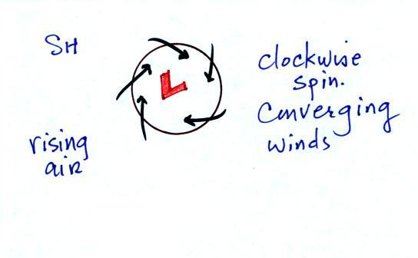

You should be able to look at an object's (or the wind's) motion and tell if there is a net force or not. The only time there is no net force is when the object is stationary or moving in a straight line at constant speed (both conditions must be met).

There aren't any forces at all acting on the object above at left. There are forces at right but they cancel each other out and the net force is zero. The objects below will continue to move in a straight line at constant speed. The pictures above and below weren't shown in class.

Another important point to take from Step #2 is that a net inward force is needed anytime an object is moving in a circular path even if the speed is constant. It doesn't matter what direction the object is moving and it doesn't matter what the object is circling around. Here are a few more examples not mentioned in class.

A net inward force is needed to keep winds spinning around a center of low pressure, an inward force is needed to keep air moving in a circular path around high pressure, and a net inward force (gravity) is needed to keep a satellite in a circular orbit around the earth.
Quite a few people would say there is an outward force being exerted in the bottom picture below, but the force is inward in each of the cases.

It's just not the same amount of inward force. The amount of force is just right in the top figure, a little "too strong" in the middle figure, and "not quite strong enough" in the bottom figure.

Now we'll start to look at the forces that cause the wind to blow.

Air moving inward toward low pressure or outward away from high pressure is similar to a rock rolling down and away from the summit of a hill or inward toward the bottom of a depression. The pressure gradient force always points perpendicular to the contour lines on a map and toward low pressure. The PGF will cause stationary air to begin to move (it will always move toward low pressure).

The Coriolis force is caused by the rotation of the earth. We'll learn more about what causes the Coriolis force on Wednesday. The CF points perpendicular to the wind and can only change the wind's direction. It can't cause the wind to speed up or slow down. The direction of the CF depends on whether you're in the northern or southern hemisphere.

Time now to begin applying what we've learned.

We start with some stationary air at Point 1. The PGF at Point 1 starts stationary air moving toward the center of low pressure (just like a rock would start to roll downhill). Once the air starts to move, the CF causes it to turn to the right (because this is a northern hemisphere chart). The wind eventually ends up blowing parallel to the contour lines and spinning in a counterclockwise direction. Note that the inward PGF is stronger than the outward CF. This results in a net inward force, something that is needed anytime wind blows in a circular path.

We start again with some stationary air at Point 1 in this figure. See if you can figure out will happen next. You’ll find the answer on the next page.
