Monday Nov. 17, 2008
Sleep all Summer from Crooked Fingers was the song played in class today. Maybe a little too slow for Monday afternoon in the 2-2:50 class.
The Experiment #4 reports turned in last week have been graded. Revised reports are due in two weeks on Monday, Dec 1, though if you could possibly get them turned in before Thanksgiving I would be grateful.
The Quiz #4 Study Guide Pt. 1 (1st law of motion, forces, upper level and surface winds) is now available online.

The T Th section of the class is now participating in the toilet bowl "experiment." I received several emails like this over the weekend:

But only one of the following, from a student that might well be preparing a PhD dissertation on
the topic:
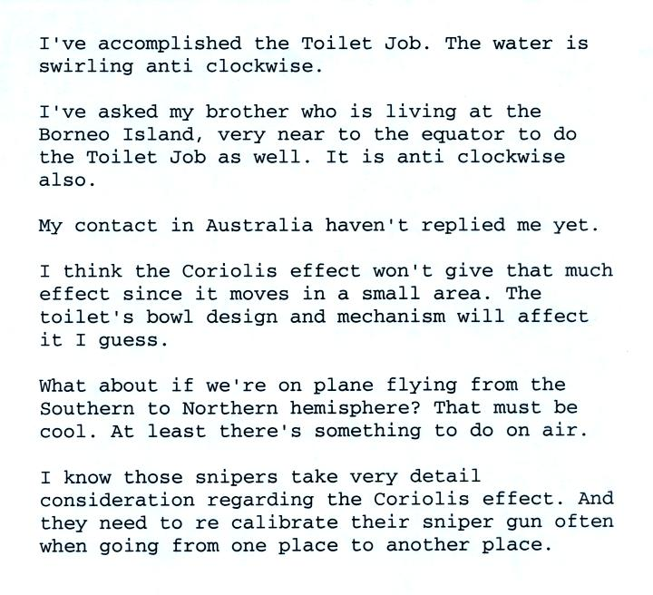

We watched a short time-lapse video of a wet microburst over the Catalina mountains. A sudden downward gush of rain was visible on the video. Surface winds may have been strong enough to blow over or uproot a couple of trees in the forest.
Here's a quick review of the 3 stage life cycle of an ordinary air mass thunderstorm.
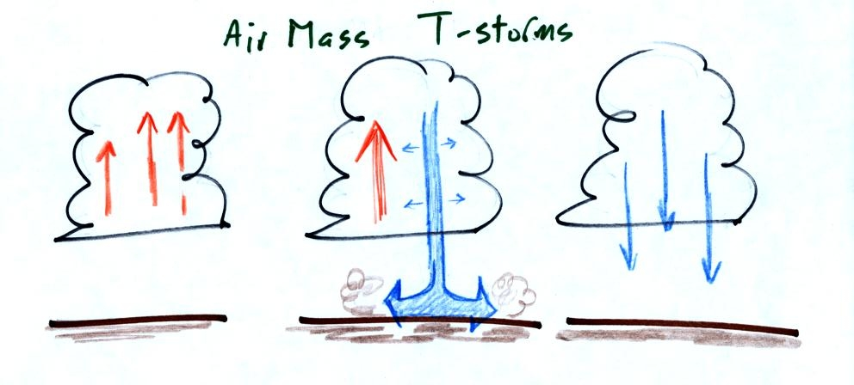
Once the downdraft forms in the middle (mature) stage, it begins to spread horizontally in the interior of the cloud. The downdraft eventually chokes off the updraft and the storm begins to weaken and dissipate.
Under certain conditions the thunderstorm will move and the updraft will tilt. This is shown in the following figure (redrawn after class, sorry about the sloppy handwriting in class):
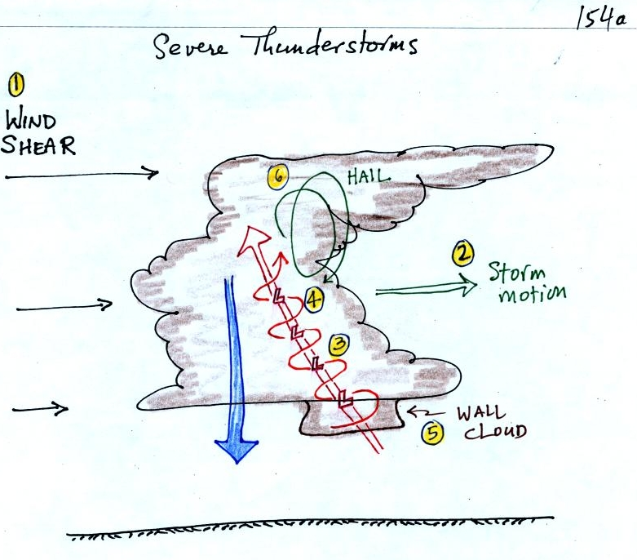
Severe storms are more likely to form when there is vertical wind shear. Wind shear (pt 1) is changing wind direction or wind speed with distance. In this case, the wind speed is increasing with increasing altitude.
The thunderstorm itself will move in this kind of an environmen, at an average of the speeds at the top and bottom of the cloud (pt. 2). The thunderstorm will move to the right more rapidly than the air at the ground which is where the updraft begins. Rising air that is situated at the front bottom edge of the thunderstorm will find itself at the back edge of the storm when it reaches the top of the cloud. This produces a tilted updraft (pt. 3). The downdraft is situated at the back of the ground. The updraft is continually moving to the right and staying away from the downdraft. The updraft and downdraft coexist and do not "get in each others way."
Sometimes the tilted updraft will begin to rotate. A rotating updraft is called a mesocyclone (pt. 4). Meso refers to medium size (thunderstorm size) and cyclone means winds spinning around low pressure. Low pressure in the core of the mesocyclone creates an inward pointing pressure gradient force needed to keep the updraft winds spinning in circular path (low pressure also keeps winds spinning in a tornado). The cloud that extends below the cloud base and surrounds the mesocyclone is called a wall cloud (pt. 5). The largest and strongest tornadoes will generally come from the wall cloud.
Note (pt. 6) that a tilted updraft provides a way of keeping growing hailstones inside the cloud. Hailstones get carried up toward the top of the cloud where they begin to fall. But they then fall back into the strong core of the updraft and get carried back up toward the top of the cloud.

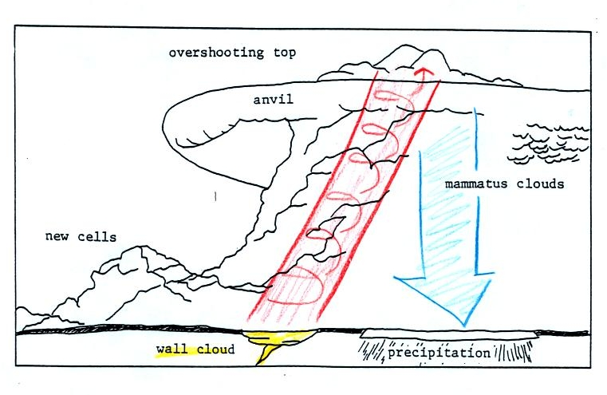
Here is a relatively simple drawing showing some of the key features on a supercell thunderstorm. In a supercell the rotating updraft (shown in orange above) is strong enough to penetrate into the stratosphere. This produces the overshooting top or dome feature above. A wall cloud and a tornado are shown at the bottom of the mesocyclone. In an ordinary thunderstorm the updraft is unable to penetrate into the very stable air in the stratosphere and the upward moving air just flattens out and forms an anvil. The flanking line is a line of new cells trying to form alongside the supercell thunderstorm.
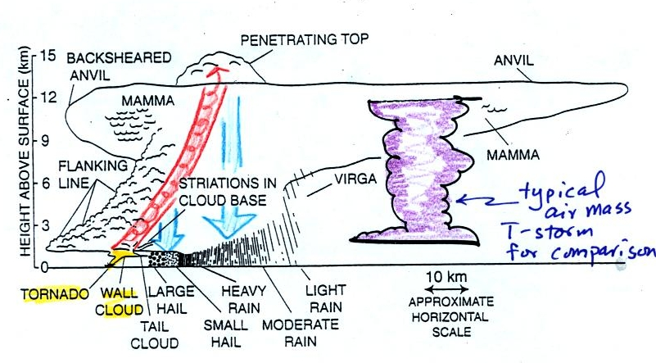
Here is a second slightly more complicated drawing of a supercell thunderstorm. A typical air mass thunderstorm (purple) has been drawn in for comparison.
We watched a short video segment at this point. It showed a photograph of a distant supercell thunderstorm with a distinctive dome. The video showed the wall clouds at the bottoms of 2 or 3 other much closer supercells. And finally a computer simulation of the air motions inside a supercell thunderstorm was shown. Researchers understand the development of a supercell pretty well. The exact process that initiates tornado development is still unknown, however.

We haven't discussed weather radar in this class. In some ways a radar image of a thunderstorm is like an X-ray photograph of a human body. The Xrays pass through the flesh but are partially absorbed by bone. The radio signals emitted by radar pass through the cloud itself but are reflected by the much larger precipitation particles.
Thunderstorms with rotating updrafts produce a very characteristic hook shaped echo on radar. Here are a couple of examples:
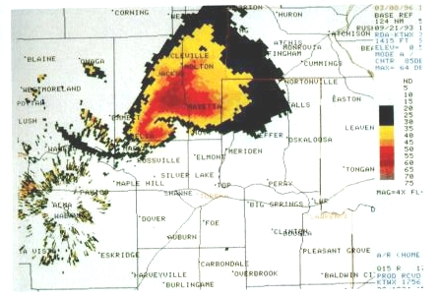
This is a copy of Fig. 11-19 in the text. The colors provide an idea of precipitation intensity (red is the heaviest precipitation).
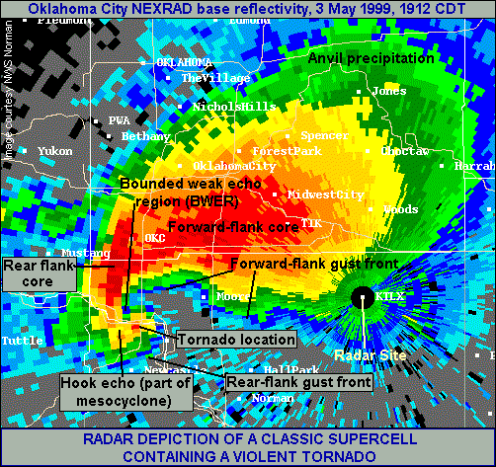
This is the radar image of a very strong tornado that hit Oklahoma City in May 1999
( http://www.spc.noaa.gov/faq/tornado/radscel.htm ). It is possible that tornado winds of over 300 MPH may have been produced during that storm.
A second type of radar, Doppler radar, can measure how quickly precipitation particles are moving toward or away from the radar. Mobile doppler radars (see p. 332 in the text) are now being used to measure tornado wind speeds ( Doppler radar is also used by the police to enforce traffic speed limits).

With all this talk of spinning updrafts in thunderstorms, the next logical topic is tornadoes.
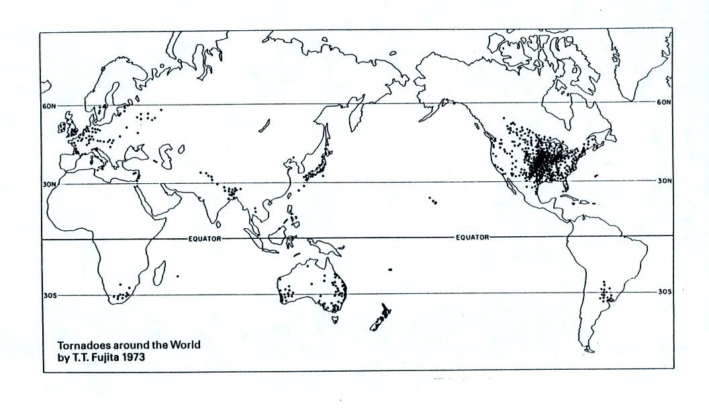
The United States has more tornadoes in an average year than any other country in the world (over 1000 per year). The central US has just the right mix of meteorological conditions.
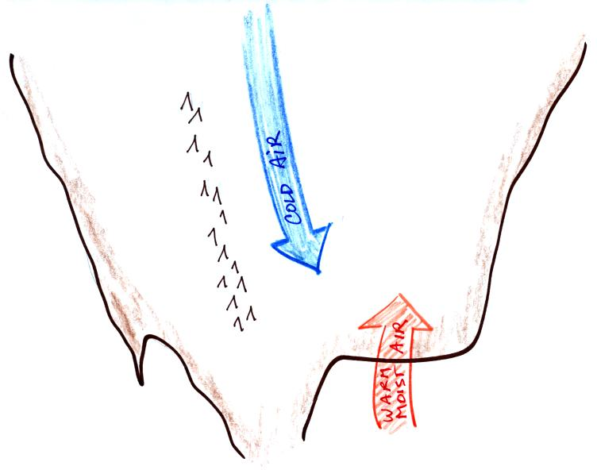 | 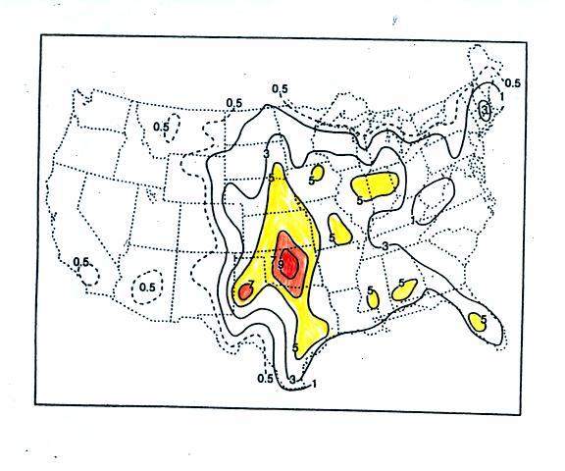
In the spring, cold dry air can move all the way from Canada and collide with warm moist air from the Gulf of Mexico to form strong cold fronts and thunderstorms.
Tornadoes have been observed in every state in the US, but tornadoes are most frequent in the central plains, a region referred to as "Tornado Alley" (highlighted in red, orange, and yellow above). The map at right above can be found on p. 161 in the photocopied ClassNotes.
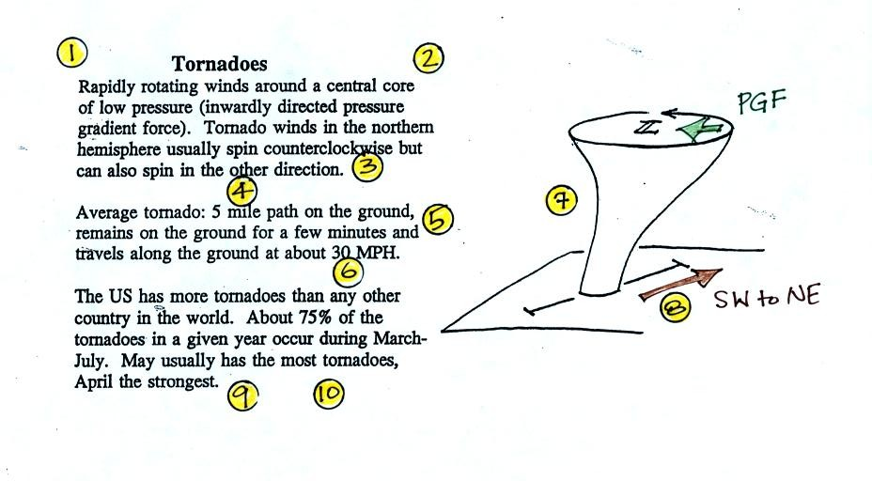
Here are some basic tornado characteristics (the figure above is found on p. 161 in the photocopied class notes).
1. About 2/3rds of tornadoes are F0 or F1 tornadoes (see below) and have spinning winds of about 100 MPH or less. Microburst winds can also reach 100 MPH. They are a lot more common in Tucson in the summer than tornadoes but can inflict some of the same kinds of damage.
2. A very strong inwardly directed pressure gradient force is needed to keep winds spinning in a circular path. The PGF is much stronger than the Coriolis Force (CF) and the CF can be neglected. The pressure in the center core of a tornado can be 100 mb less than the pressure in the air outside the tornado. This is a very large pressure difference in a short distance.
3. Tornadoes can spin clockwise or counterclockwise, though counterclockwise rotation is more common.
4, 5. Tornadoes usually last only a few minutes and leave a path on the ground that is a few miles long. We will look at an exception below.
6, 7, 8. Most tornadoes move from the SW toward the NE at a few 10s of MPH. Most tornadoes have diameters of hundreds of feet, but tornadoes with diameters over a mile have been observed.
9, 10. Tornadoes are most frequent in the Spring. The strongest tornadoes also occur at that time of year. Tornadoes are most common in the late afternoon when the atmosphere is most unstable.
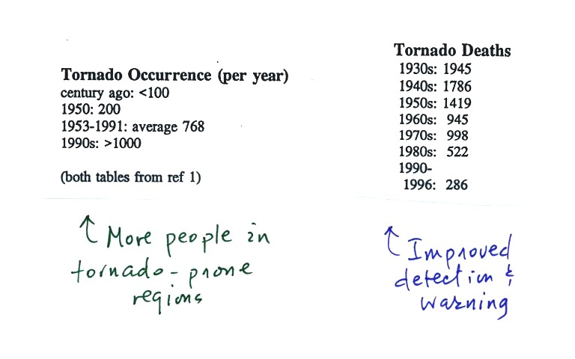
At the present time about 75 people are killed every year in the United States. Lightning and flash floods (floods are the most serious severe weather hazard) kill slightly more people. Hurricanes kill fewer people on average than tornadoes. Heat in the summer and cold in the winter kill many more people than floods, tornadoes, lightning, and hurricanes.

Most tornadoes last only a few minutes and leave a path a few miles long on the ground. There are of course exceptions. One is discussed below.
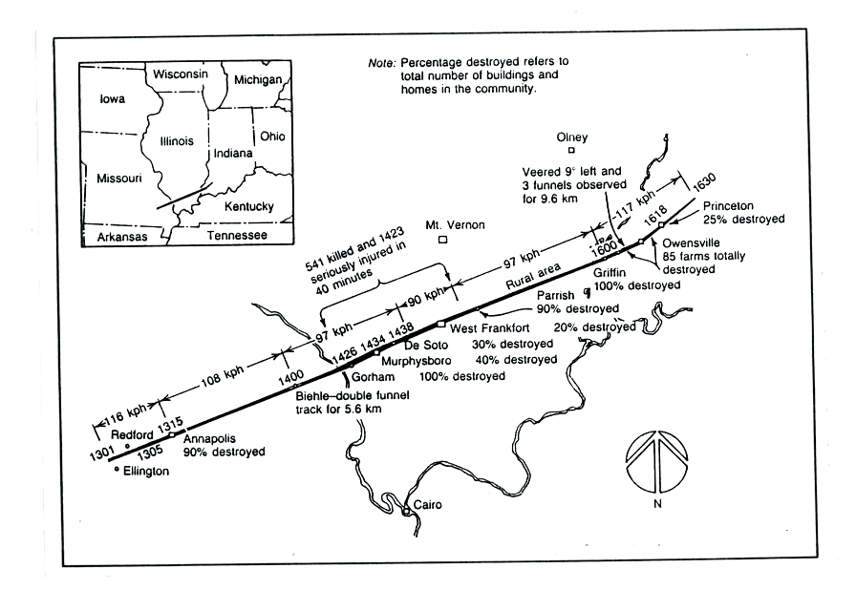
The path of the 1925 "Tri-State Tornado" is shown above. The tornado path (note the SW to NE orientation) was 219 miles long, the tornado last about 3.5 hours and killed 695 people. The tornado was traveling over 60 MPH over much of its path. It is the deadliest single tornado ever.
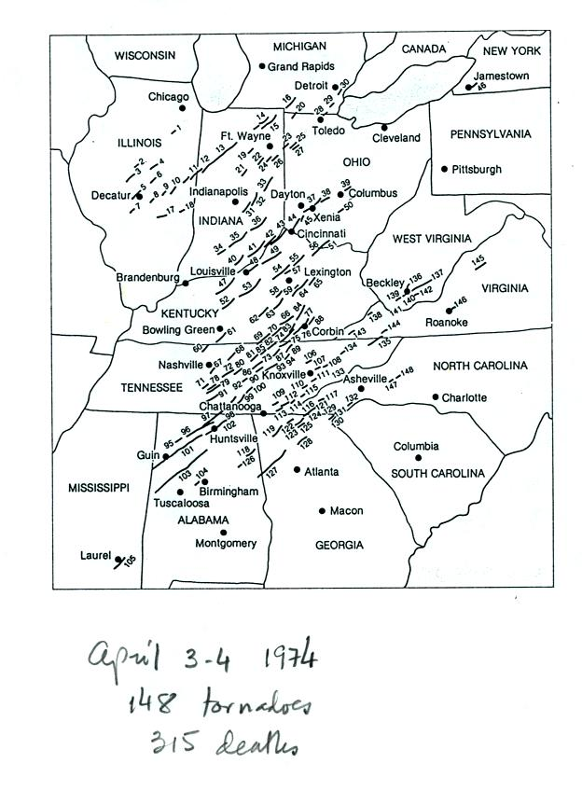 | 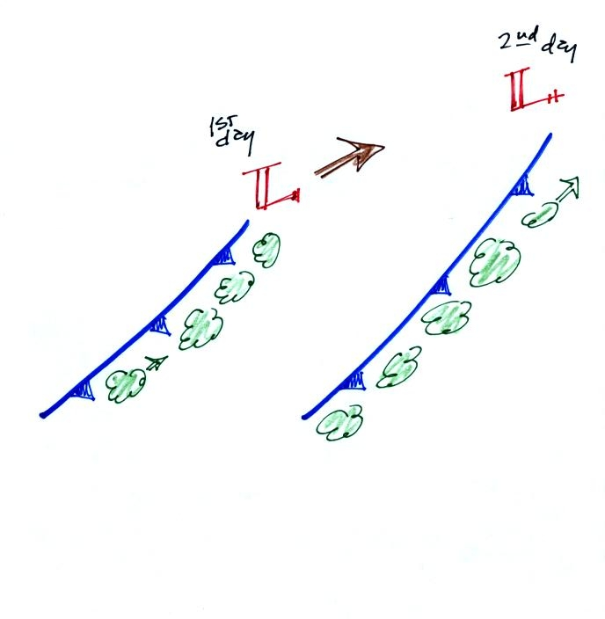
Tornadoes often occur in "outbreaks." The paths of 148 tornadoes during the April 3-4, 1974 "Jumbo Tornado Outbreak" are shown above. Note the first tornadoes were located in the upper left corner of the map. The tornadoes were produced by thunderstorms forming along a cold front. During this two day period the front moved from the NW part toward the SE part of the figure. Note that all the tornado paths have a SE toward NE orientation.

Before looking at the first of several segments of tornado video, here's an easy to remember version of the Fujita Scale used to rate tornado intensity. Because it is so hard to make measurements of tornado wind speeds, intensity estimates are usually based on an examination of the damage caused by the tornado.
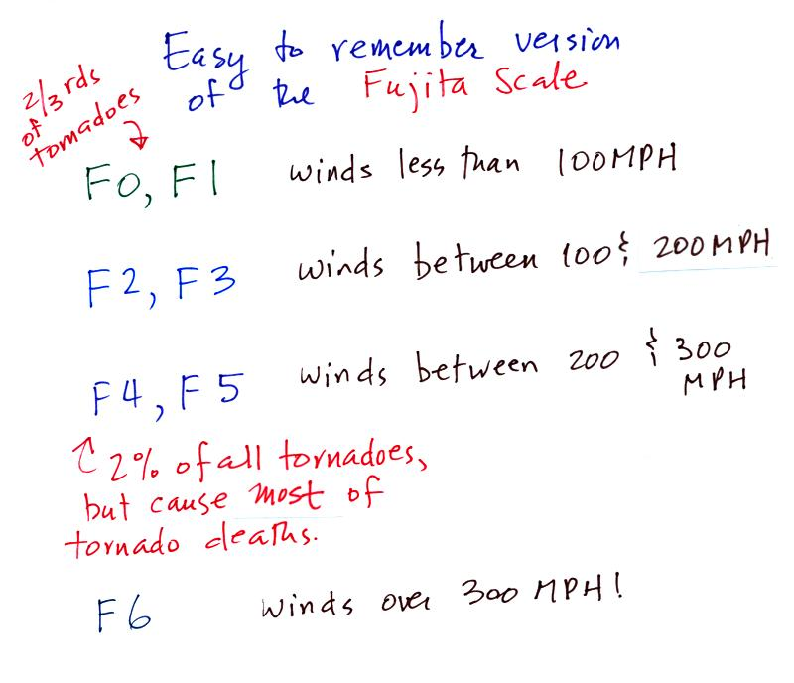
Finally a short video with images of several different tornadoes was shown. Descriptions of the tornadoes are given in the table below.
54a | F3 | Grand Island, NE | Mar. 13, 1990 | tornado cloud is pretty thick and vertical
61f | F3 | McConnell AFB KS | Apr. 26, 1991 | this is about as close to a tornado as you're ever likely to get. Try to judge the diameter of the tornado cloud. What direction are the tornado winds spinning?
52 | F5 | Hesston KS | Mar. 13, 1990 | Watch closely, you may see a tree or two uprooted by the tornado winds
51 | F3 | North Platte NE | Jun. 25, 1989 | Trees uprooted and buildings lifted by the tornado winds
65 | F1 | Brainard MN | Jul. 5, 1991 | It's a good thing this was only an F1 tornado
57 | F2 | Darlington IN | Jun. 1, 1990 | Tornado cloud without much dust
62b | F2 | Kansas Turnpike | Apr. 26, 1991 | It's sometimes hard to run away from a tornado. Watch closely you'll see a van blown off the road and rolled by the tornado. The driver of the van was killed!
47 | F2 | Minneapolis MN | Jul. 18, 1986 | Tornado cloud appears and disappears.

