ATMO 336 - Weather, Climate, and Society

Fall 2015 Homework #2: Humidity, Phase Change, and Stability Problems

Make sure you read and answer all the parts to all questions! We prefer that you type your homework, but neatly written solutions will be accepted. When asked to compute an answer, you must show your work. Where asked to fill in tables, I suggest that you cut the blank tables from this document, paste them into your homework document, and then fill in the missing values. Please do not copy this entire document (including the questions) and type your answers below the questions as this is a waste of paper. The grader knows the questions. There are 10 questions.

- On a winter day the following conditions were measured on the UA campus
At 8 AM: Air temperature, T = 45° F; Dew point temperature, T_{d} = 30° F.
At 10 AM: Air temperature, T = 55° F; Dew point temperature, T_{d} = 30° F.
At 2 PM: Air temperature, T = 70° F; Dew point temperature, T_{d} = 30° F.
- Using the table of saturation mixing ratios, compute/find the relative humidity for each of three times of day based on the measured conditions specified above.
- How did the water vapor content in the air change between 8 AM and 2 PM? Explain why the relative humidity changed the way it did from 8 AM through 2 PM.

- On a summer day, the conditions measured at Tucson, Arizona and New Orleans, Louisiana are given below

Tucson, Arizona
Air Temperature | 100° F
Relative Humidity | 10 %

New Orleans, Louisiana
Air Temperature | 90° F
Relative Humidity | 55 %

- Using the heat index chart provided with the course lecture notes (reading pages), find the heat index for the two cities. Which location is most stressful to the human body? How do the rates of heat loss from the body compare at these two locations?
- Compute the dew point temperatures for the two cities. You will need to use the table of saturation mixing ratios. You may need to interpolate between the closest values in the saturation mixing ratio table to get your answers. Which city has the higher concentration of water vapor in the air? How do you know?

- On a winter day, conditions measured at Fairbanks, Alaska and West Yellowstone, Montana are given

Fairbanks, Alaska
Air Temperature | -5° F
Wind Speed | 10 MPH

West Yellowstone, Montana
Air Temperature | 5° F
Wind Speed | 40 MPH

- Using the wind chill chart provided with the course lecture notes (reading pages), find the wind chill equivalent temperature for the two cities. Which location is most stressful to the human body? How do the rates of heat loss from the body compare at these two locations?
- The wind chill equivalent temperature accounts only for heat losses related to air temperature and wind speed. Explain why cold and windy conditions could be even more dangerous for a person wearing wet clothing (perhaps for example someone who has fallen into water, climbs out, but remains wet).
- Here in Tucson when it is hot outside, restaurants with outdoor seating often use misters to make conditions more comfortable for their customers. Misters work by spraying a fine mist of tiny liquid water droplets into the air. How do misters cool the air? (Hint. Think about what would happen to liquid water drops surrounded by desert air in summer.) What happens to the relative humidity of the air that is being cooled? Give two reasons why the relative humidity changes the way that it does.

- This question has to do with the formation of condensation funnels in tornadoes. When air parcels are drawn into a tornado’s circulation they experience a pressure drop as they approach the low pressure at the tornado’s center. The pressure drop can be as much as 20%, for example, from 1000 mb outside the tornado to 800 mb near the tornado’s center. Explain why this sometimes results in the formation of a visible condensation funnel. In other tornadoes with the same pressure drops, condensation funnels do not form. What is the most likely reason why visible condensation funnels do not always form even when inward moving air parcels experience a significant pressure drop? Even though these tornadoes do not produce visible condensation funnels, evidence of the tornado’s circulating winds can often still be seen. What else causes these tornadoes to often be “visible”?

- In lecture it was stated that the tropopause acts as a “lid on rising air motion.” In other words, rising (and unstable) parcels of air stop rising soon after they encounter the tropopause. We find evidence for this with strong thunderstorms. The highest clouds in the thunderstorm, called the anvil, top out at the troposphere-tropopause boundary. Explain why the tropopause acts as a lid on rising air motion. Hint. You need to consider how the environmental temperature profile changes in the transition from the troposphere to the tropopause, i.e., the temperature surrounding air parcels will stop decreasing with increasing altitude and become steady, and how this will affect the stability of a rising parcel. Keep in mind that rising parcels of air always cools due to expansion regardless of how the temperature changes in air surrounding the parcel.

- Suppose you perform a stability analysis of the atmosphere by moving a hypothetical surface parcel upward from the ground surface, as we did in class by filling in stability tables. In your analysis you find that a lifted parcel is unstable over the altitude range from 3000 – 9000 meters above the ground. What criteria must be met for the parcel to be unstable? In other words, how do you tell if a lifted parcel becomes unstable? Why must a parcel become unstable for thunderstorm updrafts to occur? What is the main energy source for the development of instability and thunderstorm updrafts? In other words, what type of energy release can cause a parcel to remain unstable over a large vertical distance? This type of instability often called potential (or potential energy) for thunderstorm formation. What does it mean to say that a lifting mechanism is required to “release the [potential] instability” of the atmosphere?

- Answer the following questions and fill in tables for each part below. You are going to look at the importance of condensation in the formation of unstable conditions and updrafts and of evaporation in the formation of downdrafts.

  - Dry air (low dew point temperature) at the surface case. Fill in the table below for an air parcel forced to rise from 0 meters up to 6,000 meters. At what altitude will a cloud start to form? Once a cloud starts to form, what happens to the rate at which air temperature in the parcel changes with increasing altitude? Explain why. Does this parcel become unstable?

Altitude | Parcel  Stability  for updrafts | Atmospheric  Temperature | Parcel Temperature | Parcel Dew point Temperature
6,000 meters |  | -17° C
5,000 meters |  | -9° C
4,000 meters |  | -1° C
3,000 meters |  | 6° C
2,000 meters |  | 14° C
1,000 meters |  | 22° C
0 meters | Neutral | 30° C | 30º C | -10º C

  - Wetter air (higher dew point temperature) at the surface case. Fill in the table below for an air parcel forced to rise from 0 meters up to 6,000 meters. Note that the only thing that has changed is the water vapor content (dew point temperature) of the surface air. At what altitude will a cloud start to form? Does this parcel become unstable? If so, at what altitude does it first become unstable? Explain why the result for part (b) is different from part (a), i.e., explain the effect of higher water vapor in air parcels just above ground.

Altitude | Parcel  Stability  for updrafts | Atmospheric  Temperature | Parcel Temperature | Parcel Dew point Temperature
6,000 meters |  | -17° C
5,000 meters |  | -9° C
4,000 meters |  | -1° C
3,000 meters |  | 6° C
2,000 meters |  | 14° C
1,000 meters |  | 22° C
0 meters | Neutral | 30° C | 30º C | 10º C

  - Formation of downdrafts. Fill in the table below for an air parcel at 3000 meters that is forced to sink (move downward) to the ground (0 meters). In this case assume that it is raining and thus the air parcel has liquid water drops that remain in the parcel all the way to the ground. How does the presence of raindrops (liquid water drops) in the parcel affect the rate at which the air temperature in the parcel changes with decreasing altitude compared with a parcel that does not contain liquid water droplets? Will this parcel form a downdraft? Hint: For downdrafts to form the parcel must become colder than the surrounding air.

Altitude | Condition for downdrafts | Atmospheric  Temperature | Parcel Temperature | Parcel Dew point Temperature
3,000 meters | No | 5° C | 8º C | 8º C
2,000 meters |  | 13° C
1,000 meters |  | 21° C
0 meters |  | 29° C

  - Repeat part (c), i.e., fill in the table below, but this time assume that there are no liquid water drops in the air parcel at 3000 meters. Will this parcel form a downdraft? Explain why the result for part (d) is different from part (c), i.e., explain the effect of having rain (or liquid water drops) inside the parcel as it descends in the atmosphere.

Altitude | Condition for downdrafts | Atmospheric  Temperature | Parcel Temperature | Parcel Dew point Temperature
3,000 meters | No | 5° C | 8º C | 8º C
2,000 meters |  | 13° C
1,000 meters |  | 21° C
0 meters |  | 29° C

- Answer the following questions and fill in tables for each part below.

The lifted index (LI) is defined as the difference between the environmental air temperature at 500 mb, i.e., the temperature of the atmosphere where the air pressure is 500 mb (this is labeled as T₅₀₀ below) and the air temperature inside an air parcel after it has been lifted from the surface up to 500 mb, i.e., you need to determine the temperature of a parcel that moves up from the surface to where the air pressure is 500 mb (this is labeled as T_{Parcel} below). Meteorologists use the lifted index to access the stability of the atmosphere. Note the lifted index was not covered in the reading material or during lecture. Use the simple definition of lifted index given here.

LI = T₅₀₀ - T_{Parcel}

- Explain why the atmosphere is said to be stable when the lifted index is positive and unstable when the lifted index is negative.

- The following information is available for Asheville, NC (elevation ~500 m above sea level) at 8:00 AM. Fill in the table by lifting an air parcel from the surface up to 5500 m, where air pressure is 500 mb. At what altitude does a cloud start to form? What is the lifted index at 8:00 AM? Is the atmosphere unstable for parcels lifted to 500 mb?

Air Pressure | Altitude (m) | Atmospheric Temperature (°C) | Parcel Temperature (°C) | Parcel Dew Point (°C)
500 mb | 5500 | -20  (this is T₅₀₀ for LI) | (this will be T_{Parcel} for LI)
---------- | 4500 | -13
---------- | 3500 | -6
---------- | 2500 | 1
---------- | 1500 | 8
---------- | 500 | 10 | 10 | 0

- Later that day at 3:00 PM, the following conditions were measured in Asheville, NC. Fill in the table below by lifting an air parcel from the surface up to 5500 m, where air pressure is 500 mb. At what altitude does a cloud start to form? What is the lifted index at 3:00 PM? Is the atmosphere unstable for parcels lifted to 500 mb?

Air Pressure | Altitude (m) | Atmospheric Temperature (°C) | Parcel Temperature (°C) | Parcel Dew Point (°C)
500 mb | 5500 | -20  (this is T₅₀₀ for LI) | (this will be T_{Parcel} for LI)
---------- | 4500 | -13
---------- | 3500 | -5
---------- | 2500 | 3
---------- | 1500 | 11
---------- | 500 | 20 | 20 | 0

- What change took place in the atmosphere between 8:00 AM and 3:00 PM that caused the stability of the atmosphere to change? Explain why this change tends to make the atmosphere more unstable.
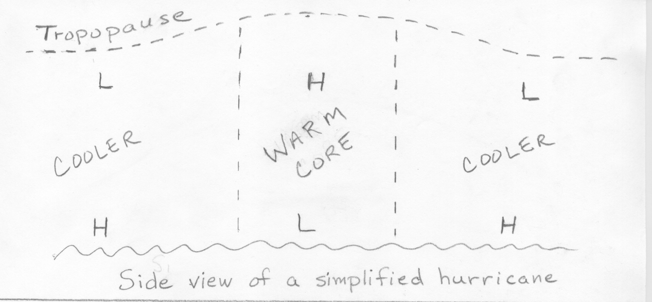
- Hurricanes are called “warm core” systems or warm core lows because the column of air above the surface low pressure area is warmer than the air surrounding the column. See figure above. The H’s and L’s in the figures indicate the positions of relatively high and low pressure respectively.
  - Explain how the warm core develops.

  - The horizontal pressure gradient at the ocean surface from high pressure outside the storm to low pressure at the storm center is the root cause of the surface winds. Explain why the strength of the pressure gradient (basically the change in pressure between the center of the storm and outside the storm) and thus the strength of the winds will get weaker as one moves upward above the ocean surface. Note. The pressure gradient is the change in pressure along a horizontal surface. Thus, we can measure a pressure gradient along the ocean surface, 1000 meters above the ocean surface, 2000 meters above the ocean surface, and so on. The question is asking why does the pressure gradient weaken at higher and higher altitudes? Eventually, if you continue to move upward, the pressure gradient will become zero, then reverse direction and get stronger in the reverse direction. Notice the change in direction of the pressure gradient at top of troposphere. Hint. To answer this question you need to consider how the air temperature in a vertical column of air affects the rate at which air pressure falls with increasing altitude, apply this above the warm core and above the cooler air outside the warm core, and note how the pressure gradient will change as you move upward.

  - Wintertime middle latitude low pressure areas are called “cold core” lows because the column of air above the surface low is colder than the surrounding air (see figure below). Most often cold core lows are not vertically stacked as shown, but are tilted with respect to the vertical; however, that would not change the answer for the question that follows. As with the warm core low, the pressure gradient across the ground surface from high pressure outside the storm to low pressure at the storm center results in surface winds that blow counterclockwise and spiral inward around the center of low pressure. For the cold core low, explain why the strength of the pressure gradient and thus the winds will get stronger as one moves upward above the ground surface. Again you need to compare the rate at which pressure falls with increasing altitude above the cold core to the rate at which pressure falls in the warmer air surrounding the cold core. Note. For the cold core low, the pressure gradient remains in the same direction and gets stronger as one moves from the ground surface to the top of the troposphere. You need to explain why. This is why we generally see the strongest winds near the jet stream in association with winter storm systems.
