More Sample Questions

1. Because of _______ the mean global average surface temperature on the earth is 60º F instead of about 0º F.
a. free convection b. latent heat energy transport
c. high specific heat of water d. the greenhouse effect

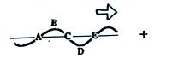
2. Points A and C on the wave of electromagnetic radiation
at right are 0.5 1 1.5 2 wavelength(s) apart. When
Point D arrives at the position of the + charge, will the
charge move UP DOWN RIGHT or LEFT?

3. What important ability or property does EM radiation have that other energy transport processes such as convection and conduction do not.

4. If a careful series of measurements revealed that the wavelength of peak emission from the sun (λ_{MAX}) was slowly increasing (shifting to longer wavelength), you could conclude the sun was getting
a. hotter b. bigger c. colder d. smaller e. closer

5. Micrometers (μm) are units of
a. energy b. distance c. frequency d. speed

6. Which two of the following are not found in the infrared (IR) portion of the spectrum?
a. 0.5 μm light b. peak emission from the earth
c. the atmospheric window d. peak emission from the sun
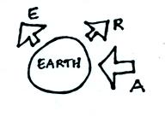
7. A in the figure at right represents incoming sunlight
that is absorbed by the earth. R is sunlight that is
reflected, and E is radiation emitted by the earth.
Which of the following equations will be true when
the earth is in radiative equilibrium?
a. E = A + R b. A = E
c. A = E + R d. E = R

8. An object that emits all the colors of visible light (violet, blue, green, yellow, orange, and red) will appear ____________________. An object that absorbs all these colors will appear _______________________.

9. The earth’s surface emits energy 24 hours per day. Does the peak emission occur during the DAY or at NIGHT?

