ATMO 170 Sect. 3 Name_________________________________________
Quiz #4 Dec. 1, 2016 (please also put your name on the back)

1. (10 pts) The _______ is caused by the rotation of the earth. When winds move from the ocean onto land you might expect an increase in the strength of the _______. (fill in the blanks)
a. frictional force b. net force c. pressure gradient force d. Coriolis force

2. (5 pts) A severe thunderstorm that is producing large hail would most likely have a TILTED VERTICAL updraft.

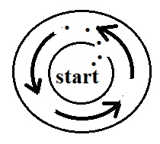
3. (10 pts) Would an automobile with a METAL or a PLASTIC body provide the best protection from lightning? Is it SAFE or DANGEROUS to use a cell phone during a lightning storm?

4. (10 pts) Based on information shown at right, you can conclude this is a
NORTHERN SOUTHERN hemisphere center of HIGH LOW pressure.
(the dots show the initial motion of the air)

5. (15 pts) A rotating thunderstorm updraft is a _______. Changing wind direction or wind speed with distance is _______. A narrow intense thunderstorm downdraft is a _______. (fill in the blanks)
a. microburst b. wind shear c. mesocylone d. gust front e. suction vortex

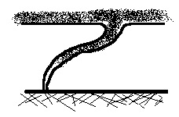
6. (15 pts) Surface winds spin CLOCKWISE COUNTERCLOCKWISE and spiral INWARD OUTWARD around high pressure in the southern hemisphere. Air RISES SINKS in the center of high pressure in the southern hemisphere.

7. (5 pts The tornado shown at right is probably at the BEGINNING MIDDLE END of its life cycle.

8. (15 pts) The direction of the _______ changes direction when you move from the northern to the southern hemisphere. The _______ can only slow down the wind. The _______ is always perpendicular to the contours on a weather map. (fill in the blanks)
a. frictional force b. net force c. pressure gradient force d. Coriolis force
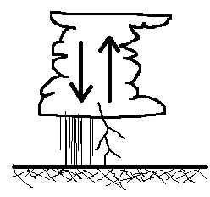
9. (5 pts) Which of the following features tells you the thunderstorm
sketched at right has reached the mature stage?
a. presence of an updraft and downdraft b. falling precipitation
c. formation of an anvil cloud d. cloud-to-ground lightning

10. (5 pts) "Dry" lightning is fairly common at the start of the summer thunderstorm season in southern Arizona. What is dry lightning?

11. (10 pts) Which two of the following are true?
a. you always find low pressure in the core of a tornado
b. the US has more tornadoes in an average year than any other country in the world
c. most tornadoes have spinning winds of over 100 MPH
d. a tilted tornado is generally stronger than a tornado that is straight up and down
Name_________________________________________

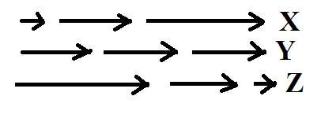
12. (10 pts) The net force is zero in _______. The net force points
toward the right in _______. (fill in the blanks)
a. none of the figures b. all of the figures
c. Fig X only d. Fig. Y only e. Fig. Z only

13. (5 pts) The _______ scale is used to rate tornado intensity.
a. Beaufort b. Fujita c. Kelvin d. Richter e. Saffir-Simpson

14. (5 pts) A cloud of dust moving outward from underneath a thunderstorm is a
a. gust front b. wall cloud c. squall line d. dry line

15. (5 pts) It takes about _______ second(s) for the sound of thunder to travel one mile.
a. 1 b. 3 c. 5 d. 10 e. 15 f. 30

16. (5 pts) When an object is moving in a circular path at constant speed, the net force _______.
a. points inward b. points outward c. is zero d. points in the direction of motion

17. (5 pts) _______ blow parallel to the contour lines.
a. Both surface and upper level winds b. Neither surface or upper level winds
c. Surface winds only d. Upper level winds only

18. (10 pts) Is intracloud lightning MORE or LESS common than cloud-to-ground lightning? Does the stepped leader occur at the BEGINNING or END of cloud-to-ground lightning discharges?

19. (10 pts) Which two of the following would be caused by a rotating thunderstorm updraft?
a. gust front b. anvil cloud c. wall cloud d. hook echo e. mammatus clouds f. microburst

20. (5 pts) The 1st law of motion that we have been using in this class was formulated by _______.
a. Archimedes b. Coriolis c. Einstein d. Galileo e. Newton
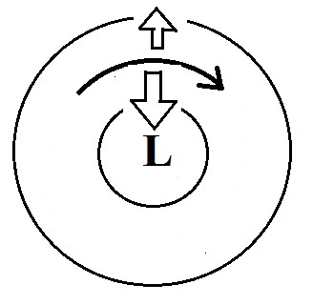
21. (15 pts) Is the inward force in the figure at right the PRESSURE GRADIENT
or the CORIOLIS force? Does this figure show UPPER LEVEL or SURFACE
winds? Is this a NORTHERN or SOUTHERN hemisphere map?

Extra credit (you can earn up to 10 pts)
1. (6 pts) Which two of the following forces cause upper level winds to blow like they do?
a. Coriolis b. frictional c. pressure gradient d. gravitational

2. (5 pts) _______ from a microburst can be a serious weather hazard.
a. High pressure b. Cold temperatures c. Strong winds d. Frequent lightning

3. (5 pts) Small rockets are being used to
a. measure the pressure in the eyes of hurricanes b. map air motions inside tornadoes
c. trigger cloud-to-ground lightning discharges d. weaken or dissipate microbursts

