ATMO 170a1 Sect. 3 Name__________________________________
Quiz #3 Nov. 3, 2016 (please also put your name on the back)

1. (5 pts) Foggy conditions mean the _______ is high.
a. relative humidity b. dew point c. mixing ratio d. air temperature e. air pressure

2. (10 pts) _______ would be used to name a layer cloud. _______ would be used in a middle altitude cloud's name. (fill in the blanks)
a. Cumulo b. Nimbo c. Strato d. Alto e. Cirro

3. (10 pts) A snowflake that first melts before reaching the ground would be called _______. If the snowflake evaporated before reaching the ground it would be called _______. (fill in the blanks)
a. sleet b. snow c. rain d. virga e. graupel

4. (5 pts) The flat top of a thunderstorm cloud is called a(n) _______.
a. anvil cloud b. cap cloud c. lenticular cloud d. shelf cloud

5. (10 pts) A cloud appeared, in the cloud-in-a-bottle demonstration, when sudden EXPANSION COMPRESSION caused moist air in the bottle to COOL WARM.

6. (10 pts) If you warm moist air but don't add or remove water vapor, the relative humidity will __________ and the dew point temperature will __________. (fill in each blank with INCRease, DECRease, or remain the SAME)

7. (5 pts) Are sundogs and haloes produced when sunlight passes through a cloud of
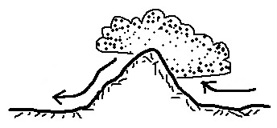
SMOKE particles WATER droplets or ICE crystals.

8. (10 pts) Water vapor is being removed from the air on the
LEFT RIGHT side of the mountain in the picture at right.
The rain shadow is on the LEFT RIGHT side of the mountain.

9. (10 pts) Does rime ice have a CLEAR or a MILKY WHITE appearance?
Is GRAUPEL or SLEET composed of rime ice?

10. (5 pts) _________________________ are the best way (Mother Nature's way) of removing small particles and gaseous pollutants from the air.

11. (5 pts) Determine the relative humidity of air that has a temperature of 75º F, a mixing ratio of 6 g/kg, a dew point temperature of 25º F, and a saturation mixing ratio of 12 g/kg.

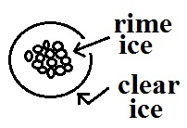
12. (5 pts) The precipitation particle sketch at right is
a. snow b. graupel c. sleet d. hail

Name______________________________________

13. (5 pts) Warm air will always have a higher _______ than cool air.
a. mixing ratio b. saturation mixing ratio c. relative humidity d. dew point

14. (10 pts) Cirrostratus clouds are THINNER THICKER than altostratus clouds. Rain falling from nimbostratus clouds is usually HEAVIER LIGHTER than rain falling from cumulonimbus clouds.

15. (10 pts) Which two of the following are true?
a. ice crystals and water droplets at the same temperature evaporate at the same rates
b. snow crystals that break into pieces increase the precipitation falling from a cloud
c. condensation nuclei are abundant but ice crystal nuclei are scarce in the atmosphere
d. water droplets are only found in clouds at temperatures warmer than freezing

16. (15 pts) _______ is a high altitude cloud with a filamentary appearance. _______ is another name for a thunderstorm. A middle level layer cloud with patches of cloud about the size of your thumb nail would be called _______. (fill in the blanks)
a. cumulonimbus b. altocumulus c. nimbostratus
d. cumulus e. stratocumulus f. cirrus

17. (5 pts) Cold air that is brought indoors in the winter and heated will often have a very LOW HIGH relative humidity

18. (10 pts) Which two of the following are true? (IC = ice crystal, CC = collision coalescence )
a. Both the IC and CC processes can produce rain
b. In Tucson the IC process produces winter rain & the CC process produces summer rain
c. The CC process works best when all the cloud droplets are the same size
d. The IC process can produce larger precipitation particles than the CC process
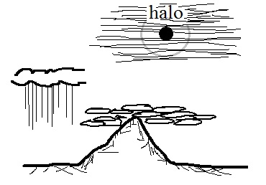
19. (10 pts) Which two of the following cloud types are shown
in the picture at right?
a. cumulonimbus b. altocumulus c. nimbostratus
d. cumulus e. stratocumulus f. stratus

Extra Credit (you can earn up to 10 pts)
1. (5 pts) Which of the following would cause moisture to be removed from air with a temperature of 75º F and a dew point of 55º F?
a. cooling the air to 65º F b. cooling the air to 45º F c. warming the air to 85º F

2. (5 pts) An ice storm is generally associated with which of the following types of precipitation?
a. hail b. sleet c. snow d. graupel e. freezing rain

3. (5 pts) A large difference between the air temperature and the dew point temperature means the relative humidity is LOW HIGH.

