ATMO 170 Sept. 17, 2015 Name__________________________________
In-class Optional (Extra Credit) Assignment

1. Three of the following would all be located at about the same altitude. Which one is found at considerably higher altitude than the other three?
a. the flat top of a thunderstorm b. the summit of Mt. Everest
c. a commercial airliner at 30,000 ft. altitude d. the ozone layer
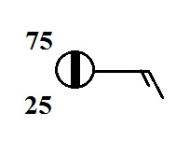
(a), (b), and (c) are all found at about 10 km altitude, at the top of the
troposphere. (d) is found near 25 km in the middle of the stratosphere.

2. According to the information plotted at right,
is MORE or LESS than half of the sky covered with clouds
1/8 th of the sky is covered with clouds. The temperature is 75º F, the dew point temperature is 25º F, and the winds are blowing from the east at 15 knots (15 MPH).

3. The atmosphere is split into layers (troposphere, stratosphere, mesosphere, etc.) according to how ___d____ changes with altitude.
a. composition b. density c. pressure d. temperature
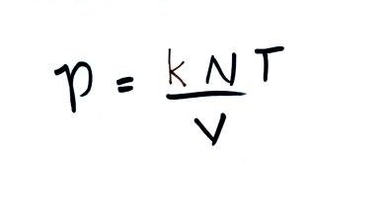
4. If you double the number (N) of air molecules in a balloon,
double the volume (V) of the balloon, and double the temperature (T),
the pressure of the air in the balloon will
a. increase by a factor of 2 b. increase by a factor of 4
c. remain constant d. decrease by a factor of 2
e. decrease by a factor of 4
Doubling N by itself would increase P by a factor of 2. Doubling T would increase P by another factor of 2 (P would now be 4 times its original value). Doubling V would reduce P by a factor of 2. So P would go from 4 times its original value to 2 times its original value

5. Warming or cooling a parcel of air in the atmosphere will cause ___V____ and ___ρ____ to change. The ___N____ and ___P____ remain constant. (fill in the blanks with ρ (density), V (volume, N (number of air molecules), or P (pressure). Each answer should be used once.)

6. The top of an average thunderstorm would be around _____10_______ kilometers tall
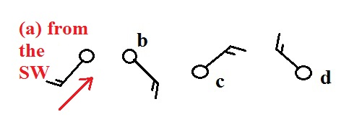
(fill in the blank with 1 10 100 or 1000)

7. Circle the figure at right that shows winds
blowing from the southwest.

8. Are clouds more likely to form when moist air is WARMED or COOLED?
Cooling air to its dew point temperature will raise the relative humidity to 100% and cause a cloud (or fog or dew) to form.
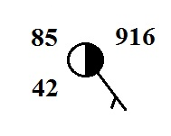
9. Which of the following are not shown at right?
a. relative humidity b. temperature c. pressure
d. dew point e. altitude
The temperature is 85º F, the dew point is 42º F, and the pressure is 991.6 mb (you need to add a leading 9 and a decimal point to the 916 plotted at upper right)

10. Would you expect the station pressures measured in Tucson and at the summit of Mt. Lemmon to be nearly EQUAL or very DIFFERENT. Would you expect the sea level pressure estimates for Tucson and Mt. Lemmon to be nearly EQUAL or very DIFFERENT.
You might expect to see a station pressure in Tucson (about 750 m altitude) of about 920 mb. Pressure decreases very rapidly with increasing altitude and the station pressure at the summit of Mt. Lemmon (about 3000 m altitude) could well be around 700 mb. That's a very large difference.

Pressure changes very slowly as you move horizontally at constant altitude. Thus once the effects of altitude are removed from the two station pressure measurements, the estimated sea level pressures in Tucson and Mt. Lemmon should be nearly equal.

If we assume pressure drops 1 mb for every 10 m of elevation gain we would need to add a 75 mb correction to the station pressure measurement in Tucson and a 300 mb correction to the station pressure measurement made at the summit of Mt. Lemmon. Thus the sea level pressure estimates for Tucson and Mt. Lemmon are 920 mb + 75 mb = 995 mb and 700 mb + 300 mb = 1000 mb, respectively.

