ATMO 170 Sect. 2 Name__________________________________
Quiz #4 Dec. 1, 2016

1. (10 pts) You can ignore the _______ force when considering upper level winds. There is no _______ force at the equator. (fill in the blanks)
a. net b. pressure gradient c. Coriolis d. frictional

2. (5 pts) A cloud of dust moving outward from underneath a thunderstorm is a
a. gust front b. wall cloud c. squall line d. dry line

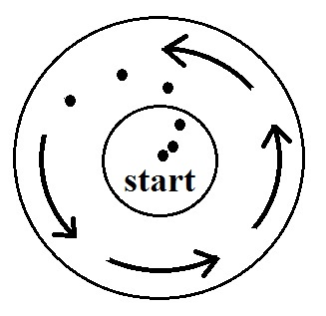
3. (10 pts) Would a metal car be a SAFE or a DANGEROUS place to be during a lightning storm. Is it SAFE or DANGEROUS to use a cell phone during a thunderstorm?

4. (10 pts) Based on the direction of initial motion in the figure at right
(shown with dots) you can say this is a center of HIGH LOW pressure.
Is this a NORTHERN or SOUTHERN hemisphere chart?

5. (10 pts) The strongest tornadoes are THICK THIN and VERTICAL TILTED.

6. (5 pts) The 1st law of motion
that we have been using in this class was formulated by ______________________________.

7. (10 pts) You normally find POSITIVE NEGATIVE charge at the top of electrified thunderstorms. Does the stepped leader discharge in negative cloud-to-ground discharges travel UPWARD or DOWNWARD?

8. (15 pts) You will find clockwise spinning surface winds blowing around HIGH LOW pressure in the northern hemisphere and around HIGH LOW pressure in the southern hemisphere. You would find rising air motions are associated with surface low pressure in the northern hemisphere and surface HIGH LOW pressure in the southern hemisphere.

9. (5 pts) The _______ scale is used to rate tornado intensity.
a. Beaufort b. Fujita c. Kelvin d. Richter e. Saffir-Simpson

10. (5 pts) _______ blow parallel to the contour lines.
a. Both surface and upper level winds b. Neither surface or upper level winds
c. Surface winds only d. Upper level winds only

11. ( 5 pts) The net force acting on an object that is moving at constant speed is ALWAYS SOMETIMES NEVER zero.

12. (5 pts) A narrow, intense thunderstorm downdraft is called a(n) __________________________.

13. (5 pts) _______ lightning is the most common type of lightning discharge.
a. Intracloud b. Negative cloud-to-ground c. Positive cloud-to-ground d. Upward

Name_________________________________________
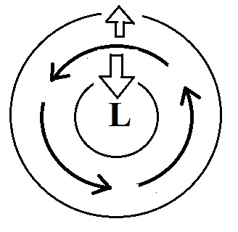
14. (15 pts) Does the figure at right show SURFACE or UPPER-LEVEL winds? Does the Coriolis force point INWARD or OUTWARD?
Is this a NORTHERN or a SOUTHERN hemisphere chart?

15. (15 pts) Which three of the following are true?
a. tornado winds can spin in a clockwise or counterclockwise direction
b. most (about 2/3rds) tornadoes have winds of 100 MPH or less
c. tornadoes occur with the same frequency in the spring and fall
d. tornadoes can form around a core of high or low pressure
e. the United States has more tornadoes than any other country in the world.

16. (15 pts) The direction of the _______ force is always perpendicular to the wind. The _______ force can cause stationary air to start to move. The _______ force can only slow down the wind (fill in the blanks)
a. Coriolis b. frictional c. pressure gradient d. net
.
17. (5 pts) Generally the strongest and longest lived thunderstorm is one with a VERTICAL TILTED updraft.

18. (5 pts) Which of the following is not associated with a rotating thunderstorm updraft?
a. gust front b. mesocyclone c. hook echo d. wall cloud
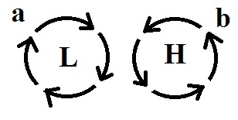
19. (10 pts) The winds are blowing in a circular path at constant speed in
the two figures at right. The net force is in Fig. (a) is _______. The
net force in Fig. (b) is _______. (fill in the blanks)
a. inward b. outward c. zero d. in the direction of motion

20. (5 pts) Three seconds delay between a lightning flash and the sound of the thunder means the
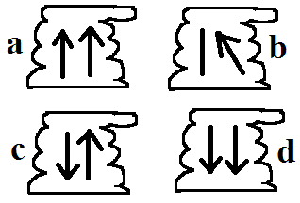
lightning strike was LESS EQUAL MORE than(to) 1 mile away.

21. (10 pts) Figure _______ contains a feature found in severe
thunderstorms. Figure _______ shows the mature (middle)
stage in an air mass thunderstorm. (fill in the blanks)

Extra Credit (you can earn up to 10 pts)
1. (5 pts) Increasing wind speed with increasing altitude is known as
a. a mesocyclone b. a microburst c an inversion d. wind shear

2. (5 pts) When winds blow from the ocean onto land you might expect an increase
in the strength of the _______.
a. Coriolis force b. frictional force c. net force d. pressure gradient force

3. (5 pts) The Coriolis force is caused by
a. temperature differences between the equator and poles b. the rotation of the earth
c. the gravitational force of the moon d. the tilt of the earth

