ATMO 170a1 Sect. 2 Name______________________________________
Quiz #3 Nov. 3, 2016 (please also put your name on the back)

1. (5 pts) Foggy conditions mean the _______ is high.
a. dew point b. mixing ratio c. relative humidity d. saturation mixing ratio e. air temperature

2. (10 pts) _______ would be used to name a cloud producing precipitation. _______ would be used in a middle altitude cloud's name. (fill in the blanks)
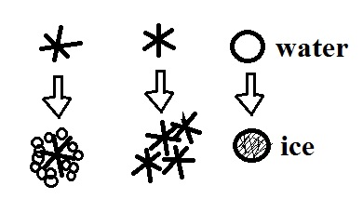
a. nimbo b. strato c. alto d. cirro e. cumulo

3. (5 pts) The formation of _______ is not shown in the figure at right.
a. graupel b. snow c. hail d. sleet

4. (5 pts) Which of the following is not a feature found on cumulonimbus clouds?
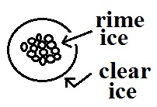
a. shelf cloud b. lenticular cloud c. anvil cloud d. mammatus cloud

5. (5 pts) The precipitation particle shown at right is _______
a. graupel b. snow c. hail d. sleet

6. (5 pts) Which of the following doesn't belong in the same group as the other three?
a. graupel b. rime ice c. sleet d. milky white appearance

7. (10 pts) Mixing ratio and _____ provide an idea of the actual amount of water vapor in the air. If you warm the air but don't add or remove any water vapor the _______ will decrease. (fill in the blanks)
a. relative humidity b. saturation mixing ratio c. dew point d. air temperature
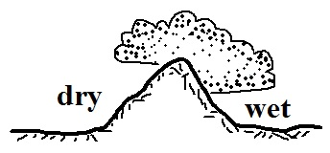
8. (10 pts) The term rain shadow refers to conditions on the WET DRY
side of the mountain in the picture at right. Would rising air motions
be found on the WET or DRY side of the mountain?

9. (5 pts) Determine the relative humidity for air with a dew point temperature of 55º F, a mixing ratio of 8 g/kg, a saturation mixing ratio of 16 g/kg, and an air temperature of 70º F.

10. (5 pts) If you COOL WARM air enough you can remove moisture from it.

11. (15 pts) _______ is a high altitude cloud with a filamentary appearance. _______ is another name for a thunderstorm. A lumpy layer cloud found at low altitude would be called _______. (fill in the blanks)
a. cumulonimbus b. altocumulus c. nimbostratus
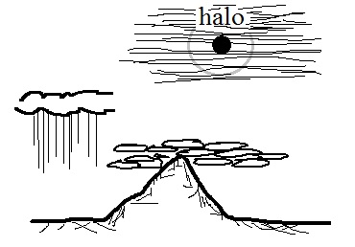
d. cumulus e. stratocumulus f. cirrus

12. (10 pts) Which two of the following cloud types are shown
in the picture at right?
a. cumulonimbus b. altocumulus c. nimbostratus
d. cumulus e. stratus f. cirrostratus
Name______________________________________

13. (10 pts) Which two of the following are true of the collision-coalescence process?
a. works best when the cloud droplets have different sizes
b. produces larger raindrops when the updrafts are strong
c. produces the electrical charge needed for lightning
d. produces most of the summer rain in Tucson

14. (10 pts) Cirrostratus clouds are THINNER THICKER than altostratus clouds. The patches of cloud in ALTOCUMULUS STRATOCUMULUS clouds are about the size of your thumbnail.

15. (5 pts) _______ is more likely when cloud bases are high and the air below the cloud is dry.
a. Hail b. Virga c. Sleet d. Snow e. Graupel

16. (5 pts) A combination of hot temperatures and ______________________________ makes it feel hotter than it really is

17. (5 pts) The maximum amount of water vapor that can be found in air depends on the _______.
a. air temperature b. air density c. dew point d. air pressure

18. (5 pts) Haloes are produced by thin clouds that are composed of ICE crystals WATER droplets.

19. (5 pts) Virga is rain that MELTS EVAPORATES CONDENSES FREEZES before reaching the ground.

20. (10 pts) During the cloud-in-a-bottle demonstration, the cloud formed when EXPANSION COMPRESSION caused the air in the flask to suddenly COOL WARM.

21. (10 pts) Which two of the following are true?
a. ice crystals and water droplets at the same temperature evaporate at the same rate
b. clouds can be composed of ice crystals or water droplets but not a mixture of both
c. condensation nuclei are abundant, ice crystal nuclei are scarce
d. water droplets cooled to below freezing don't always freeze

Extra credit (you can earn up to 10 pts)
1. (5 pts) One 200 µm diameter drop of drizzle has a volume that is _______ times larger than a 20 µm diameter cloud droplet.
a. 1,000,000 b. 100,000 c. 10,000 d. 1000 e. 100 f. 10
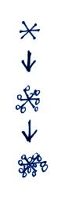
2. (5 pts) An ice storm is generally associated with which of the following types of precipitation?
a. hail b. sleet c. snow d. graupel e. freezing rain

3. (5 pts) An ice crystal falling through a cloud is colliding with supercooled
water droplets. They stick and freeze to the crystal. This process is called
a. riming or accretion b. collision and coalescence
c. condensation and deposition d. convection and convergence

