ATMO 170 Sect. 2 Name_________________________________________
Quiz #2 Oct. 13, 2016 (please also put your name on the back)

1. (10 pts) Which two of the following phase changes would release energy.
a. water boiling b. water vapor condensing c. water freezing
d. dry ice subliming e. ice melting

2. (5 pts) The earth reflects about 30% of the sunlight striking it. If this increased to 40% would the earth's temperature of radiative equilbrium INCREASE DECREASE or remain the SAME.
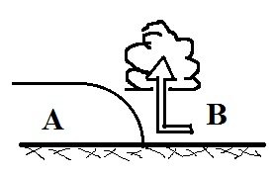
3. (15 pts) The figure at right is a cross sectional view of a WARM COLD front. Air mass A is moving toward the RIGHT LEFT. Air mass B is WARMER COLDER than air mass A.

4. (5 pts) The formation of frost is an example of a _______ phase change.
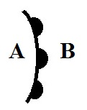
a. gas to solid b. solid to gas c. liquid to solid d. gas to liquid

5. (10 pts) Is the front shown at right moving toward POINT A or POINT B?
Is the warmest air found at POINT A or POINT B?

6. (10 pts) Compared to visible light, infrared light has LONGER SHORTER wavelength and HIGHER LOWER energy.

7. (5 pts) Isobars are contours of ALTITUDE PRESSURE TEMPERATURE.

8. (5 pts) Metals often feel cold to the touch because metals have high
a. latent heat b. specific heat c. density d. thermal conductivity
9. (5 pts) The wavelength of peak emission (λ_{MAX} ) for _______ falls in the visible part of the spectrum.
a. the sun b. the earth c. both the earth and sun d. neither the earth nor sun

10. (5 pts) Water vapor carries _______ that is released when the water vapor condenses.
a. latent heat energy b. static electricity c. kinetic energy d. specific heat

11. (5 pts) Because of _______ the global annual average surface temperature on the earth is about 60º F instead of about 0º F.
a. free convection b. the tilt of the earth relative to its orbit around the sun
c. latent heat energy d. the greenhouse effect e. the high specific heat of water
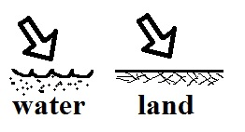
12. (5 pts) Equal amounts of energy are being added to equal amounts of water and land in the figure at right. Will the water warm MORE LESS or the SAME than(as) the land?

13. (5 pts) Which of the following plays the most important role in the greenhouse effect?
a. reflection of incoming sunlight by clouds
b. absorption of ultraviolet light by gases in the stratosphere
c. absorption & emission of infrared light by the atmosphere
d. different rates of warming and cooling of land and water
Name_________________________________________
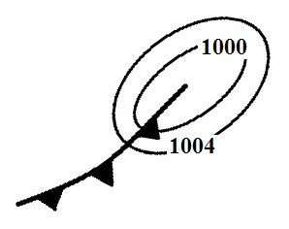
14. (10 pts) The front shown at right is rotating in a CLOCKWISE COUNTERCLOCKWISE direction around a surface center of LOW HIGH pressure.

15. (5 pts) Temperatures never go below zero on the ____________________ scale.

16. (5 pts) Contour spacing on a surface weather map tells you whether the winds will be
a. rising or sinking b. hot or cold c. dry or moist d. fast or slow e. stable or unstable

17. (10 pts) _____ in the list below is the hottest temperature and _____ is the coldest. (fill in the blanks)
a. 100º C b. 200º F c. 300º K

18. (5 pts) Wien's Law says that if an object warms the _______ will decrease.
a. wavelength of peak emission b. speed of propagation
c. intensity of emitted radiation d. radiative equilibrium temperature

19. (10 pts) A thin layer of air in contact with the ground will warm by _______. Once the air becomes warm it will start of rise and transport energy upward by _______. (fill in the blanks)
a. conduction b. convergence c. convection d. latent heat

20. (10 pts) Winds spin in a CLOCKWISE COUNTERCLOCKWISE direction spiral INWARD OUTWARD around surface centers of low pressure in the northern hemisphere.

21. (15 pts) Most of the _________ in sunlight arriving at the earth never makes it to the ground because it is absorbed by gases in the atmosphere. The atmosphere absorbs and emits _________ light. Greenhouse gases absorb certain wavelengths of _________ light. (fill in each blank with UV for ultraviolet, VIS for visible, or IR for infrared)

22. (10 pts) Everything else being equal, the coldest winter temperatures would be found at a location surrounded by OCEAN LAND. The smallest annual range of temperatures would be found at a location surrounded by OCEAN LAND.

23. (5 pts) The wavelength of peak emission (λ_{MAX}) for a tungsten bulb is 1 μm. Is this INFRARED VISIBLE or ULTRAVIOLET light.

24. (5 pts) The rapid motions of the atoms or molecules in a substance is
a. kinetic energy b. convection c. static electricity d. specific heat

Extra Credit (you can earn up to 10 pts)
1. (6 pts) Air expands when it RISES SINKS. Expanding air COOLS WARMS.

2. (6 pts) Winds blowing from the NW SW and relatively DRY MOIST air are found behind a cold front.

3. (5 pts) A thermometer outdoors reads 35º F on a day when the winds are calm. If the wind starts to blow will the temperature reading INCREASE DECREASE or remain the SAME
The following equations may help with some of the questions on this quiz:

