ATMO 336 - Weather, Climate, and Society, Fall 2015 - Homework #1
September 14, 2015. This homework is complete. There are 10 questions.
Make sure you read and answer all the parts to each question!
If you are asked to explain an answer, you must provide an explanation for full credit.
We prefer that you type your homework, however, neatly written solutions will be accepted.
Please only submit the answers to the questions, labeled by the question number. DO NOT submit copies of the questions or the maps and charts with your homework!

- The image below shows an idealized average pattern of 500 mb heights around the globe. The highest 500 mb heights run east to west around the globe at about 30° latitude in both the northern and southern hemispheres. Between these belts of highest 500 mb heights is an area of relatively lower 500 mb heights that runs east to west around the globe over the Equator. Lastly, the lowest 500 mb heights around the globe are found above the Arctic and Antarctic regions. The regions between the belts of 500 mb heights are labeled with zone numbers 1 to 4. What is the direction of the pressure gradient force (PGF) in each of the zones 1 to 4? What is the wind direction in each of the zones 1 to 4? Hint. You need to consider how the Coriolis Force affects the wind direction keeping in mind that in the Southern Hemisphere, the turning of the wind by the Coriolis Force is opposite to the direction it is turned in the Northern Hemisphere. Tucson (at 32° North Latitude) is located to the north of the average position of the subtropical belt of high 500 mb heights centered at 30° North Latitude. However, during the summer monsoon season, the center of highest 500 mb heights moves to a position north of Tucson, sometimes near 35° North latitude. Explain how the seasonal movement in the position of the subtropical center of highest 500 mb heights, results in the monsoonal shift in wind that is observed every year in Tucson.

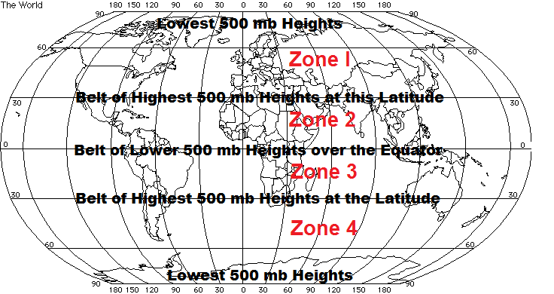
- The next two questions are based on the 500 mb maps shown below each question. The first map is a 48 hour forecast that was valid for 12 Z Wednesday, July 13, 2011. What is the corresponding local time in Tucson? What is the 500 mb height in Tucson based on the map? Note. The unlabeled height line below or south of the marked 5820 line is a line of constant 5880 meter heights. Compare the 500 mb height over Tucson from this map with the average 500 mb height over Tucson for the month of July, which is 5920 meters. Based on this comparison, would you forecast above or below average temperature for Tucson? What is the 500 mb wind direction above Tucson? (You need to determine this from the 500mb height pattern). Is the direction generally favorable or unfavorable for monsoon rains in Tucson?
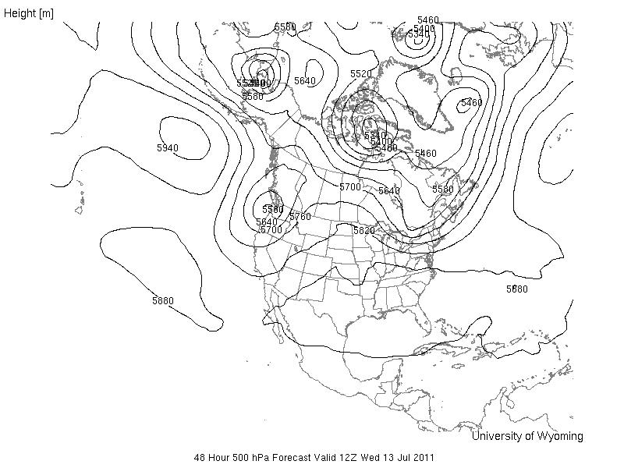

- Repeat the same questions for the map below, which is a 168 hour forecast that was valid for 12 Z Monday, July 18, 2011. Repeating the questions … Local time in Tucson? 500 mb height over Tucson? Would you forecast above or below average temperature for Tucson? 500 mb wind direction above Tucson? Is the direction generally favorable or unfavorable for monsoon rains in Tucson? Hint. The 5940 meter closed contour is a large closed high. You can assume that the center of the highest heights is near the middle of this feature, say in eastern Colorado. You can label the figure with an H over eastern Colorado if that helps. Now you will have to think about how the winds flow around a closed high to determine the wind direction over Tucson.
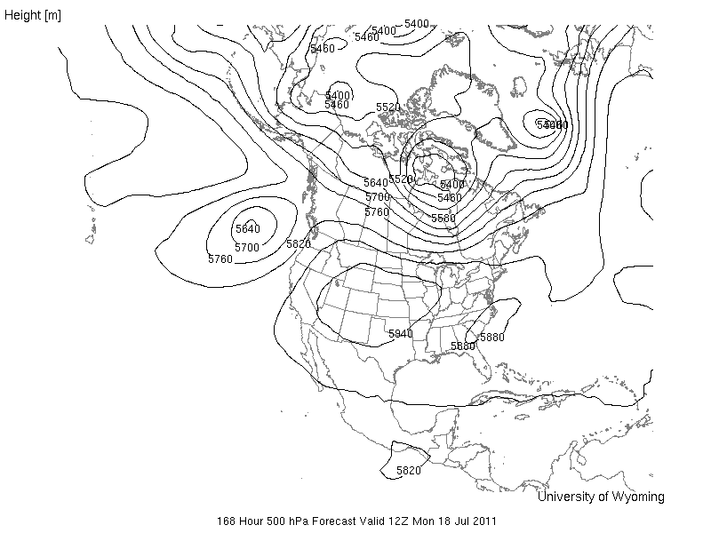

- The image below shows a portion of a sea level (or surface) weather map. Based on the pattern of isobars, determine the wind direction at the dots labeled A and B. Note that the wind direction will be the same at all three A dots and the wind direction will be the same at all three B dots. I am looking for a direction (like southeast) for each set of dots, A and B. Assume that north is straight up. Remember wind direction is defined as the direction from which the wind is blowing. Hint. Start with the pressure gradient force and work through the steps to determine surface wind direction. Does the wind pattern at the two sets of dots result in divergence, convergence, or neither for the air located between the dots? Is this wind pattern favorable, unfavorable, or neutral in regard to the possibility of rain between the two dots? Explain your answer.
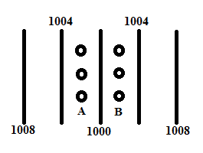

- Suppose you are about to begin a rafting trip through the Grand Canyon. A guide unrolls your inflatable raft on the grass next to the river and pumps air into the raft until it becomes nice and firm. The raft is then placed onto the cold water of the Colorado River and is anchored to a tree by a rope. A short time later you notice that the raft has lost its firmness and has become “baggy”. A whiner in your group cries “Oh no! There is a hole in our raft. I’m not going!” But you say “Don’t worry the raft lost its firmness because it was put in the cold water.” Explain why the raft would lose its firmness. In your answer you should describe what happens to the temperature and number density of the air in the raft after being placed in the cold water. (Hint. Think about the Kinetic Model for gases. You can assume that the air pressure inside the raft changes little as it loses its firmness, since basically the raft loses volume to keep the air pressure inside the raft nearly the same as the air pressure outside the raft, so if you want to use the gas law to answer this question, consider pressure is held constant.) How can this “problem” be fixed?
- Suppose you are driving from sea level up to the top of Mauna Kea in Hawaii, which is at 4,200 meters or 14,800 feet above sea level. In your car you have a sealed, unopened bad of potato chips. Which may happen to your bag of chips on the drive up? (a) The bag could explode outward or (b) The bag could implode or burst by being crushed inward You must explain your answer. On top of Mauna Kea, you drank half of your plastic bottle of water and then screwed on the top tightly so that no air can enter or leave the bottle. On your drive down the mountain, what could happen to the bottle? (a) The bottle could explode outward or (b) The bottle could implode or be crushed inward? You must explain your answer.

- Suppose you were going to walk from the ocean near Calcutta, India up to the top of Mount Everest at 8846 meters above sea level. I round the elevation to 9000 meters. We will look at how air temperature, pressure, and density change on your way up.

Elevation (meters) | Fraction of way up by altitude | Air Temperature | Air Pressure | Percentage of the atmosphere below you by weight
0 | At bottom | 32° C | 1000 mb | 0 %
3000 | 1/3 | ? | 700 mb | ?
6000 | 2/3 | ? | 500 mb | ?
9000 | At top | ? | 330 mb | ?

- Estimate the air temperature at 3000, 6000, and 9000 meters. To do this use the average rate at which air temperature falls with increasing altitude in the troposphere, which is -6.5° C for every 1000 meter gain in elevation.
- Compute the percentage of the atmosphere below 3000, 6000, and 9000 meters (based on weight). You will need to use the equation for the fraction of the atmosphere above you by weight provided in the reading page “Temperature, Pressure, and Density of the Atmosphere” and during lecture.
- Explain why the rate of decrease of air pressure is not constant (or linear) with increasing altitude, i.e., it drops by 300 mb over the first 3000 meters of the climb (from 0 m to 3000 m), 200 mb over the next 3000 meters of the climb (from 3000 m to 6000 m), and 170 mb over the last 3000 meters of the climb (from 6000 m to 9000 m). Hint: the answer has to do with how air density changes with increasing altitude.

- Shown on the next page is a 500 mb height map valid at 12 Z Monday, September 16, 2013. Four cities are labeled on the map and marked with dots: Spokane, WA, International Falls, MN, Pittsburgh, PA, and Albany, NY. Below the map are 4 skew-T diagrams, one from each of the four labeled cities. The skew-T diagrams are not labeled with the city name, and show titles, skew-T #1, skew-T #2, skew-T #3, and skew-T #4. The skew-T information was observed at the same time as the 500 mb height map, 12 Z Monday, September 16, 2013. For this question, you are to match each skew-T diagram with the four cities marked on the maps. You should be able to give at least two reasons to explain how you decided which skew-T is from which city. You may need to zoom on the images to see them more clearly, i.e., use zoom on WORD. I tried to fit everything on these pages. I will also place links to the original images under the homework link in the class web pages.

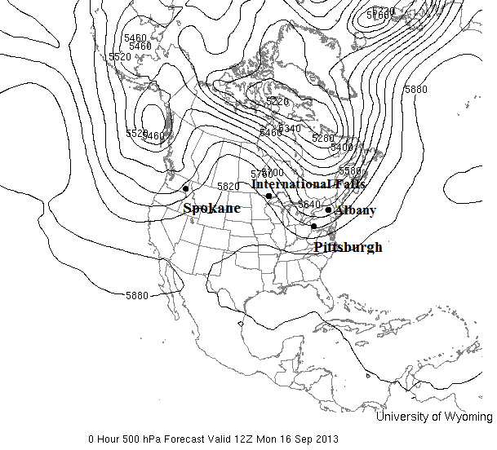

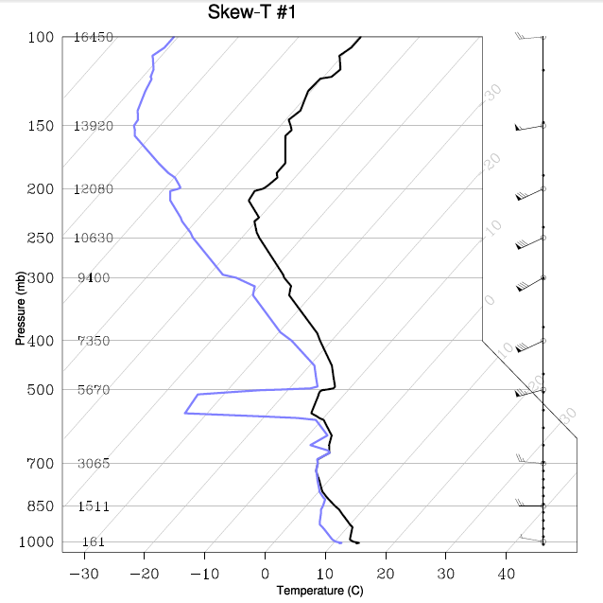
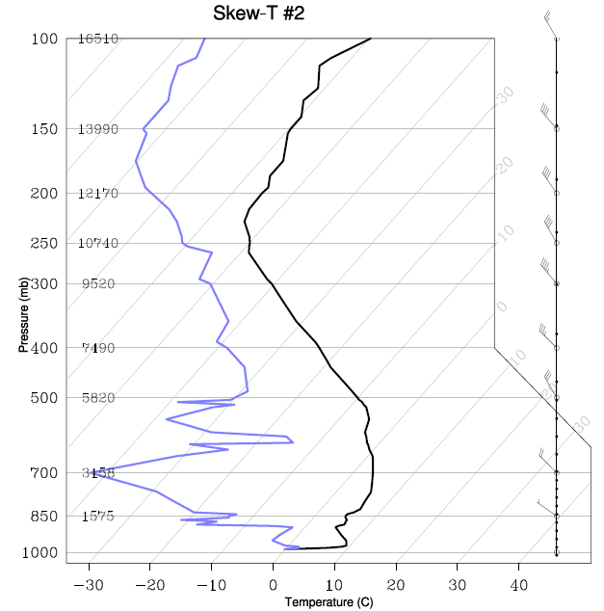

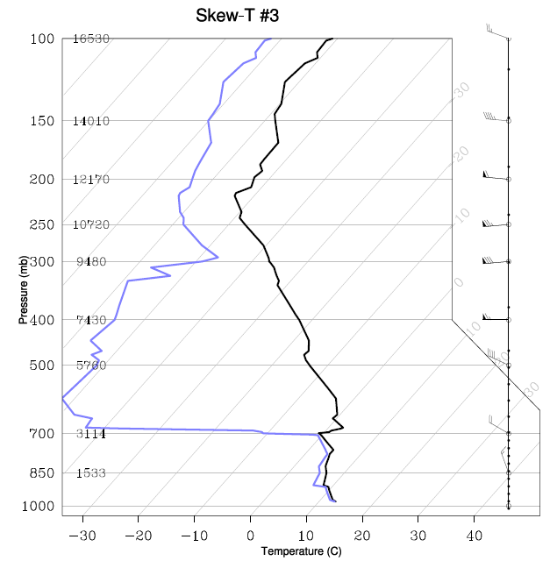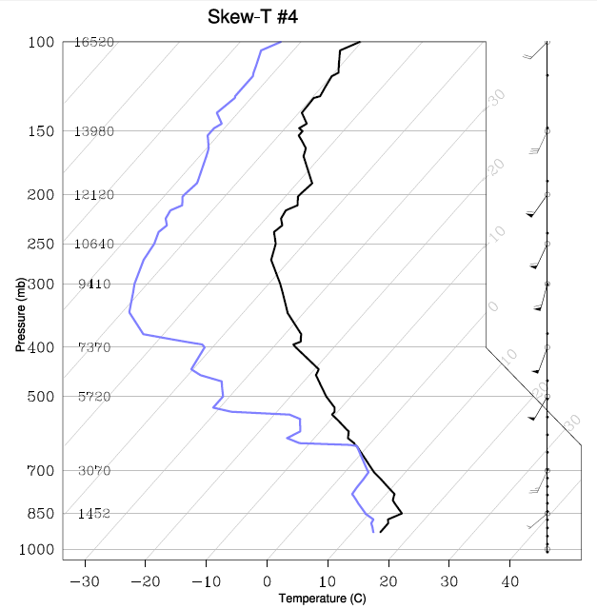
- The skew-T diagram shown below was observed over Tucson at 12Z on September 10, 2015. Fill in the missing values in the table below the skew-T diagram by reading values from the diagram. Please copy and paste the blank table into your homework document and fill in the missing values. Do not submit any of the skew-T diagrams or 500 mb maps with your completed homework. Again you may need to zoom in on the skew-T diagram to read values. I will also place links to the original images under the homework link in the class web pages.
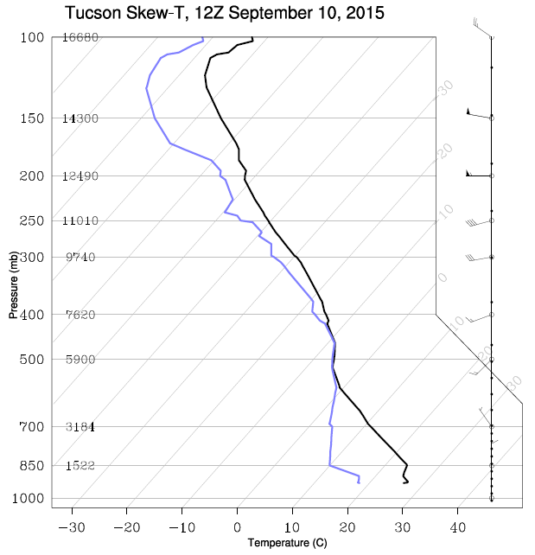

Pressure level (mb) | Altitude above sea level (m) | Air Temperature (°C) | Dew Point Temperature (°C) | Wind Direction | Wind Speed (knots)
200
300
500
700
850 | 1522 | 24 | 10 | North | 10
Ground Level | 751 | 26 | 18 | Not Plotted | Not Plotted

Table for Question 9. Fill in the missing values by reading them from the skew-T diagram (above), which was observed at 12Z on September 10, 2015.

- Consider a beaker that is half full of liquid water and is sealed at the top so that no air can enter or leave the beaker. This is the “closed system” described in the lecture notes. Initially, the temperature of the liquid water and air inside is held at 15° C. After a short time, the water vapor content of the air in the beaker reaches a “dynamic equilibrium” or a state of “saturation”. Explain what is meant by “saturation” and why is it called a “dynamic equilibrium”. Now assume that the temperature of the water and air inside the beaker is warmed up to 30° C. This temporarily causes the system to no longer be in dynamic equilibrium or a state of saturation with respect to water vapor. If the temperature is now held at 30° C, explain how the system will return to a new dynamic equilibrium or state of saturation.

