ATMO 170 Sept. 17, 2015 Name__________________________________
In-class Optional (Extra Credit) Assignment

1. Three of the following would all be located at about the same altitude. Which one is found at considerably higher altitude than the other three?
a. the flat top of a thunderstorm b. the summit of Mt. Everest
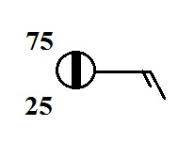
c. a commercial airliner at 30,000 ft. altitude d. the ozone layer

2. According to the information plotted at right,
is MORE or LESS than half of the sky covered with clouds

3. The atmosphere is split into layers (troposphere, stratosphere, mesosphere, etc.) according to how _______ changes with altitude.
a. composition b. density c. pressure d. temperature
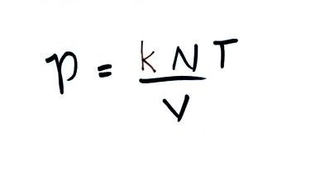
4. If you double the number (N) of air molecules in a balloon,
double the volume (V) of the balloon, and double the temperature (T),
the pressure of the air in the balloon will
a. increase by a factor of 2 b. increase by a factor of 4
c. remain constant d. decrease by a factor of 2
e. decrease by a factor of 4

5. Warming or cooling a parcel of air in the atmosphere will cause _______ and _______ to change. The _______ and _______ remain constant. (fill in the blanks with ρ (density), V (volume, N (number of air molecules), or P (pressure). Each answer should be used once.)

6. The top of an average thunderstorm would be around ____________ kilometers tall
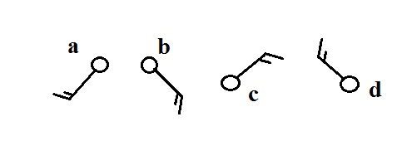
(fill in the blank with 1 10 100 or 1000)

7. Circle the figure at right that shows winds
blowing from the southwest.

8. Are clouds more likely to form when moist air is WARMED or COOLED?
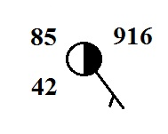
9. Which of the following are not shown at right?
a. relative humidity b. temperature c. pressure
d. dew point e. altitude

10. Would you expect the station pressures measured in Tucson and at the summit of Mt. Lemmon to be nearly EQUAL or very DIFFERENT. Would you expect the sea level pressure estimates for Tucson and Mt. Lemmon to be nearly EQUAL or very DIFFERENT.

