ATMO 170 Oct. 20, 2015
Optional Assignment Answers

Energy balance
1. Here's the original figure
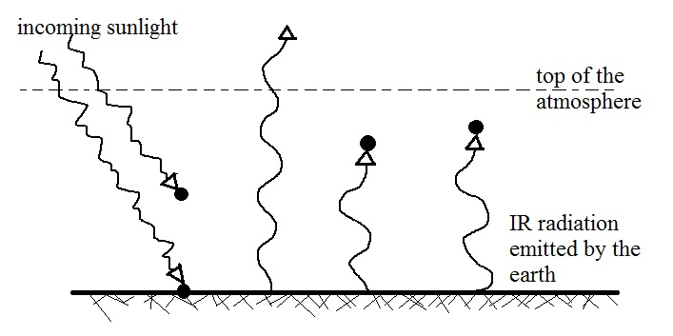

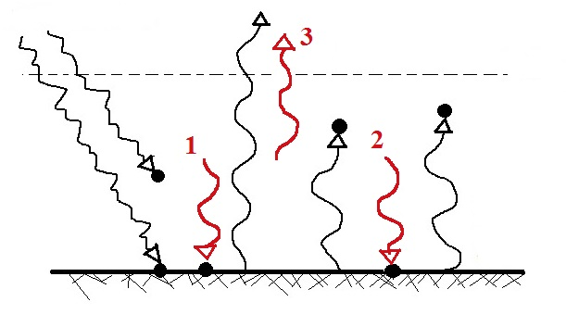
The atmosphere is absorbing 3 arrows (3 units) of energy. To be in energy balance it must also emit 3 arrows. The question is how many to send upward and how many to send downward to the ground.

The 3 arrows emitted by the atmosphere are shown above. Arrows 1 and 2 are sent downward toward the ground. Together with the 1 arrow of sunlight three arrows absorbed by the ground balances the three arrows being emitted by the ground.

The 3rd arrow emitted by the atmosphere is sent upward. Two arrows leaving the earth's atmosphere and going out into space balances the 2 arrows of sunlight arriving and entering the earth's atmosphere
2. The original figure is shown below at left. Two arrows of EM radiation being emitted by the atmosphere have been added to the figure at right and bring the picture into energy balance.

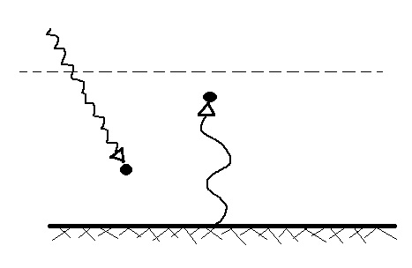 | 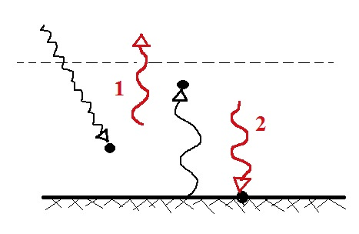

The atmosphere is absorbing 2 arrows of EM radiation and must emit 2 arrows to be in energy balance. We send 1 arrow upward and into space, the other downward to the ground where it is absorbed. This brings the picture into energy balance.

Effects of clouds on daytime high and nighttime low temperatures
1. The daytime high is generally HIGHER LOWER (cooler) the SAME on a cloudy day than(as) it is on a clear day. The nighttime low is generally WARMER COLDER the SAME on a cloudy night than (as) on a clear night.

2. Clouds are good ABSORBERS REFLECTORS of visible light and good ABSORBERS REFLECTORS of far IR light.

Humidity variables
1. A mixing ratio of 6 g/kg means there are 6 grams of ________water vapor__________
mixed in
with 1 kilogram of ____________air (dry air)__________.

2. If you know the air's temperature you can look up the value of the ___b___ in a table.
a. mixing ratio b. saturation mixing ratio c. relative humidity d. dew point
The saturation mixing ratio is the maximum amount of water vapor that can be found in air. It depends on the air's temperature so you would need to look up the value in a table. It tells nothing about how much water vapor is in the air.

3. Adding water vapor to the air will not increase the ___b___.
a. mixing ratio b. saturation mixing ratio c. relative humidity d. dew point
Adding water vapor to air will increase r, RH, and Td.

4. 90º F air can potentially hold ___c___ times as much water vapor as 45º F air (consult the table on p. 86 in the photocopied ClassNotes)
a. 2 b. 4 c. 5 d. 10
1 kg of 90º F air can hold up to 30 grams of water vapor. 45º F could, at most, hold 6 g/kg.

5. To calculate the relative humidity you need to know the ___a___ and the ___b___.
a. mixing ratio b. saturation mixing ratio c. air temperature d. dew point

RH = 100% x (r / r_{S})

6. The value of the _______ will tell you whether moist air is saturated or not.
a. mixing ratio b. saturation mixing ratio c. relative humidity d. dew point

7. Based on the data in the figure below, does the parcel of 70º F air have MORE LESS or the SAME amount of water vapor than(as) the 85º F air?

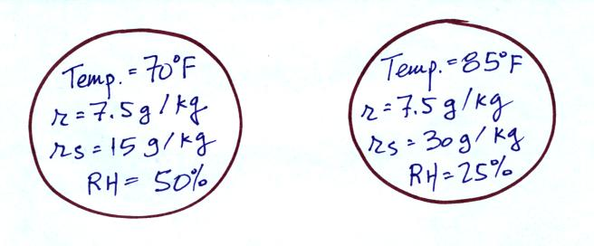

The mixing ratio tells you how much water vapor is actually in the air. The two volumes of air above have the same mixing ratio thus the same amount of water vapor.

8. Which two of the following have the same job, telling you how much water vapor is actually in the air?
a. mixing ratio b. saturation mixing ratio c. relative humidity d. dew point

