ATMO 170 Sect. 3 Name______________________________________
Quiz #4 Dec. 3, 2015 (please also put your name on the back)
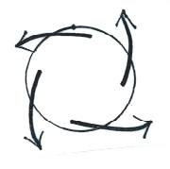
1. (15 pts) The figure at right shows surface winds blowing around a center of
HIGH LOW pressure found in the NORTHERN SOUTHERN hemisphere
Would you expect to find RISING or SINKING air at the center of the picture.

2. (5 pts) Changing wind direction and/or wind speed with distance is called

3. (10 pts) When a hurricane moves onto land, the frictional force will STRENGTHEN WEAKEN and the hurricane winds will blow FASTER SLOWER

4. (5 pts) An ordinary air mass thunderstorm will begin to dissipate when
a. lightning activity begins b. all the cloud particles turn to ice
c. the downdraft cuts off the updraft d. the thunderstorm top reaches the stratosphere

5. (10 pts) A metal car is a SAFE DANGEROUS place to seek shelter during a lightning storm. It is SAFE DANGEROUS to use a cell phone during a lightning storm.
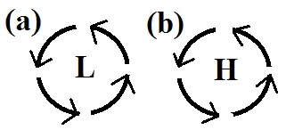
6. (5 pts) The net force exerted on the spinning air in the 2 examples at right is
a. inward in A, outward in B b. inward in both cases
c. in the direction of motion d. zero in both cases

7. (5 pts) The strong ring of thunderstorms surrounding the eye of a hurricane is called the
a. wall cloud b. eye wall c. mesocyclone d. ring cloud

8. (15 pts) The direction of the _______ force is always perpendicular to the wind. The _______ force is always perpendicular to the contours on a weather map. The strength of the _______ force for winds blowing over land will be different from wind blowing over the ocean (fill in the blanks)
a. frictional b. net c. pressure gradient d. Coriolis

9. (10 pts) A narrow intense thunderstorm downdraft is called a MICROBURST MESOCYCLONE. Potentially the strongest and longest lasting thunderstorm is one with a TILTED VERTICAL updraft.

10. (5 pts) "An object in motion tends to stay in motion" as long as no net force is exerted on the object. What type of motion is permitted?
a. it must be in a straight line b. it must be both straight line and constant speed
c. it must be at constant speed d. any type of motion is allowed

11. (5 pts) A(n) ______ is a rise in ocean levels near a coastline caused by an approaching hurricane.
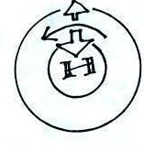
a. storm surge b. riptide c. easterly wave d. tsunami

12. (10 pts) Is the inward pointing force in the figure at right
the PRESSURE GRADIENT or the CORIOLIS force.
Is this a SOUTHERN or NORTHERN hemisphere map.
Name______________________________________

13. (5 pts) The front edge of the cold downdraft air moving outward at the ground below a thunderstorm is called a
a. gust front b. thermal circulation c. dry line d. mesocyclone

14. (5 pts) Which of the following creates the electricity in thunderstorms needed for lightning?
a. ultraviolet light b. collisions between precipitation particles c. wind shear
d. condensation and evaporation e. St. Elmo's fire f. expanding air
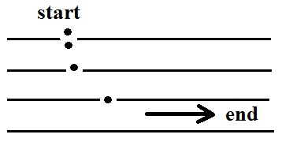
15. (10 pts) Stationary air begins to move as shown by the dots in the figure at right. From this initial motion you can say that low pressure is found at the TOP RIGHT BOTTOM LEFT side of the figure. The bending that occurs once the air is moving tells you this is a NORTHERN SOUTHERN hemisphere chart.

16. (5 pts) The _______scale is used to rate hurricane strength or intensity
a. Beaufort b. Fujita c. Kelvin d. Richter e. Saffir-Simpson

17. (10 pts) Which two of the following would be the best indicators of a thunderstorm with a rotating updraft?
a. gust front b. anvil cloud c. wall cloud d. hook echo e. mammatus cloud f. microburst

18. (5 pts) There is no _______ force at the equator.
a. Coriolis b. pressure gradient c. frictional d. gravitational

19. (15 pts) Is intracloud lightning MORE or LESS common than cloud-to-ground lightning? Is the top of a thunderstorm normally POSITIVELY or NEGATIVELY charged? Is the stepped leader the LAST or FIRST process in a normal cloud-to-ground lightning stroke?

20. (5 pts) The 1st law of motion that we have been using in this course was formulated by
a. Einstein b. Foucault c. Coriolis d. Galileo e. Newton

21. (15 pts) Tornado winds always spin around a center of LOW HIGH pressure. Are the winds in most tornadoes MORE or LESS than 100 MPH? Do the strongest tornadoes occur in the SPRING SUMMER WINTER or FALL.

Extra Credit (you can earn up to 10 pts)
1. (6 pts) Evaporating precipitation beneath a thunderstorm would WARM COOL the air and STRENGTHEN WEAKEN a thunderstorm downdraft.

2. (5 pts) A delay of 5 seconds between the flash of light from lightning and the sound of the thunder means the strike was about _______ mile(s) away.
a. 1 b. 3 c. 5 d. 10 e. 15

3. (5 pts) There are about _______ tornadoes per year in the United States.
a. 10 b. 100 c. 1000 d. 10,000 e. 100,000

