ATMO 170 Sect. 3 Name______________________________________
Quiz #3 Nov. 5, 2015 (please also put your name on the back)

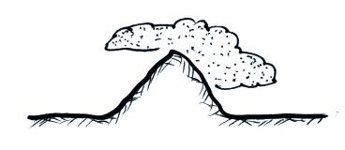
1. (15 pts) If you warm moist air but don't add any moisture the relative humidity will _______, the dew point will_______, and the saturation mixing ratio will _______. (fill in each blank with INCRease, DECRease, or remain the SAME)

2. (10 pts) Based on the figure it appears that rising air would be
found on the LEFT RIGHT side of the figure. A rain shadow
would be found on the LEFT RIGHT side of the mountain.

3. (5 pts) Are sundogs and haloes produced when sunlight passes through a cloud of
SMOKE particles WATER droplets or ICE crystals.

4. (5 pts) What is the "key word" used to identify a cloud that is producing precipitation?

5. (20 pts) _______ is a high altitude cloud with a patchy appearance. _______ is a middle altitude cloud. _______ is another name for a thunderstorm. A lumpy layer cloud found at low altitude would be called _______. Haloes are a pretty good indication that _______ clouds are overhead. (fill in the blanks, each answer below should be used once)
a. altostratus b. stratocumulus c. cirrostratus d. cumulonimbus e. cirrocumulus
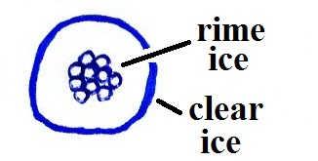
6. (5 pts) The precipitation particle sketch at right is
a. snow b. graupel c. sleet d. hail

7. (5 pts) Cold air that is brought indoors in the winter and heated will often have a very LOW HIGH relative humidity

8. (10 pts) The actual amount of water vapor in the air A B
in City A at right is GREATER LESS than in City B. Tair = 80º F Tair = 60º F
The relative humidity of the air in City A is GREATER Td = 60º F Td = 50º F
LESS than in City B.

9. (10 pts) STRATIFORM CUMULIFORM clouds grow horizontally which indicates that the atmosphere is STABLE UNSTABLE.

10. (10 pts) Does rime ice have a CLEAR or a MILKY WHITE appearance?
Is GRAUPEL or SLEET composed of rime ice?

11. (5 pts) Determine the relative humidity of air that has a temperature of 75º F, a pressure of 1010 mb, a mixing ratio of 5 g/kg, a dew point temperature of 25º F, and a saturation mixing ratio of 20 g/kg.
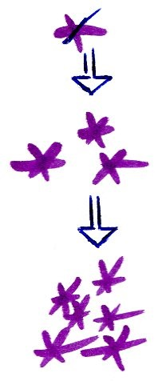

12. (5 pts) The figure at right with snow crystals that are colliding and sticking
together shows the formation of _______.
a. snow b. graupel c. sleet d. hail
Name______________________________________

13. (5 pts) The largest percentage of the sunlight arriving at the top of the atmosphere
a. passes through the air and gets absorbed by the ground b. is absorbed by ozone
c. is absorbed by greenhouse gases d. is reflected back into space

14. (15 pts) Rain which evaporates before reaching the ground is _______. Snow that melts before reaching the ground is _______. Rain that freezes before reaching the ground is _______. (fill in the blanks)
a. hail b. rain c. sleet d. snow e. virga f. graupel

15. (5 pts) Warm air will always have a higher _______ than cool air.
a. saturation mixing ratio b. relative humidity c. dew point d. mixing ratio
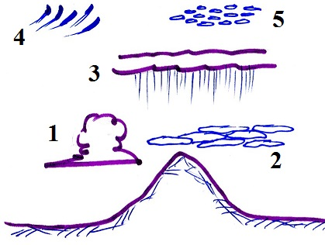
16. (10 pts) Cloud 1 in the figure is a _______ cloud. Cloud 3
is a _______ cloud. (fill in the blanks)
a. nimbostratus b. cumulus c. cirrus
d. cirrocumulus e. stratocumulus f. stratus

17. (10 pts) It is generally COLDER WARMER on a cloudy night
than on a clear night because clouds are good absorbers of INFRARED VISIBLE light.

18. (15 pts) Which three of the following are true? (IC= ice crystal, CC=collision-coalescence)
a. water droplets are only found in clouds at temperatures warmer than freezing
b. condensation nuclei are more abundant in air than ice crystal nuclei
c. the IC process can produce larger precipitation particles than the CC process.
d. in Tucson the IC process produces winter rain, the CC summer precipitation
e. the CC process works best when the cloud droplets are all the same size.
f. both the IC process and the CC process can produce rain.

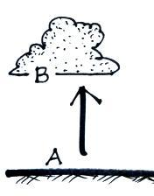
19. (10 pts) When the cork popped out during the cloud in a bottle demonstration, the sudden expansion caused the moist air in the bottle to COOL WARM and a cloud formed. Was the best (most visible) cloud produced when the air in the flask was CLEAN or filled with SMOKE?

Extra Credit (you can earn up to 10 pts)
1. (5 pts) As moist air rises from A to B in the figure at right the _______ will increase.
a. mixing ratio b. relative humidity c. saturation mixing ratio d. dew point

2. (5 pts) Which of the following would cause moisture to be removed from air with a temperature of 75º F and a dew point of 55º F?
a. cooling the air to 65º F b. cooling the air to 45º F c. warming the air to 85º F

3. (6 pts) Hail would never fall from a CUMULONIMBUS NIMBOSTRATUS
cloud because the updrafts are too STRONG WEAK.

