ATMO 170 Sect. 3 Name_____________________________________
Quiz #2 Oct. 15, 2015 (please also put your name on the back)

1. (10 pts) Adding energy to an object with LARGE SMALL mass and HIGH LOW specific heat would result in the smallest temperature change.

2. (5 pts) Which of the following is an example of deposition?
a. cold air sinking near dry ice b. drops of water on a cold can
c. formation of frost d. steam above a pot of boiling water

3. (5 pts) If an object warms the _______ will decrease.
a. wavelength of peak emission b. speed of propagation
c. intensity of emitted radiation d. radiative equilibrium temperature

4. (5 pts) The wavelength of peak emission (λ_{max}) for a tungsten light bulb is 1 µm. Is this INFRARED VISIBLE or ULTRAVIOLET light.

5. (15 pts) Greenhouse gases absorb and emit _______ light. Ozone and oxygen make the atmosphere pretty nearly completely opaque to _______ light. Air is mostly nitrogen & oxygen which are largely transparent to _______ light. [fill in each blank with VIS(visible), UV(ultraviolet) or IR(infrared) ]

6. (10 pts) Is the driest air usually found AHEAD of or BEHIND a cold front? Would winds blowing from the northwest most likely be found AHEAD of or BEHIND a cold front?

7. (5 pts) The Stefan Boltzmann law (E = σ T⁴) tells you the
a. amount of energy emitted by an object b. specific heat of an object
c. energy needed to melt an object d. average speed of the atoms in an object

8. (10 pts) Everything else being equal, the coldest winter temperatures would be found at a location surrounded by OCEAN LAND. The smallest difference between the summertime high and wintertime low temperatures would be found at a location surrounded by OCEAN LAND.

9. (5 pts) When water freezes it releases
a. specific heat b. kinetic energy c. IR radiation d. latent heat
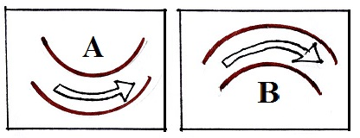
10. (10 pts) Does Figure A at right show an upper level RIDGE
or TROUGH. Would you expect the air in Figure A to be
WARMER or COLDER than average?

11. (5 pts) A thermometer outdoors reads 35º F on a day when the winds are calm. If the wind starts to blow will the temperature reading INCREASE DECREASE or remain the SAME

12. (15 pts) The figure shows both a crossectional view
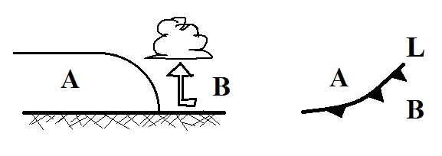
and a map view of a COLD WARM front. Is the
coldest air found at POINT A or POINT B? Is
the front moving toward POINT A or POINT B?

Name_________________________________________

13. (5 pts) The wavelength of peak emission for _______ falls in the visible part of the spectrum.
a. the sun b. the earth c. both the earth and sun d. neither the earth nor sun

14. (5 pts) An object at room temperature that feels cold to the touch probably has
a. high specific heat b. high thermal conductivity c. high latent heat
d. low specific heat e. low thermal conducitivity f. low latent heat

15. (5 pts) In order for an object to be in radiative equilibrium the emitted energy must be _______ as the energy absorbed.
a. the same amount b. the same kind c. both the same amount & the same kind

16. (10 pts) _______ is the coldest temperature. _______ is the hottest temperature (fill in the blanks)
a. 300º K b. 200º F c. 100º C d. 100º F e. 0º C f. 0º F

17. (5 pts) Which of the following plays the most important role in the greenhouse effect?
a. reflection of incoming sunlight by clouds b. absorption of UV light by gases in the stratosphere
c. absorption & emission of IR light by the atmosphere d. high specific heat of water

18. (10 pts) A thin layer of air in contact with hot ground will warm by _______. Once the air becomes warm it will start to rise and transport energy upward by _______. (fill in the blanks)
a. conduction b. convergence c. convection d. latent heat

19. (10 pts) Compared to visible light, infrared light has LONGER SHORTER wavelength and HIGHER LOWER energy.

20. (5 pts) Temperatures never go below zero on the ____________________ scale.

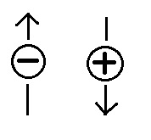
21. (10 pts) Liquid nitrogen (LN₂) is very cold. If you pour LN₂ into a cup and leave it in a warm room it will SUBLIMATE EVAPORATE CONDENSE FREEZE. As it changes phase does the LN₂ TAKE energy from or RELEASE energy into the surrounding air.

22. (5 pts) Based on the motions of the charges at right could you say the electric
field arrow points UPWARD, points DOWNWARD, or is ZERO?

Extra Credit (you can earn up to 10 pts)
1. (5 pts) The earth reflects about 30% of the sunlight striking it. If this increased to 40% would the earth's temperature of radiative equilibrium INCREASE DECREASE or REMAIN the same?

2. (5 pts) If you add one _________________________ of energy to 1 gram of water, the water's temperature will rise 1º C.

3. (5 pts) _______ will cause air to rise.
a. Cold fronts only b. Warm fronts only c. Both warm and cold fronts
The following equations can be used on this quiz:

