ATMO 170 Sect. 2 Name______________________________________
Quiz #3 Nov. 5, 2015

1. (20 pts) _______ is a high altitude cloud with a filamentary appearance. _______ is a middle altitude cloud with rain or snow. _______ is another name for a thunderstorm. A halo is a pretty sure indication that a _______ cloud is overhead. A lumpy low level layer cloud would be called _______. (fill in the blanks, each answer below should be used once)
a. cirrus b. nimbostratus c. stratocumulus d. cirrostratus e. cumulonimbus

2. (15 pts) Which three of the following are true?
(CC = collision coalescence, IC = ice crystal, Ns = nimbostratus, Cb = cumulonimbus)
a. when snow crystals break into pieces the amount of precipitation falling from a cloud will decrease
b. both the IC process and the CC process can produce rain
c. the IC process can produce larger precipitation particles than the CC process.
d. The CC process only works in Ns clouds, the IC process only works in Cb clouds.
e. Water droplets and ice crystals can be found together in clouds at below freezing temperatures
f. The CC process works best when the water droplets in a cloud all have the same size

3. (10 pts) Clouds are good ABSORBERS REFLECTORS of infrared light. This explains why it is WARMER COLDER on a cloudy night than on a clear night.

4. (10 pts) Sleet forms when rain falls into _______. Virga forms when rain falls into _______ .
a. moist air b. warm air c. dry air d. cold air

5. (5 pts) Foggy conditions outside would mean the _______ is high.
a. relative humidity b. dew point c. mixing ratio d. saturation mixing ratio

6. (5 pts) Which of the following would cause moisture to be removed from air with a temperature of 75º F and a dew point of 55º F?
a. cooling the air to 65º F b. cooling the air to 45º F c. warming the air to 85º F

7. (10 pts) Stratiform clouds form when the atmosphere is STABLE UNSTABLE and mainly grow in a HORIZONTAL VERTICAL direction

8. (5 pts) In order to cause the relative humidity
to increase to 100% you must cool the air to the _________________________.
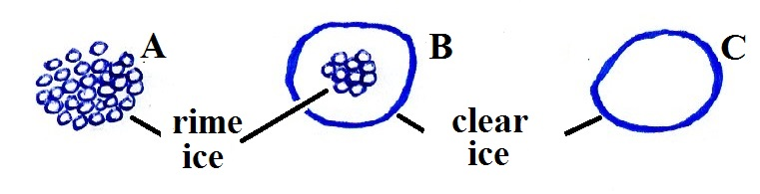
9. (10 pts) Particle _______ at right is sleet and
_______ is hail. (fill in the blanks)

10. (5 pts) Are sundogs and haloes produced when sunlight passes through a cloud of SMOKE particles WATER droplets or ICE crystals.

11. (10 pts) The term rain shadow refers to the conditions on the
DRY WET side of the mountain in the picture at right. Rising
air motions would be found on the DRY WET side of the mountain.
Name______________________________________

12. (5 pts) The words cirro and alto tell you something about cloud ALTITUDE APPEARANCE

13. (10 pts) A falling snowflake that first melts then evaporates before reaching the ground would be called _______. An "ice storm" is caused by _______. (fill in the blanks)
a. snow b. sleet c. freezing rain d. virga e. hail

14. (5 pts) Determine the relative humidity on a day when the temperature is 80º F, the dew point is 50º F, the mixing ratio is 10 g/kg, the air pressure is 1000 mb, the saturation mixing ratio is 25 g/kg.


15. (5 pts) A falling snow crystal is colliding with supercooled water
droplets which stick and freeze to the crystal. This is how _______ forms.
a. snow b. sleet c. graupel d. hail

16. (10 pts) Did a cloud form in the cloud in a bottle demonstration when the air EXPANDED and cooled or when the air was COMPRESSED and warmed? Was the best cloud observed when there were a LOT or relatively FEW condensation nuclei in the air.

17. (5 pts) On average about _______ of the sunlight arriving at the top reaches the ground.
a. 10% b. 25% c. 50% d. 75% e. 90% f. 100%

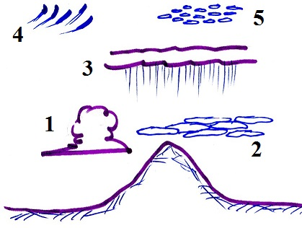
18. (5 pts) When the relative humidity increases and dry haze becomes wet haze will the visibility IMPROVE stay the SAME or WORSEN?

19. (10 pts) Cloud 1 in the figure is a _______ cloud. Cloud 3
is a _______ cloud. (fill in the blanks)
a. nimbostratus b. cumulus c. cirrus
d. cirrocumulus e. stratocumulus f. stratus

20. (15 pts) If you warm moist air but don't add any water vapor the mixing ratio will __________, the dew point temperature will __________ and the relative humidity will _______. (fill in each blank with INCRease, DECRease, or remain the SAME)

Extra credit (you can earn up to 10 pts)
1. (5 pts) It takes _______20 µm diameter cloud droplets to make one 2000 µm raindrop.
a. 100 b. 1000 c. 10,000 d. 100,000 e. 1,000,000

2. (6 pts) Hail would never fall from a NIMBOSTRATUS CUMULONIMBUS cloud because the updrafts are too STRONG WEAK

3. (5 pts) Grams per kilogram are the units of
a. air density b. dew point c. mixing ratio d. relative humidity

