ATMO 170 Sept. 30, 2014 Name____________Answers_______________
In Class Assignment

1. A whole bunch of temperature data are shown below. 40º F, 50ºF, and 60º F isotherms are drawn in. Note how the 50º F and the 60º F isotherms pass through one of the plotted points.
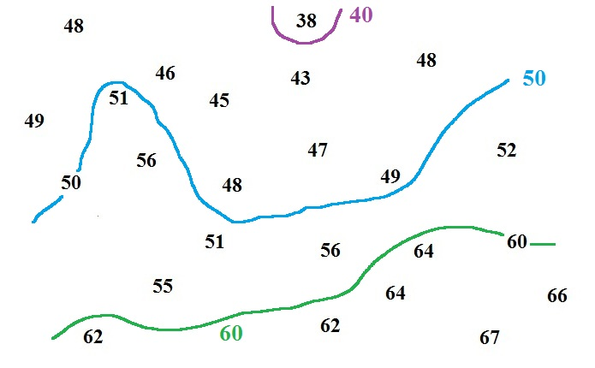

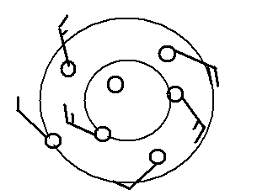

2. Does the figure at right show winds blowing in a CLOCKWISE or COUNTERCLOCKWISE direction? Are the winds CONVERGING
or DIVERGING?

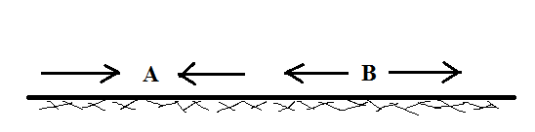
3. Do you see converging surface winds at
POINT A or at POINT B in the figure
at right. Would clouds be more likely to
form above POINT A or POINT B?
Convergence at Pt. 1 will cause rising air motions. Rising air expands and cools. If the air cools enough (to or below the dew point) cloud will form

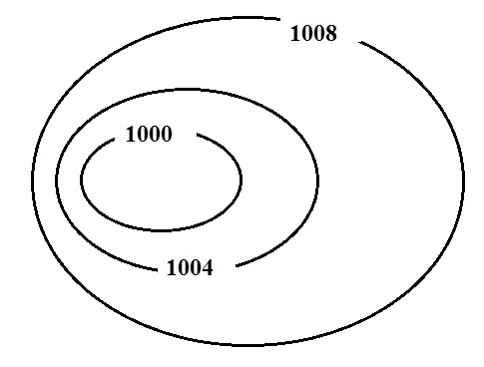

4. Which of the following would be true on a surface
weather map where the isobars are tightly spaced.
(more than one answer)
a. high pressure b. fast winds c. cold winds
d. weak pressure gradient e. slow winds
f. warm winds g. low pressure
h. dry winds i. strong pressure gradient j. moist winds
Answers (b) and (i) would be true regardless of whether this was high or low pressure. The drawing does show a center of low pressure. This may have led some students to also circle (i). The winds on the left hand side of the picture would be coming from the northwest and would be cold. Thus several students also circled (c).

