Atmo 170A1 Name_______________________________
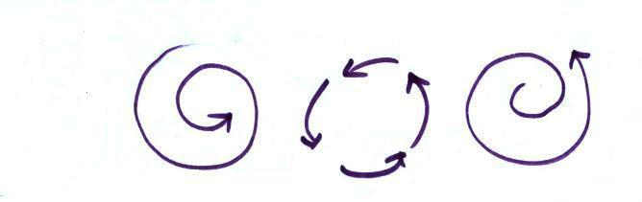
InClass Optional Assignment

1.

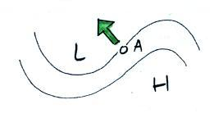
For the 3 types of motion shown above indicate whether the net force is Inward, Outward, or Zero. The force would be INWARD in all three cases. Just the right amount of inward force is being exerted in the middle picture. A little too much inward force is present in the left picture and a not quite enough inward force is being exerted in the figure at right.

2.

With an arrow show the direction of the PGF at Point A. The PGF must be perpendicular to the contours and point toward low pressure. Many people make the mistake of drawing the arrow pointing left straight at the L, but the arrow isn’t perpendicular to the contours in that case.
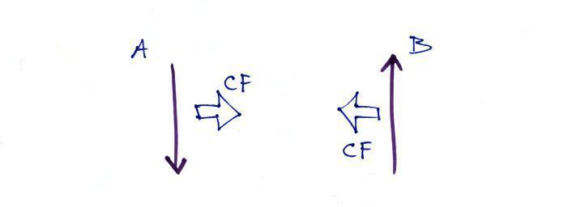
3.

Which of these shows winds blowing in the northern hemisphere? (A, B, Both or Neither) The CF is perpendicular and to the left of the wind in both cases (be sure to turn the page so that you’re looking in the direction the wind is blowing with A). That means these are both southern hemisphere winds.

4.

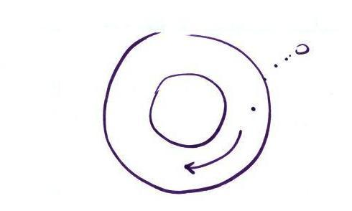

Based on the direction of the initial motion you can say this is a center of HIGH LOW pressure in the NORTHERN SOUTHERN hemisphere.
A rock will always start to roll downhill (toward low altitude). Stationary air will always start to move toward low pressure (in the direction of the PGF which always points toward low pressure). Once the air starts to move it takes a turn to the left. This is caused by the CF which is acting to the left of the wind indicating these are southern hemisphere winds.
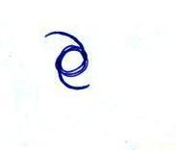
5. Does the symbol at right indicate a NORTHERN or SOUTHERN
hemisphere HURRICANE or TROPICAL STORM. Would you
expect this storm to moving toward the EAST or WEST?
The symbol for a hurricane would be darkened in. The spiral arms on this symbol indicate the winds are spinning in a clockwise direction. Since tropical storms and hurricanes have low pressure cores this must be a southern hemisphere tropical storm. Tropical cyclones move from east to west.

