Mon., Sep. 10, 2012
A couple of songs from one of my favorite local groups: Calexico. I played "Quattro (World Drifts In)" and most of "Alone Again Or". You'll need to come to the T Th 8 am class tomorrow if you want to hear "Ballad of Cable Hogue".
The first set of 1S1P reports was collected today. It usually takes some time to get all of these graded. I will try not to make a new assignment until you get at least one of your reports back.
The first Optional Assignment is due at the start of class on Friday. There's a good chance that there will be an In-class Optional Assignment Wednesday or Friday this week.
Today was the "last call" for Expt. #1. If you didn't pick up materials you'll need to try to do Expt. #2 or Expt #3.

We've spent the last couple of classes looking at air pressure and how it changes with altitude. Today we'll consider air density and air temperature.
How does air density change with increasing altitude? You should know the answer to that question. You get out of breathe more easily at high altitude than at sea level. Air gets thinner (less dense) at higher altitude. A lungful of air at high altitude just doesn't contain as much oxygen as at lower altitude or at sea level.
Because air is compressible, a stack of mattresses might be a more realistic representation of layers of air than a pile of bricks.

Four mattresses are stacked on top of each other. Mattresses are reasonably heavy, the mattress at the bottom of the pile is compressed by the weight of the three mattresses above. This is shown at right. The mattresses higher up aren't squished as much because their is less weight remaining above. The same is true with layers of air in the atmosphere.

The statement above is at the top of p. 34 in the photocopied ClassNotes. I've redrawn the figure found at the bottom of p. 34 below.

There's a lot of information in this figure and it is worth spending a minute or two looking at it and thinking about it.
1. You can first notice and remember that pressure decreases with increasing altitude. 1000 mb at the bottom decreases to 700 mb at the top of the picture. You should be able to explain why this happens.
2. Each layer of air contain the same amount (mass) of air. This is a fairly subtle point. You can tell because the pressure drops by 100 mb as you move upward through each layer. Pressure depends on weight. So if all the pressure changes are equal, the weights of each of the layers must be the same. Each of the layers must contain the same amount (mass) of air (each layer contains 10% of the air in the atmosphere).
3. The densest air is found at the bottom of the picture. The bottom layer is compressed the most because it is supporting the weight of all of the rest of the atmosphere. It is the thinnest layer in the picture and the layer with the smallest volume. Since each layer has the same amount of air (same mass) and the bottom layer has the smallest volume it must have the highest density. The top layer has the same amount of air but about twice the volume. It therefore has a lower density (half the density of the air at sea level). Density is decreasing with increasing altitude.
4. Finally pressure is decreasing most rapidly with increasing altitude in the densest air in the bottom layer. This is something we covered just before the Practice Quiz last Wednesday.

What happens to air temperature with increasing altitude. Again our personal experience is that it decrreases with increasing altitude. It is colder at the top of Mt. Lemmon than it is here in the Tucson valley.
That is true up to an altitude of about 10 km (about 30,000 ft.). People were very surprised in the early 1900s when they used balloons to carry instruments above 10 km and found that temperature stopped decreased and even began to increase with increasing altitude.
The figures below are more clearly drawn versions of what was done in class.

The atmosphere can be split into layers depending on whether temperature is increasing or decreasing with increasing altitude. The two lowest layers are shown in the figure above. There are additional layers (the mesosphere and the thermosphere) above 50 km but we won't worry about them in this class.
1. We live in the troposphere. The troposphere is found, on average, between 0 and about 10 km altitude, and is where temperature usually decreases with increasing altitude. [the troposphere is usually a little higher in the tropics and lower at polar latitudes]
The troposphere contains most of the water vapor in the atmosphere (the water vapor comes from evaporation of ocean water and then gets mixed throughout the troposphere by up and down air motions) and is where most of the clouds and weather occurs. The troposphere can be stable or unstable (tropo means "to turn over" and refers to the fact that air can move up and down in the troposphere).
2a. The thunderstorm shown in the figure with its strong updrafts and downdrafts indicates unstable conditions. When the thunderstorm reaches the top of the troposphere, it runs into the bottom of the stratosphere which is a very stable layer. The air can't continue to rise into the stratosphere so the cloud flattens out and forms an anvil (anvil is the name given to the flat top of the thunderstorm). The flat anvil top is something that you can go outside and see and often marks the top of the troposphere.
2b. The summit of Mt. Everest is a little over 29,000 ft. tall and is close to the average height of the top of the troposphere.
2c. Cruising altitude in a passenger jet is usually between 30,000 and 40,000, near or just above the top of the troposphere, and at the bottom of the stratosphere. The next time you're in an airplane try to look up at the sky above. There's less air and less scattering of light. As a result the sky is a darker blue. If you got high enough the sky would eventually become black.
3. Temperature remains constant between 10 and 20 km and then increases with increasing altitude between 20 and 50 km. These two sections form the stratosphere. The stratosphere is a very stable air layer. Increasing temperature with increasing altitude is called an inversion. This is what makes the stratosphere so stable.
4. A kilometer is one thousand meters. Since 1 meter is about 3 feet, 10 km is about 30,000 feet. There are 5280 feet in a mile so this is about 6 miles (about is usually close enough in this class).
5. The ozone layer is found in the stratosphere. Peak ozone concentrations occur near 25 km altitude.
Here's the same picture drawn again (for clarity) with some additional information. We need to explain why when temperature decreases all the way up to the top of the troposphere, it can start increasing again in the stratosphere.
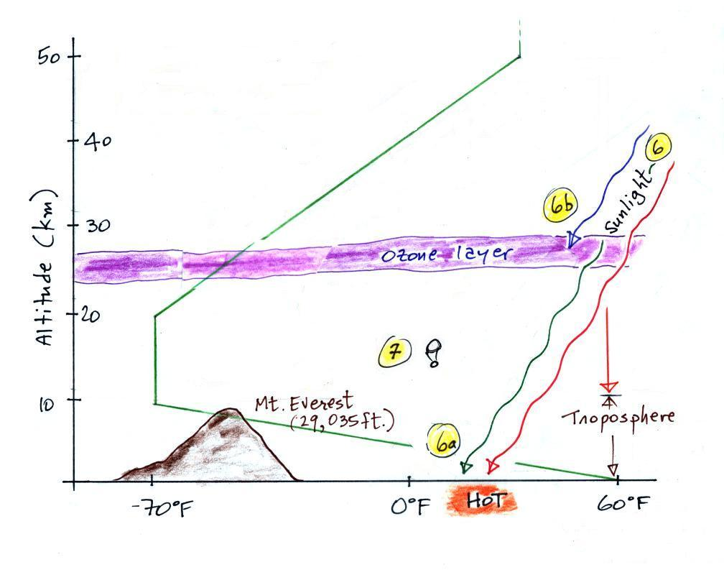
6. Sunlight is a mixture of ultraviolet (7%), visible (44%, colored green in the picture above) and infrared light (49%, colored red). We can see the visible light.
6a. On average about 50% of the sunlight arriving at the top of the atmosphere passes through the atmosphere and is absorbed at the ground (20% is absorbed by gases in the air, 30% is reflected back into space). This warms the ground. The air in contact with the ground is warmer than air just above. As you get further and further from the warm ground, the air is colder and colder. This explains why air temperature decreases with increasing altitude in the troposphere.
5b. How do you explain increasing temperature with increasing altitude in the stratosphere?
Absorption of ultraviolet light by ozone warms the air in the stratosphere and explains why the air can warm (oxygen also absorbs UV light). The air in the stratosphere is much less dense (thinner) than in the troposphere. So even though there is not very much UV light in sunlight, it doesn't take as much energy to warm this thin air as it would to warm denser air closer to the ground.
7. That's a manned balloon; Auguste Piccard and Paul Kipfer are inside. They were the first men to travel into the stratosphere (see pps 31 & 32 in the photocopied Class Notes). It really was quite a daring trip at the time at the time, and they very nearly didn't survive it. More about this in the next section.

Pages 31 and 32 in the ClassNotes list some of the significant events in the early study and exploration of the atmosphere. A few of them are included below.

Galileo's experiment that proved that air had weight was mentioned earlier in the online notes. The mercury barometer was invented in 1643.

The earliest balloon trips into the upper atmosphere were in unheated and unpressurized gondolas. Climbers have made it to the summit of Mt. Everest without carrying supplementary oxygen but it is difficult and requires acclimation. Read "Into Thin Air" by Jon Krakauer if you'd like to get some idea of what it's like trying to climb Mt. Everest.

Measurements of air temperature at high altitude in unmanned balloons lead to the discovery of the stratosphere in about 1900.

Capt. Grey was mentioned early in the video segment shown in class. Note the clothing he had to wear to try to stay warm. All of his trips were in an unpressurized open gondola.

This flight lead by Auguste Piccard was the subject of the video segment shown in class (from a PBS program called The Adventurers).
Jacques Piccard, Auguste's son, was in the video. He would later travel with Lt. Don Walsh of the US Navy to a depth of about 35,800 feet in the ocean in the Mariana Trench.
Bertrand Piccard, Jacques son was part of the first two man team to circle the globe non-stop in a balloon.

Coming on Wednesday. We'll spend a big part of the period trying to answer the following question.

