Monday Oct. 15, 2012
"Sometimes" from the Punch Brothers was the first song you heard today (here's a live version). After that you heard part of "Movement and Location".
The In-class Optional Assignment from last Friday was returned in class today. Everyone earned at least 0.1 extra credit points. Only a handful of students received full credit (0.2 pts of extra credit). You were supposed to bring the picture shown below at left into energy balance.
We now have a preceptor for this class, Nicole Venn. She has taken the class and already served once as a Preceptor. You'll find contact information on the class home page.
The Scientific Paper option is now open for students that don't want to do either an Experiment or Book report. The Scientific Paper reports are due by Monday, Nov. 5.
Two of the three 1S1P Assignment #2 reports are due Wednesday this week. The 3rd topic isn't due until next Wednesday.
Hurricane Paul is moving northward along the coast of Baja California. The clouds in the sky today are from that hurricane. There is a chance that it might bring some moisture and showers to S. Arizona later this week. You can get the latest information from the National Hurricane Center (www.nhc.noaa.gov).
And finally, something that I didn't mention in class. I am working hard to finish grading the Experiment #2 reports so that I can put all the grades into my computer and printout midterm grade summaries. I am hoping to have them ready to handout on Friday this week.

Next we used our simplified representation of the greenhouse effect to understand the effects of clouds on daytime high and nighttime low temperatures. The following can be found on pps. 72a & 72b in the ClassNotes (I've rearranged things slightly to try to make it clearer)

Here's the simplified picture of radiative equilibrium again (you're probably getting pretty tired of seeing this). You should be able to say something about every arrow in the picture. The two pictures below show what happens at night when you remove the two green rays of incoming sunlight.

The picture on the left shows a clear night. The ground is losing 3 arrows of energy and getting one back from the atmosphere. That's a net loss of 2 arrows. The ground cools rapidly and gets cold during the night.
A cloudy night is shown at right. Notice the effect of the clouds. Clouds are good absorbers of infrared radiation. If we could see IR light, clouds would appear black, very different from what we are used to (because clouds also emit IR light, if we could see IR light the clouds might also glow). Now none of the IR radiation emitted by the ground passes through the atmosphere into space. It is all absorbed either by greenhouse gases or by the clouds. Because the clouds and atmosphere are now absorbing 3 units of radiation they must emit 3 units: 1 goes upward into space, the other 2 downward to the ground. There is now a net loss at the ground of only 1 arrow.
The ground won't cool as quickly and won't get as cold on a cloudy night as it does on a clear night. That makes for somewhat warmer early morning bicycle rides this time of the year.
The next two figures compare clear and cloudy days.

Clouds are good reflectors of visible light (we see visible light and clouds appear white). The effect of this is to reduce the amount of sunlight energy reaching the ground in the right picture. With less sunlight being absorbed at the ground, the ground doesn't need to get as warm to be in energy balance.
It is generally cooler during the day on a cloudy day than on a clear day.
Clouds raise the nighttime minimum temperature and lower the daytime maximum temperature. Here are some typical daytime high and nighttime low temperature values on clear and cloudy days for this time of the year.

We'll use our simplified representation of radiative equilibrium to understand enhancement of the greenhouse effect and global warming.

The figure (p. 72c in the photocopied Class Notes) on the left shows energy balance on the earth without an atmosphere (or with an atmosphere that doesn't contain greenhouse gases). The ground achieves energy balance by emitting only 2 units of energy to balance out what it is getting from the sun. The ground wouldn't need to be very warm to do this.
If you add an atmosphere and greenhouse gases, the atmosphere will begin to absorb some of the outgoing IR radiation. The atmosphere will also begin to emit IR radiation, upward into space and downard toward the ground. After a period of adjustment you end up with a new energy balance. The ground is warmer and is now emitting 3 units of energy even though it is only getting 2 units from the sun. It can do this because it gets a unit of energy from the atmosphere. This is what I refer to as the beneficial greenhouse effect. It makes the earth more habitable (average surface temperature of 60 F versus about 0 F without a greenhouse effect).
In the right figure the concentration of greenhouse gases has increased even more (due to human activities). The earth would find a new energy balance. In this case the ground would be warmer and would be emitting 4 units of energy, but still only getting 2 units from the sun. With more greenhouse gases, the atmosphere is now able to absorb 3 units of the IR emitted by the ground. The atmosphere sends 2 back to the ground and 1 up into space.
The next figure shows a common misconception about the cause of global warming.

Many people know that sunlight contains UV light and that the ozone absorbs much of this dangerous type of high energy radiation. People also know that release of chemicals such as CFCs are destroying stratospheric ozone and letting some of this UV light reach the ground. That is all correct.
They then conclude that it is this additional UV energy reaching the ground that is causing the globe to warm. This is not correct. There isn't much (about 7%) UV light in sunlight in the first place and the small amount of additional UV light reaching the ground won't be enough to cause global warming. It will cause cataracts and skin cancer and those kinds of problems but not global warming.
If all of the UV light in sunlight were to reach the ground it probably would cause some warming. But it probably wouldn't matter because some of the shortest wavelength and most energetic forms of UV light would probably kill us and most other forms of life on earth.

We spent the remainder of the class period on an introduction to the next major topic we will be covering: humidity (moisture in the air). This topic and the terms that we will be learning and using can be confusing. That's the reason for this introduction. We will be mainly be interested in 4 variables:

Our first job will be to figure out what their "jobs" are and what can cause them to change value. What follows is a pretty detailed explanation of what will initially be confusing.
Mixing ratio tells you how much water vapor is actually in the air. You can think of it as just a number: when the value is large there's more water vapor in the air than when the value is small. But it's not a difficult concept to grasp. Mixing ratio has units of grams of water vapor per kilogram of dry air (the amount of water vapor in grams mixed with a kilogram of dry air). It's basically the same idea as teaspoons of sugar mixed in a cup of tea.

The value of the mixing ratio won't change unless you add water vapor to or remove water vapor from the air. Warming the air won't change the mixing ratio. Cooling the air won't change the mixing ratio (unless the air is cooled below its dew point temperature and water vapor starts to condense). Since the mixing ratio's job is to tell you how much water vapor is in the air, you don't want it to change unless water vapor is actually added to or removed from the air.

Saturation mixing ratio is just an upper limit to how much water vapor can be found in air, the air's capacity for water vapor. It's a property of air and depends on the air's temperature; warm air can potentially hold more water vapor than cold air. It doesn't say anything about how much water vapor is actually in the air (that's the mixing ratio's job). This variable has the same units: grams of water vapor per kilogram of dry air. Saturation mixing ratio values for different air temperatures are listed and graphed on p. 86 in the photocopied class notes.
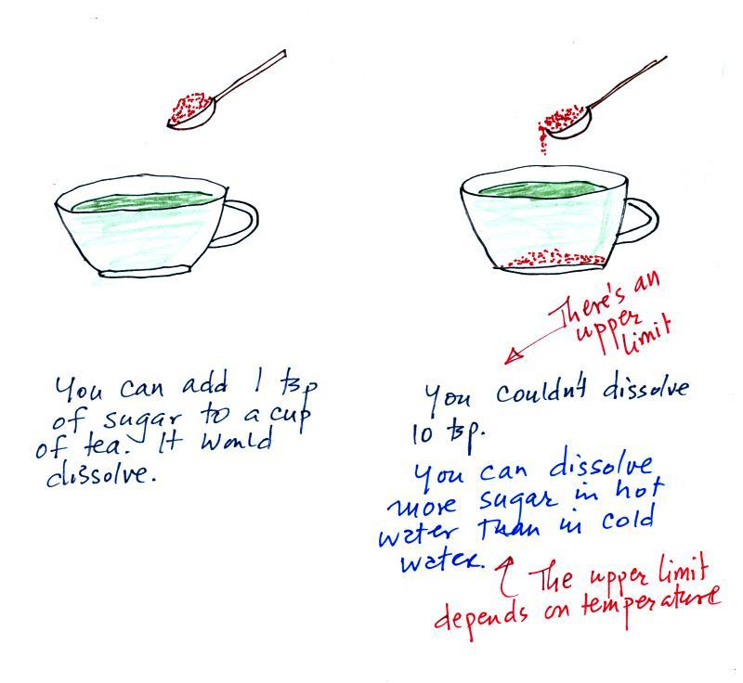
The sugar dissolved in tea analogy is still helpful. Just as is the case with water vapor in air, there's a limit to how much sugar can be dissolved in a cup of hot water. You can dissolve more sugar in hot water than in cold water.
The dependence of saturation mixing ratio on air temperature is illustrated below:

The small specks represent all of the gases in air except for the water vapor. Each of the open circles represents 1 gram of water vapor that the air could potentially hold. There are 15 open circles drawn in the 1 kg of 70 F air; each 1 kg of 70 F air could hold up to 15 grams of water vapor. The 40 F air only has 5 open circles; this cooler air can only hold up to 5 grams of water vapor per kilogram of dry air. The numbers 15 and 5 came from the table on p. 86.

Now we have gone and actually put some water vapor into the volumes of 70 F and 40 F air (the open circles are colored in). The same amount, 3 grams of water vapor, has been added to each volume of air. The mixing ratio, r, is 3 g/kg in both cases.
After looking at the figure above you might start to guess at what relative humidity might mean.

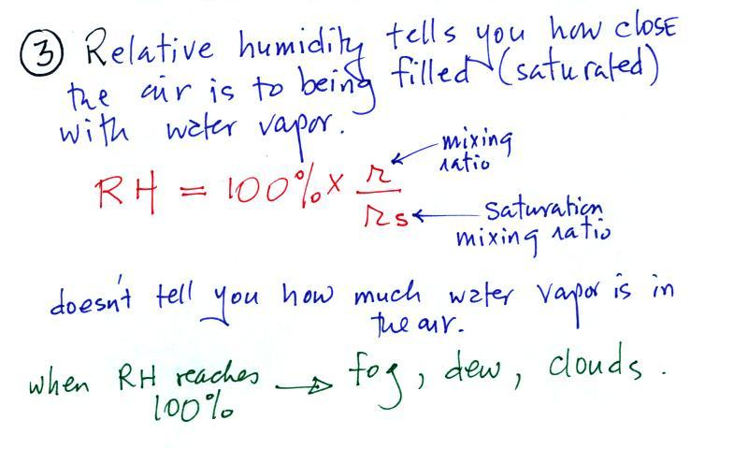

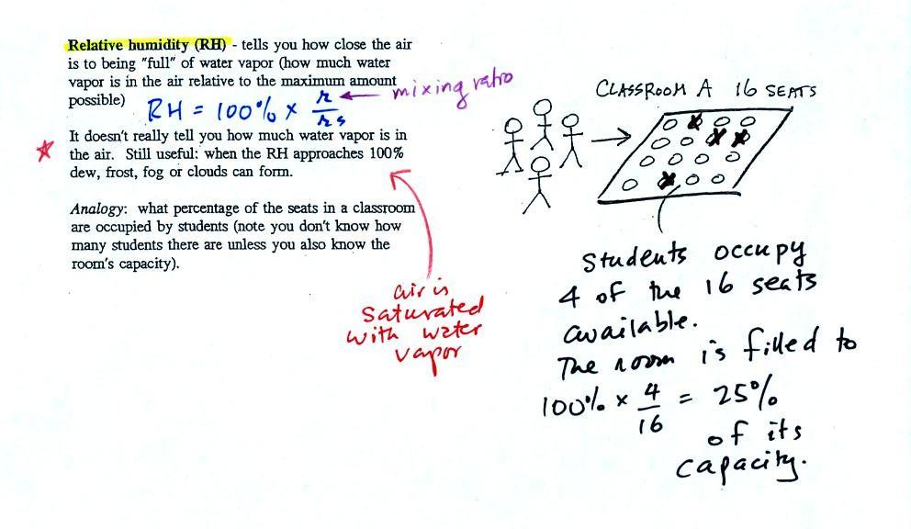
The relative humidity is the variable most people are familiar with. It tells you how "full" the air is with water vapor, how close it is to being filled to capacity with water vapor.
In the analogy (sketched on the right hand side of p. 83 in the photocopied notes) 4 students wander into Classroom A which has 16 empty seats. Classroom A is filled to 25% of its capacity. You can think of 4, the actual number of students, as being analogous to the mixing ratio. The classroom capacity is analogous to the saturation mixing ratio. The percentage occupancy is analogous to the relative humidity.
The figure below goes back to the volumes (1 kg each) of 70 F and 40 F air that could potentially hold 15 grams or 5 grams of water vapor.

Both the 70 F and the 40 F air each contain 3 grams of water vapor. The 70 F air is only filled to 20% of capacity (3 of the 15 open circles is colored in) because this warm air's capacity, the saturation mixing ratio, is large. The RH in the 40 F is 60% even though it has the same actual amount of water vapor because the 40 F air can't hold as much water vapor and is closer to being saturated.
Something important to note: RH doesn't really tell you how much water vapor is actually in the air. The two volumes of air above contain the same amount of water vapor (3 grams per kilogram) but have very different relative humidities. You could just as easily have two volumes of air with the same relative humidities but different actual amounts of water vapor.
The dew point temperature has two jobs. First it gives you an idea of the actual amount of water vapor in the air. In this respect it is just like the mixing ratio. If the dew point temperature is low the air doesn't contain much water vapor. If it is high the air contains more water vapor.
Second the dew point tells you how much you must cool the air in order to cause the RH to increase to 100% (at which point a cloud, or dew or frost, or fog would form).
We ran out of time at this point, but I'm going to include a few more figures to finish this introduction. We'll come back and quickly review all of this again on Wednesday.

If we cool the 70 F air or the 40 F air to 30 F we would find that the saturation mixing ratio would decrease to 3 grams/kilogram. Since the air actually contains 3 g/kg, the RH of the 30 F air would become 100%. The 30 F air would be saturated, it would be filled to capacity with water vapor. 30 F is the dew point temperature for 70 F air that contains 3 grams of water vapor per kilogram of dry air. It is also the dew point temperature for 40 F air that contains 3 grams of water vapor per kilogram of dry air.Because both volumes of air had the same amount of water vapor, they both also have the same dew point temperature.
Now back to the student/classroom analogy

The 4 students move into classrooms of smaller and smaller capacity. The decreasing capacity of the classrooms is analogous to the decrease in saturation mixing ratio that occurs when you cool air. Eventually the students move into a classroom that they just fill to capacity. This is analogous to cooling the air to the dew point.

