source: http://www.wunderground.com/blog/JeffMasters/comment.html?entrynum=2157

Dr. Jeff Masters' WunderBlog
Historic 2012 U.S. drought continues to expand and intensify

The great U.S. drought of 2012 continues to accelerate, and grew larger and more intense over the past week, said NOAA in their weekly U.S. Drought Monitor report issued Thursday, July 19. The area of the contiguous U.S. covered by drought expanded from 61% to 64%, and the area covered by severe or greater drought jumped from 37% to 42%. These are truly historic levels of drought, exceeded only during the great Dust Bowl drought of the 1930s and a severe drought in the mid-1950s. If we make the reasonable assumption that the current area covered by drought is representative of what the average for the entire month of July will be (based on the latest drought forecast from NOAA's Climate Prediction Center), the July 2012 drought is second only to the great Dust Bowl drought of July 1934 in terms of the area of the contiguous U.S. covered by moderate or greater drought. The five months with the greatest percent area in moderate or greater drought, since 1895, now look like this:
1) Jul 1934, 80%
2) Jul 2012, 64%
3) Dec 1939, 60%
4) Jul 1954, 60%
5) Dec 1956, 58%
If we consider the area of the contiguous U.S. covered by severe or greater drought, July 2012 ranks in 5th place:
1) Jul 1934, 63%
2) Sep 1954, 50%
3) Dec 1956, 43%
4) Aug 1936, 43%
5) Jul 2012, 42%
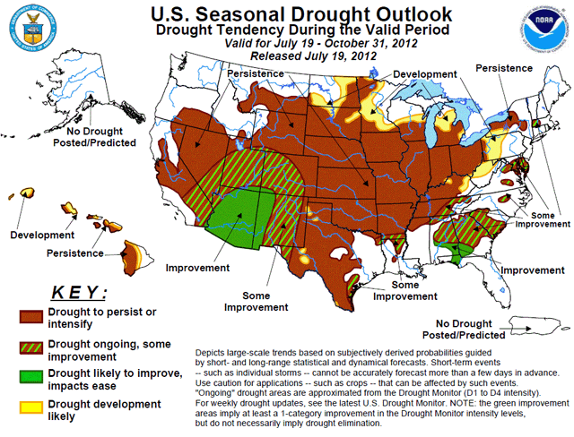
Figure 1. The twice-monthly U.S. Drought Outlook, updated on Thursday, July 19, predicts that drought will continue through October over most of the U.S., and expand to the north and northeast. Image credit: NOAA Climate Prediction Center.
The drought forecast: not encouraging
In their twice-monthly drought outlook, released on Thursday, NOAA's Climate Prediction Center had this to say about the drought: The combination of heat and dryness has severely reduced the quality and quantity of the corn and soybean crop, with 38 percent of the corn and 30 percent of the soybeans rated as poor or very poor as of July 15 by NASS/USDA. Some states, such as Kentucky, Missouri, and Indiana, had over 70 percent of their corn adversely rated. Unfortunately, drought is expected to develop, persist, or intensify across these areas, and temperatures are likely to average above normal. Some widely-scattered relief may come in the form of cold front passages or organized thunderstorm clusters (MCSs), but widespread relief for much of the area is not expected. Unfortunately, the self-perpetuation of regional drought conditions, with very dry soils and very limited evapotranspiration, tends to inhibit widespread development of or weaken existing thunderstorm complexes. It would require a dramatic shift in the weather pattern to provide significant relief to this drought, and most tools and models do not forecast this. Unfortunately, all indicators (short and medium-term, August, and August-October) favor above normal temperatures. With much of the Plains already in drought, above normal temperatures expected into the fall, and a dry short-term and 30-day forecast, the drought should persist, with some possible development in the northern Plains.
One bright spot: drought conditions are expected to improve over the Southwest U.S. over the next few weeks, as the annual summer monsoon peaks and brings heavy rains. The Southeast U.S. has seen some improvement over the past week, due to an upper-level low pressure system that has brought heavy rains. The potential for a landfalling tropical storm to bring drought-busting rains during the August - September - October peak of hurricane season led NOAA to predict possible improvement in drought conditions over the Southeast U.S.
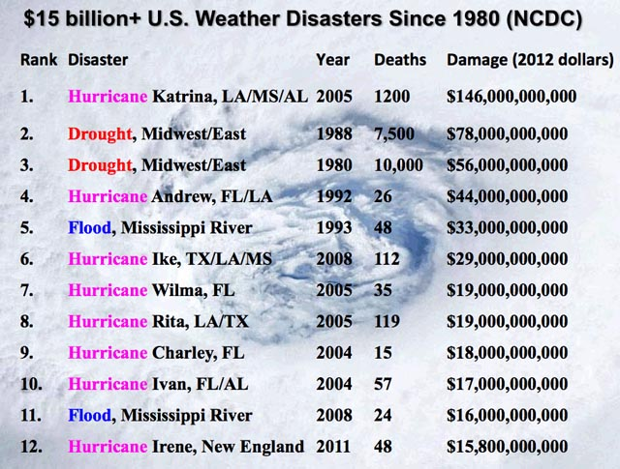Figure 2. The U.S. has seen twelve weather-related disasters costing at least $15 billion since 1980, according to NOAA's National Climatic Data Center. Two of the top three most expensive disasters have been droughts. The drought of 2012 could well make it three out of four. "It might be a $50 billion event for the economy as it blends into everything over the next four quarters," said Michael Swanson, agricultural economist at Wells Fargo & Co. in Minneapolis, the largest commercial agriculture lender. Only three $50 billion weather disasters have hit the U.S. since 1980.
The Atlantic is quiet
There are no tropical cyclone threat areas in the Atlantic to discuss. The models are showing formation of an extratropical cyclone along an old frontal boundary over 1,000 miles off the Northeast U.S. coast on Tuesday, and it is possible such a storm could acquire tropical characteristics and get a name. Such a storm would not be a threat to any land areas. There is an unusual amount of dry, sinking air over the tropical Atlantic and Caribbean that is squashing development of tropical waves coming off the coast of Africa, so it doesn't look too likely that the U.S. will get something it really needs--a big, wet Category 1 hurricane that sloshes ashore over the Gulf Coast, stalling over the Midwest, bringing copious drought-busting rains.
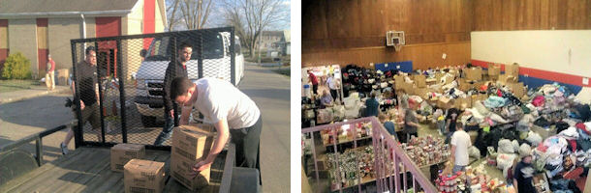Figure 3. Portlight volunteers unloading supplies at the FBC in Henryville, Indiana on March 10, 2012. Henryville was devastated by an EF-4 tornado on March 2 that killed 11 people along its path.
Helping out with disaster relief
It's been another busy year for natural disasters in the U.S., and the portlight.org disaster-relief charity, founded by members of the wunderground community, has been very active helping out victims of this year's disasters. Portlight responded to the deadly March tornado outbreak in the Midwest, two separate April tornado outbreaks in Texas and Oklahoma, and the June wildfires in Colorado. Paul Timmons of Portlight has put together a year-to-date summary of portlight's efforts in 2012, and has this call for action:
Now we’re in July…things have gotten quiet, but we know they won’t be quiet for long. We’re in the middle of hurricane season and mid-summer is a time of unsettled and dangerous weather that happens when we least expect it. Our work is never really done and new tasks pop up all the time. With your help and the help of our friends like the amazing people at Wunderground.com and our new friends at Team Rubicon, The Mahalia Partnership, and CCDC, we will be ready.
Where do we go from here? That depends on you, our supporters, volunteers and friends. Our purpose hasn’t changed: we will continue providing support, relief and aid for unserved, under-served and forgotten people wherever they may be…
Peace to all this weekend, and I'll be back on Sunday or Monday with a new post.
Jeff Masters

