ATMO 170A1 Name___________Answers___________
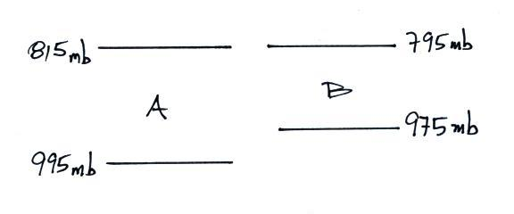
In-class Optional Assignment

1. As you move upward in the figure
at right, is pressure in Layer A
decreasing MORE rapidly,
LESS rapidly, or at the SAME
rate than(as) the pressure in Layer B?
There is a 180 mb pressure decrease in both cases (995 mb -815 mb = 180 mb & 975 mb - 795 mb =180 mb). Layer A is thicker than Layer B so the rate of pressure decrease is lower in Layer A than in Layer B.

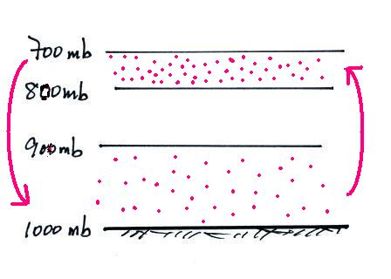
2. Average sea-level pressure is about ____1000____ millibars (mb). The highest sea level pressure ever recorded is ____1085.7 mb____ mb. The record low sea level pressure reading was___850 mb_____.

3. What’s wrong with the picture at right?
This picture shows the top layer being
compressed the most and having the
highest density. That isn’t correct. The
thinnest layer and the highest density air
should be found at the bottom of the
atmosphere.

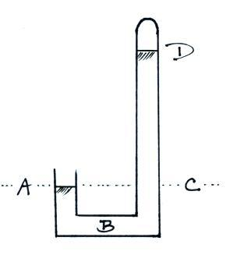
4. Air pressure ____decreases____, air density ____decreases____, and air temperature ___both increases and decreases___ with increasing altitude. (fill in each blank with DECReases, INCReases, or can BOTH increase or decrease depending on altitude)

5. The same pressure would be measured at
Points ___A___ and ___C___ on the
barometer shown at right. The pressure is
zero at Point ___B___. The highest
pressure would be found at Point ___D___.
(each letter in the figure at right should be
used once as an answer)

6. Which one of the following doesn’t belong in the same group as the other three?
a. stable layer b. stratosphere c. temperature inversion d. thunderstorm
Temperature increases with increasing altitude in the stratosphere. Increasing temp. with altitude is called an inversion and produces stable conditions. The strong up and down air motions in thunderstorms can only occur when the atmosphere is unstable.

